ADVANCED BIOLOGY: VIRUSES
(USE CHAPTER 19 AS A RESOURCE)
A VIRUS CONSISTS OF A NUCLEIC ACID SURROUNDED BY A PROTEIN COAT
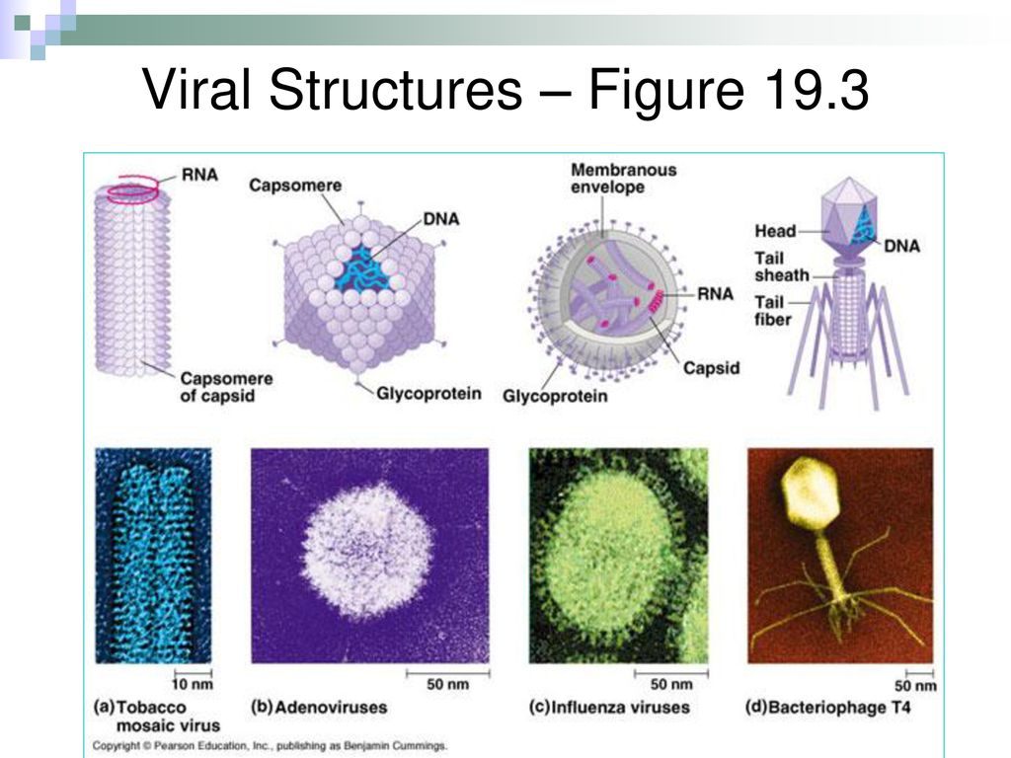
- Viral Genomes

- Capsids and Envelopes

VIRUSES REPLICATE ONLY IN HOST CELLS
Host Range

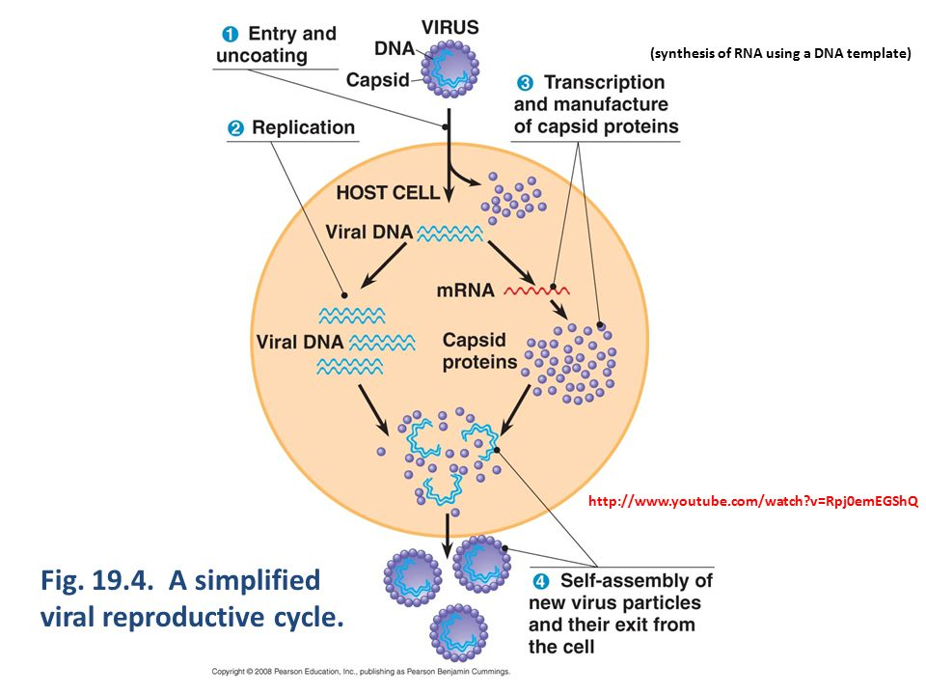

- General Features of Viral Replicative Cycle

- Replicative Cycles of Phages
- They Lytic Cycle
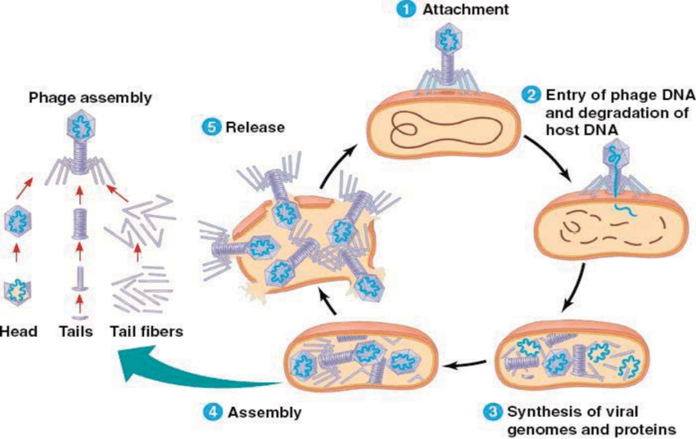

- Virulent phage

- Restriction Enzymes

- The Lysogenic Cycle
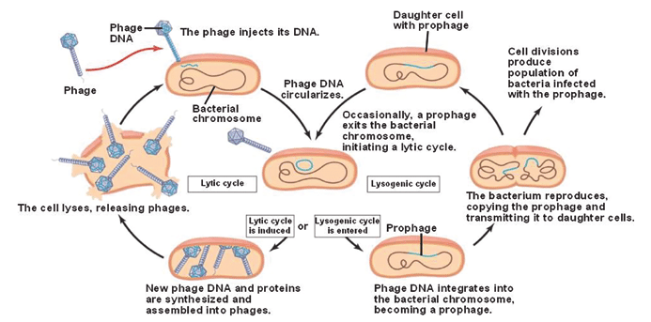

- Temperate phage

- Prophage

- Replicative Cycle of Animal Viruses

- Viral Envelopes
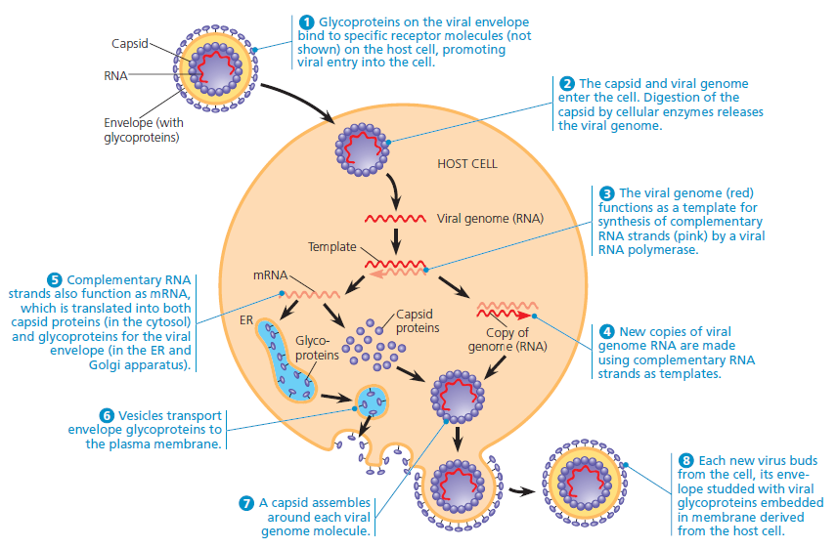

- RNA as a Viral Genetic Material

- Retroviruses

- Reverse Transcriptase

- HIV and AIDs

- Provirus

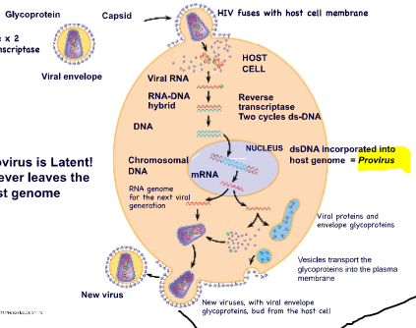

- Evolution of Viruses

VIRUSES ARE FORMIDABLE PATHOGENS IN ANIMALS AND PLANTS
- Viral Diseases in Animals

- Emerging Viruses

- Viral Diseases in Plants

