TISSUES
- Epithelial Tissues

- Types

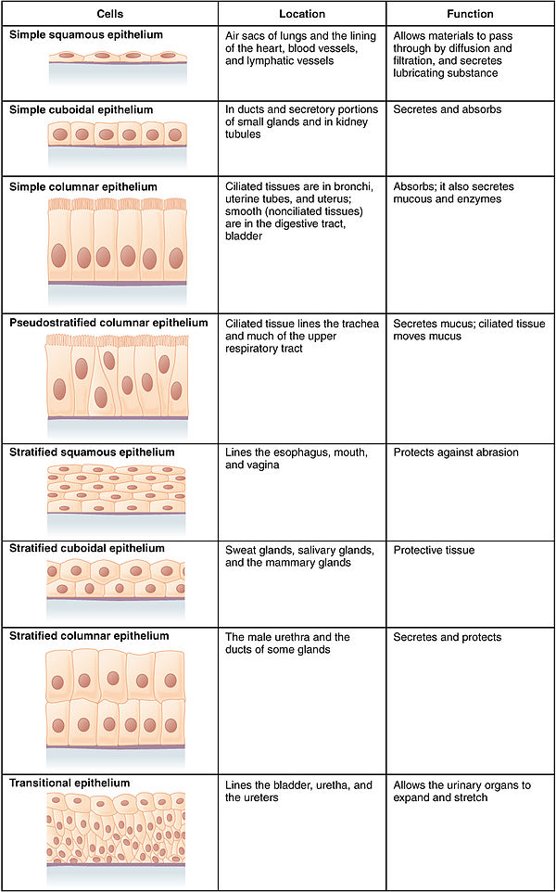

- General Characteristics

- CONNECTIVE TISSUES
- General Characteristics

- Connective Tissues

- Extracellular Matrix

- Other characteristics

- Major Cell Types
- Fibroblasts

- Macrophages

- Mast Cells

- Connective Tissue Fibers

- Collagenous fibers

- Elastic fibers

- Reticular fibers

- Categories of Connective Tissue
- Loose Connective Tissue

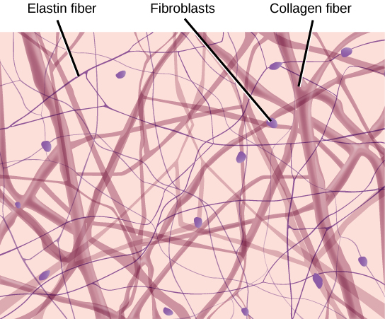

- Adipose Tissue

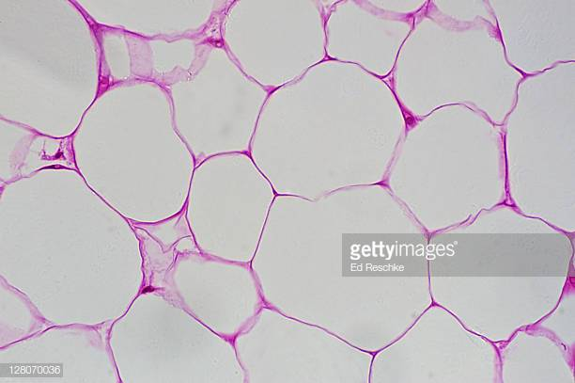

- Dense Connective Tissue

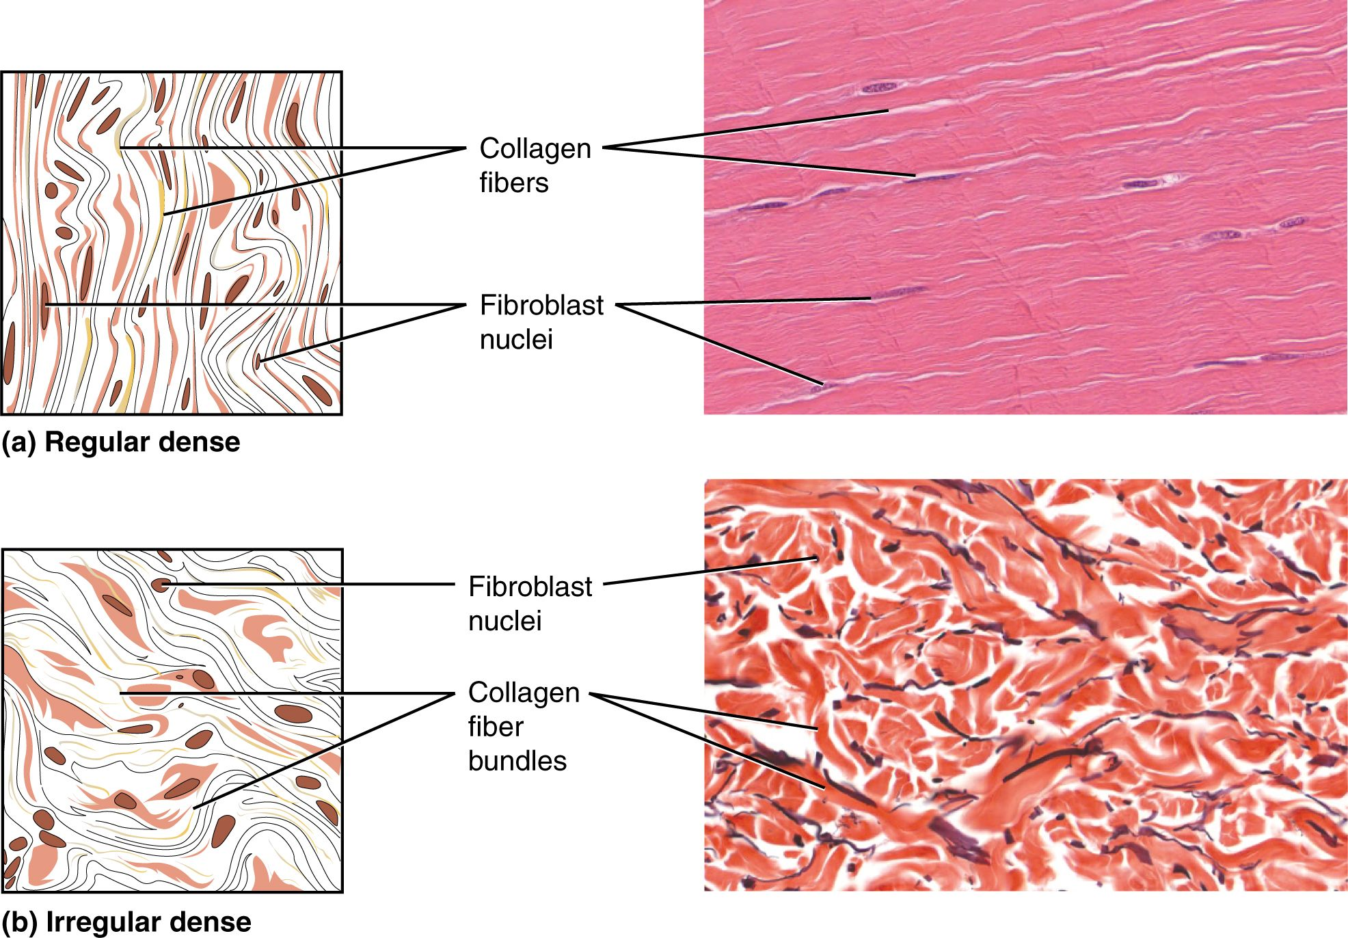

- Cartilage
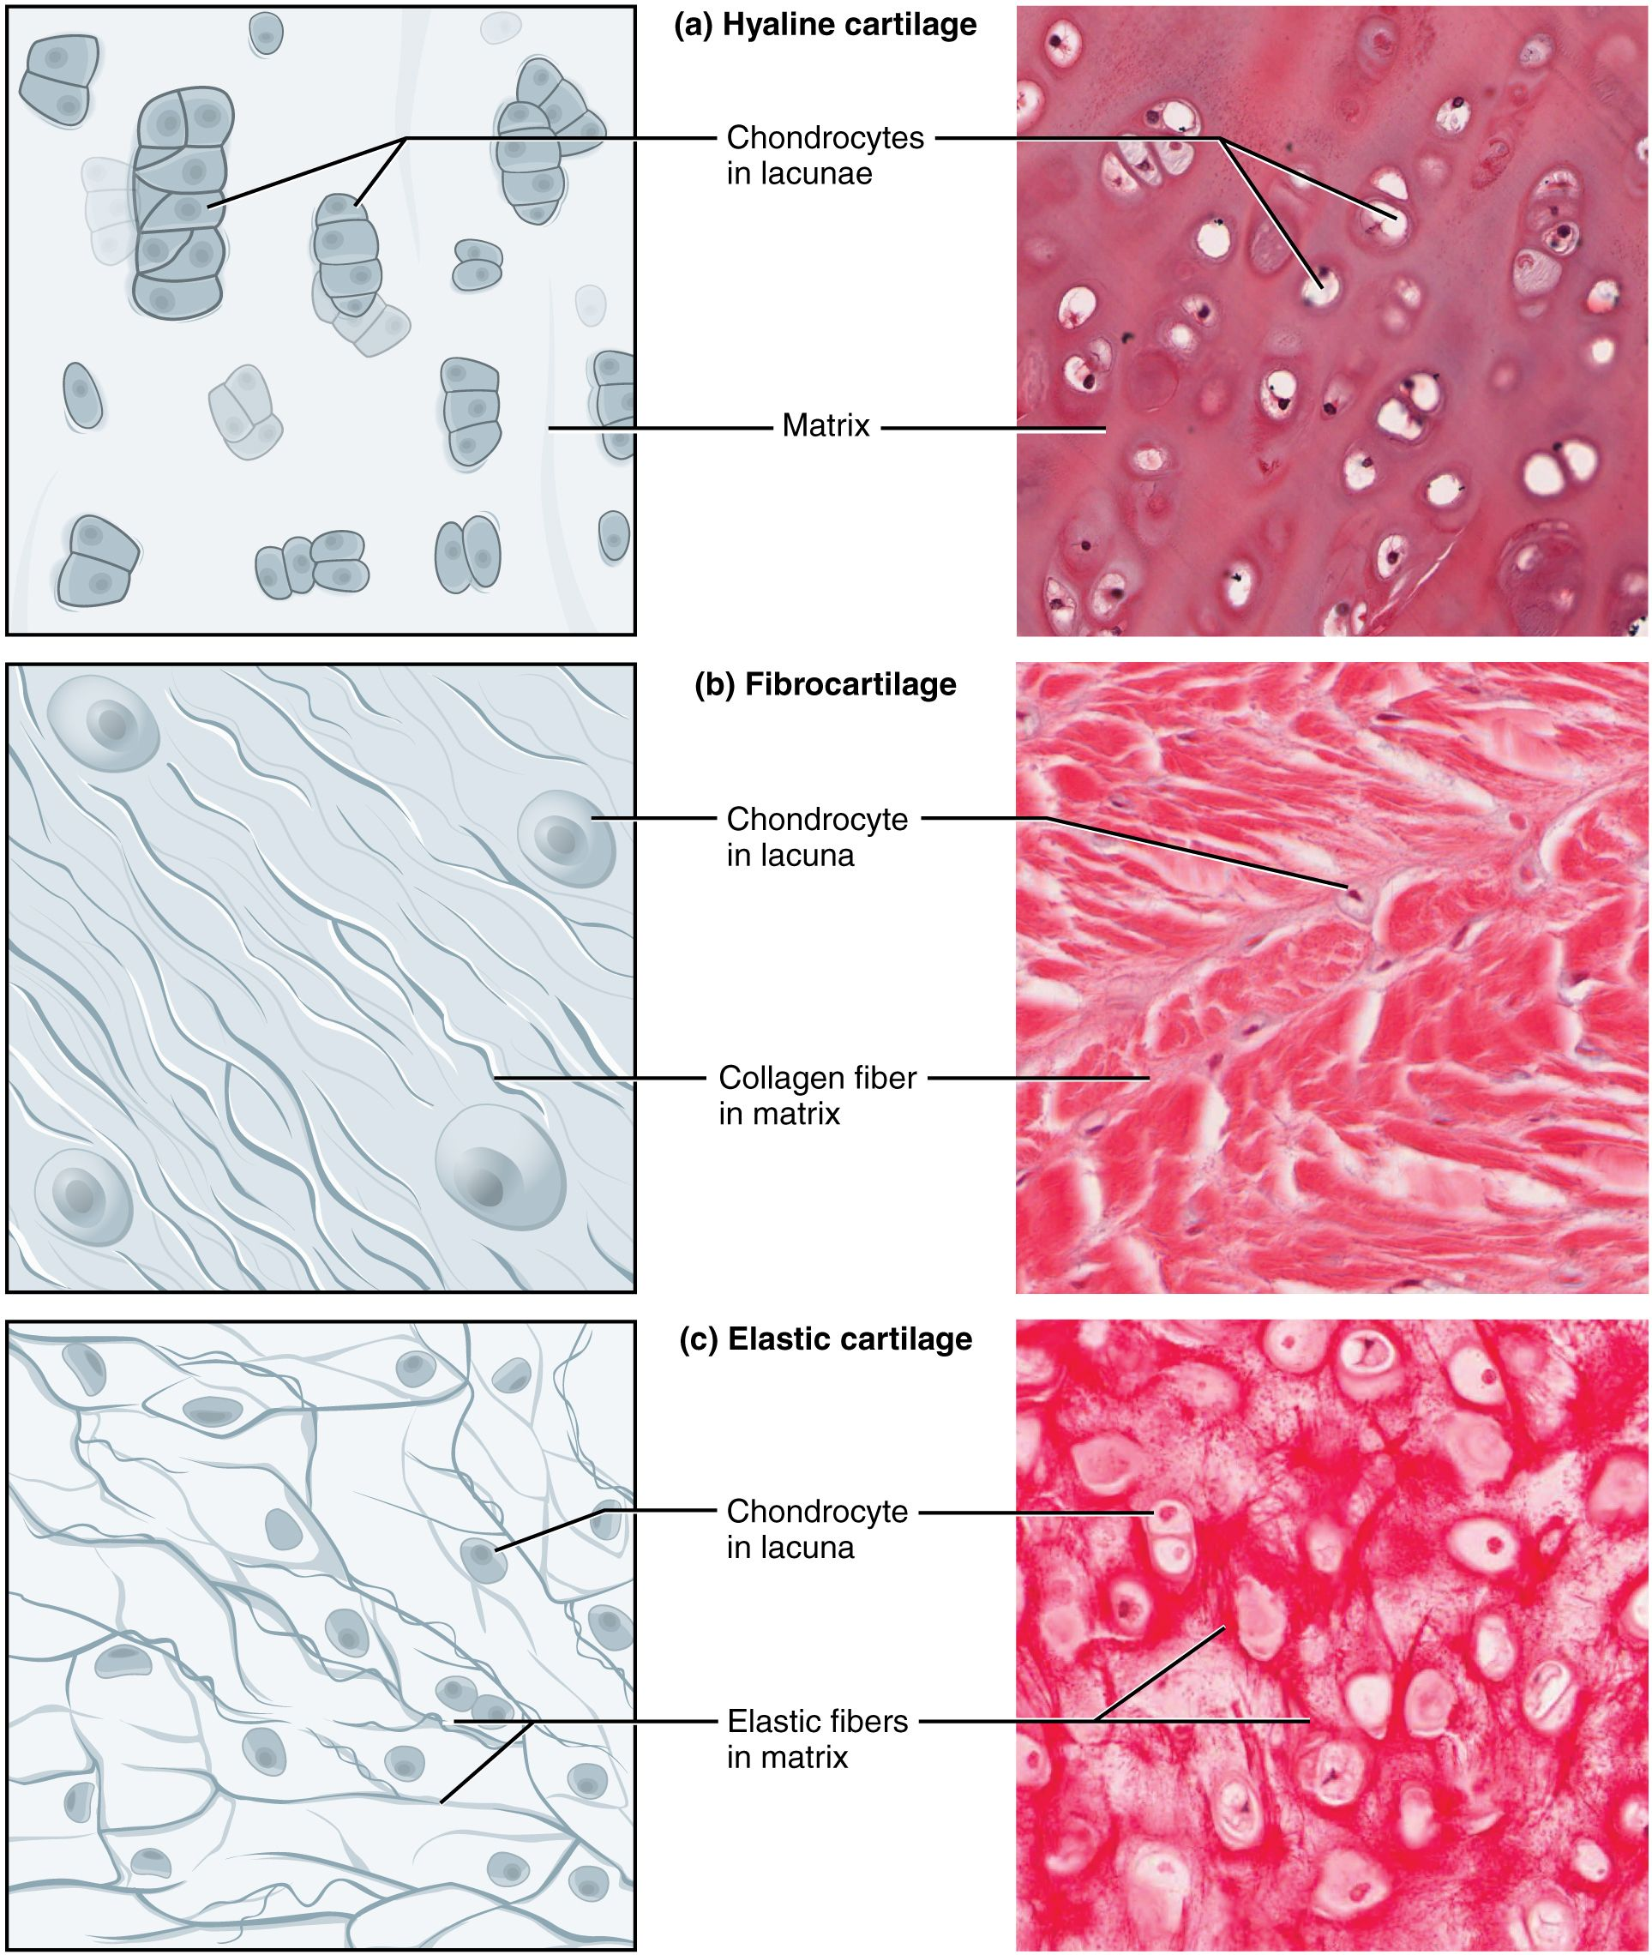

- Hyaline cartilage

- Elastic cartilage

- Fibrocartilage

- Bone

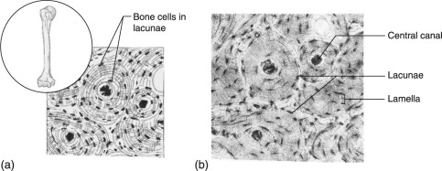

- Blood

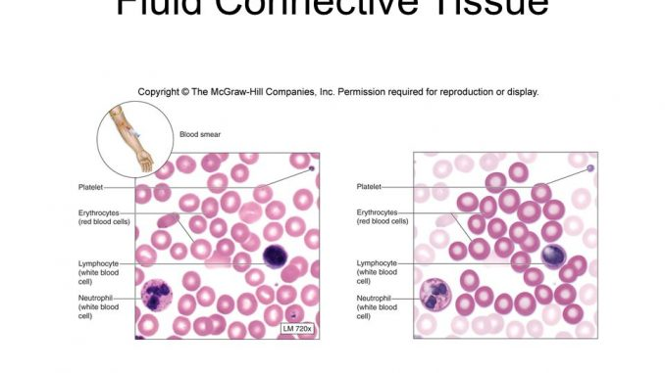

- Muscle Tissue
- General Characteristics

- Skeletal Muscle Tissue

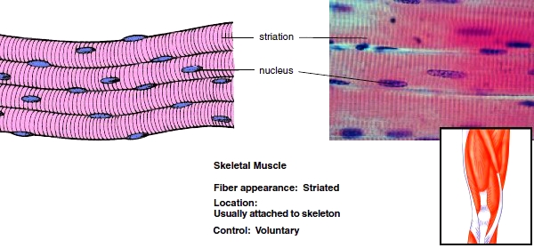

- Smooth Muscle Tissue

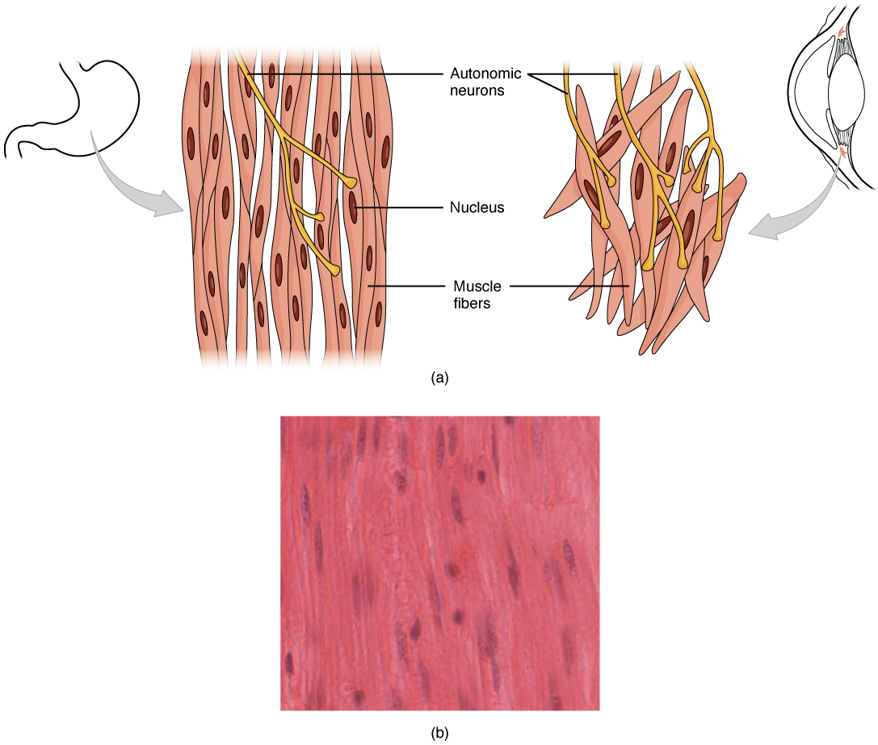

- Cardiac Muscle

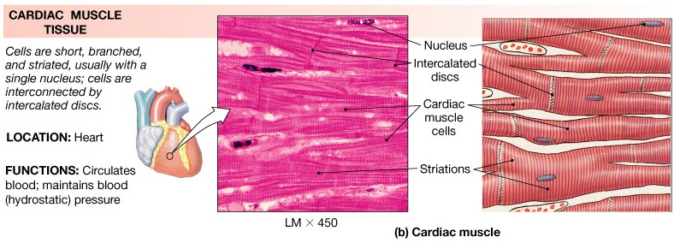

- Nervous Tissue

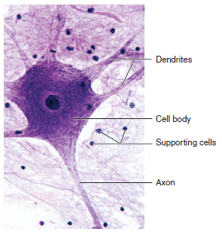

- Types of Membranes
- Serous membranes

- Mucous membranes

- Cutaneous membrane

- Synovial membrane

