ADVANCED BIOLOGY: THE EVOLUTION OF POPULATIONS
(USE CHAPTER 23 AS A RESOURCE)
Microevolution

GENETIC VARIATION MAKES EVOLUTION POSSIBLE

- Genetic Variation

- Sources of Genetic Variation

- Formation of New Alleles

- Altering Gene Number or Position

- Rapid Reproduction

- Sexual Reproduction

THE HARDY-WEINBERG EQUATION CAN BE USED TO TEST WHETHER A POPULATION IS EVOLVING

- Gene Pools and Allele Frequencies
- Population

- Gene pool

- Example of frequency of alleles
Color of flower | Red Flowers | Pink Flowers | White Flowers
Genotype | RR | RW | WW
Number of flowers | 320 | 160 | 20

- How many R alleles in the population and what is the frequency of R (p)?

- How many W Alleles in the population and what is the frequency of W (q)?

- p + q = 1

- The Hardy-Weinberg Principle

- Hardy-Weinberg Equilibrium (Application)
Use the calculated p and q from above to calculate genotype frequencies

- Probability of RR

- Probability of RW

- Probability of WW

- What does this mean?

- Conditions for Hardy-Weinberg Equilibrium
(1)

(2)

(3)

(4)

(5)

- Applying the Hardy-Weinberg Principle (PKU as an example)
The probability of a child with PKU is 1/10000

NATURAL SELECTION, GENETIC DRIFT, AND GENE FLOW CAN ALTER ALLELE FREQUENCIES IN A POPULATION

- Natural Selection

- Genetic Drift

- The Founder Effect

- The Bottleneck Effect

- Effects of Genetic Drift: A Summary
(1)

(2)

(3)

(4)

- Gene Flow

NATURAL SELECTION IS THE ONLY MECHANISM THAT CONSISTENTLY CAUSES ADAPTIVE EVOLUTION
Adaptive Evolution

- Natural Selection: A Closer Look
- Relative Fitness

- Directional, Disruptive, and Stabilizing Selection
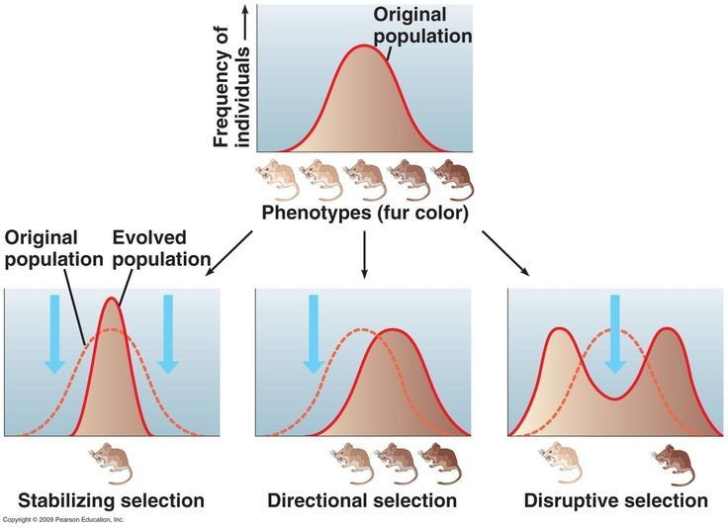

- Directional

- Disruptive

- Stabilizing

- The Key Role of Natural Selection in Adaptive Evolution

- Sexual Selection

- Sexual dimorphism

- Intrasexual selection

- Intersexual selection

- The Preservation of Genetic Variation

Neutral variation

- Diploidy

- Balancing Selection

- Heterozygote Advantage

- Frequency-Dependent Selection

- Why Natural Selection Cannot Fashion Perfect Organisms

a.

b.

c.

d.

