ADVANCED BIOLOGY: REGULATION OF GENE EXPRESSION
(USE CHAPTER 18 AS A RESOURCE)
BACTERIA OFTEN RESPOND TO ENVIRONMENTAL CHANGE BY REGULATING TRANSCRIPTION
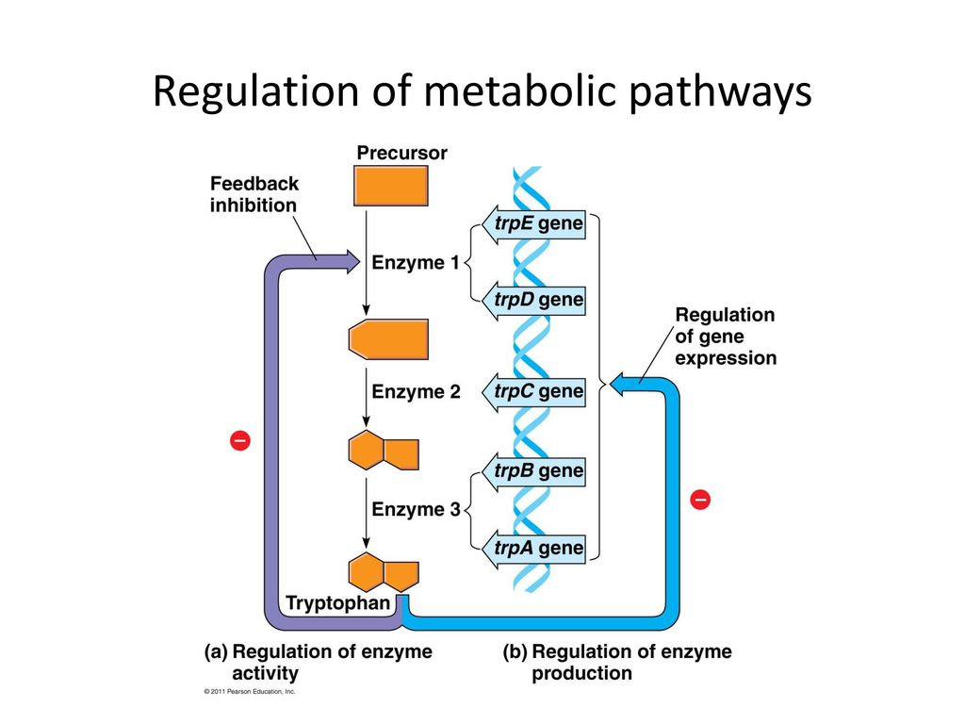

- Operons: The Basic Concept
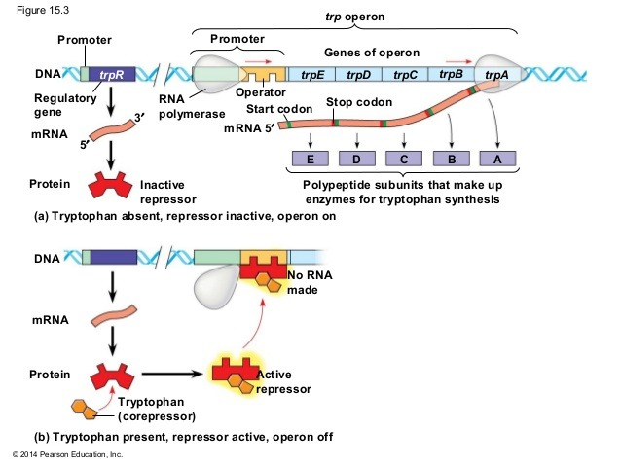

- Operator

- Operon

- Repressor

- Regulatory gene

- Corepressor

- Repressible and Inducible Operons: Two Types of negative Gene Regulation
- Repressible Operon

- Inducible Operon
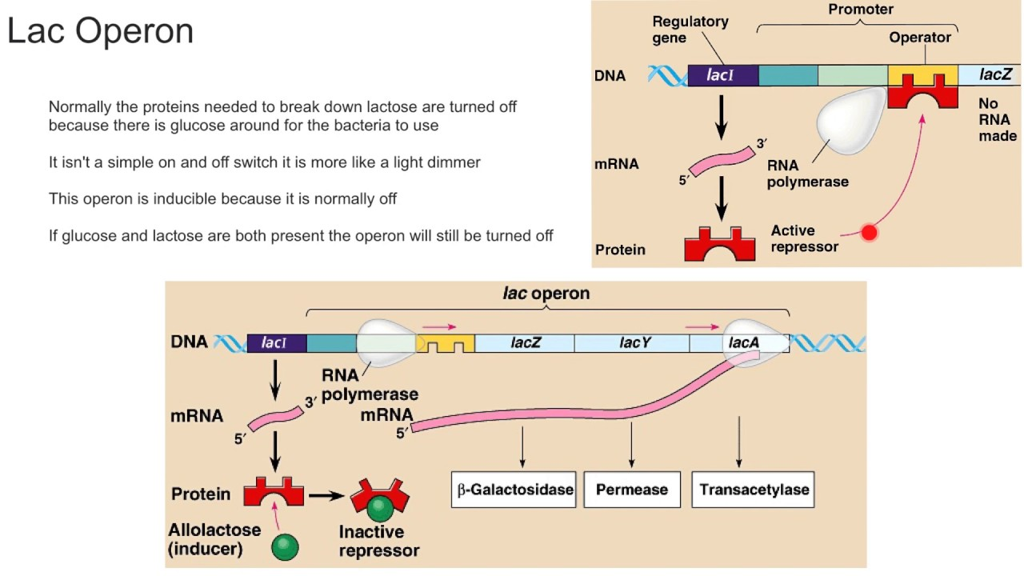
- Inducer

- Positive Gene Regulation
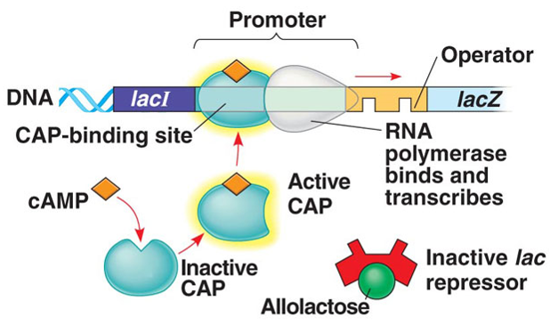

EUKARYOTIC GENE EXPRESSION IS REGULATED AT MANY STAGES

- Differential Gene Expression

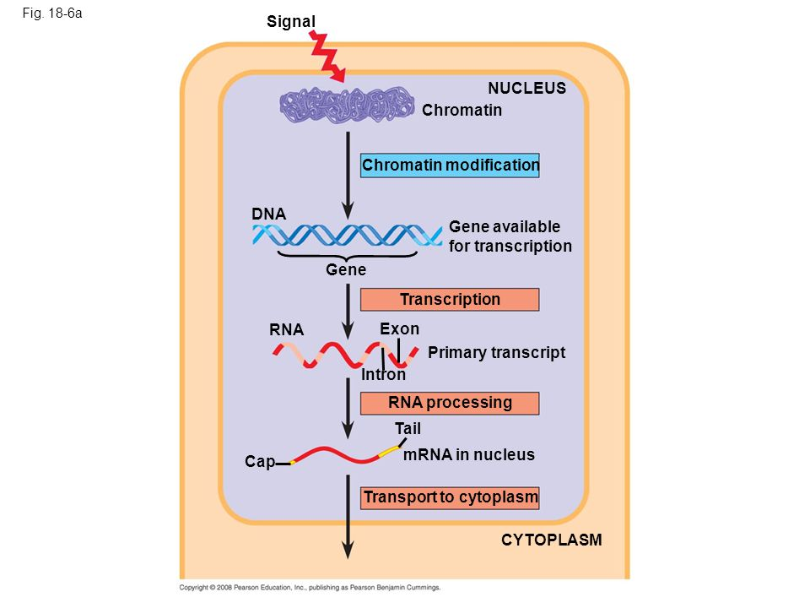

- Regulation of Chromatin Structure

- Histone Modifications and DNA Methylation

- Epigenetic Inheritance

- Regulation of Transcription Initiation

- Organization of a Typical Eukaryotic Gene

- The Roles of Transcription Factors

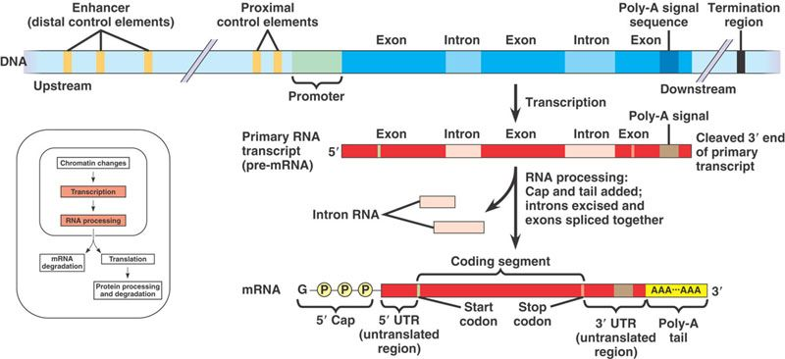

- Enhancers and Specific Transcription Factors

- Combinatorial Control of Gene Activity

- Coordinately Controlled Genes In Eukaryotes

- Mechanisms of Post-Transcriptional Regulation

- RNA Processing
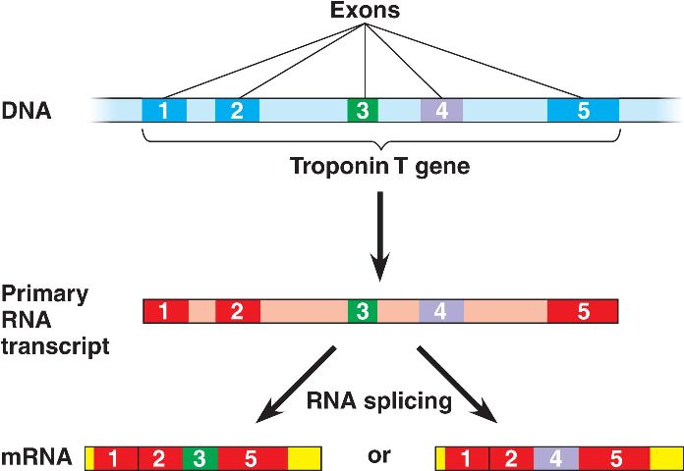

- mRNA Degradation

- Initiation of Translation

- Protein Processing and Degradation
NONCODING RNAS PLAY MULTIPLE ROLES IN CONTROLLING GENE EXPRESSION

- Effects on mRNAs by MicroRNAs and Small Interfering RNAs

- miRNA

- siRNA

- RNAi

- Chromatin Remodeling and Effects on Transcription by ncRNAs

RESEARCHERS CAN MONITOR EXPRESSION OF SPECIFIC GENES

- Studying the Expression of Single Genes

- Nucleic acid hybridization

- Nucleic acid probe

- In-situ hybridization

- cDNA

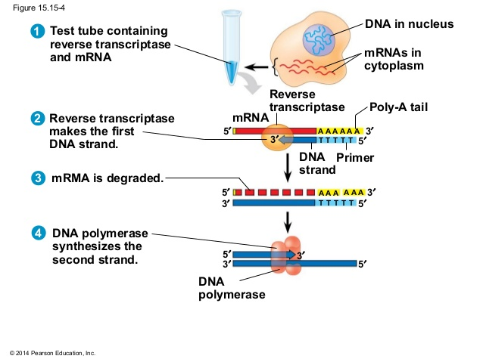

- Studying the Expression of Groups of Genes

DNA microarray assays

