ADVANCED BIOLOGY: PLANT STRUCTURE AND GROWTH
(USE CHAPTER 35 AS A REFERENCE)
A comparison of monocots and dicots (Angiosperms)- for more information about plant classification see chapter 29 and 30 for the types.
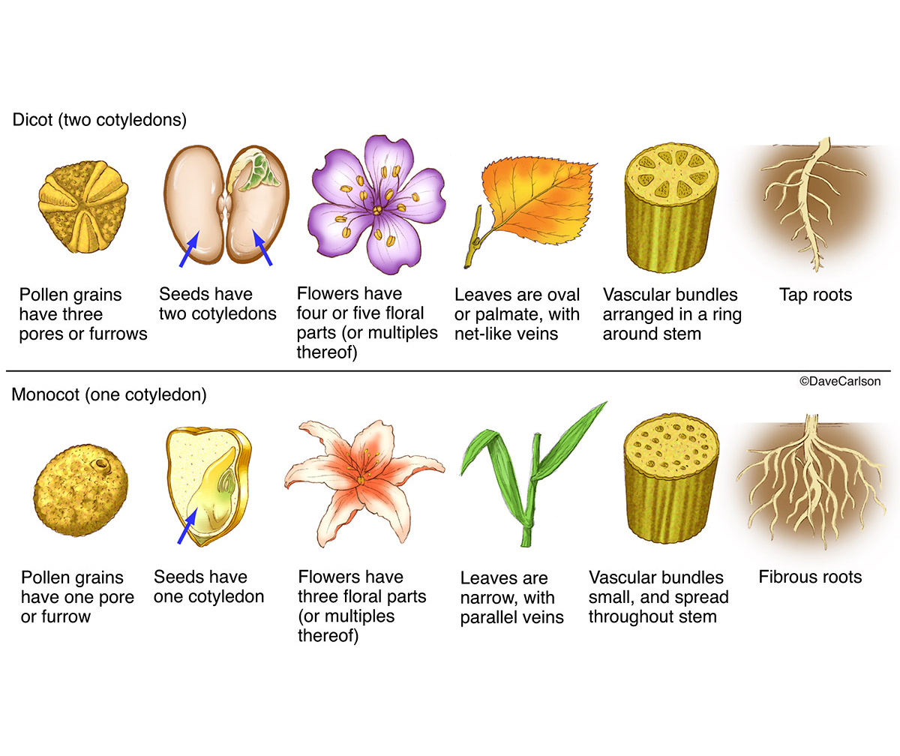

PLANTS HAVE A HIERARCHICAL ORGANIZATION CONSISTING OF ORGANS, TISSUES, AND CELLS
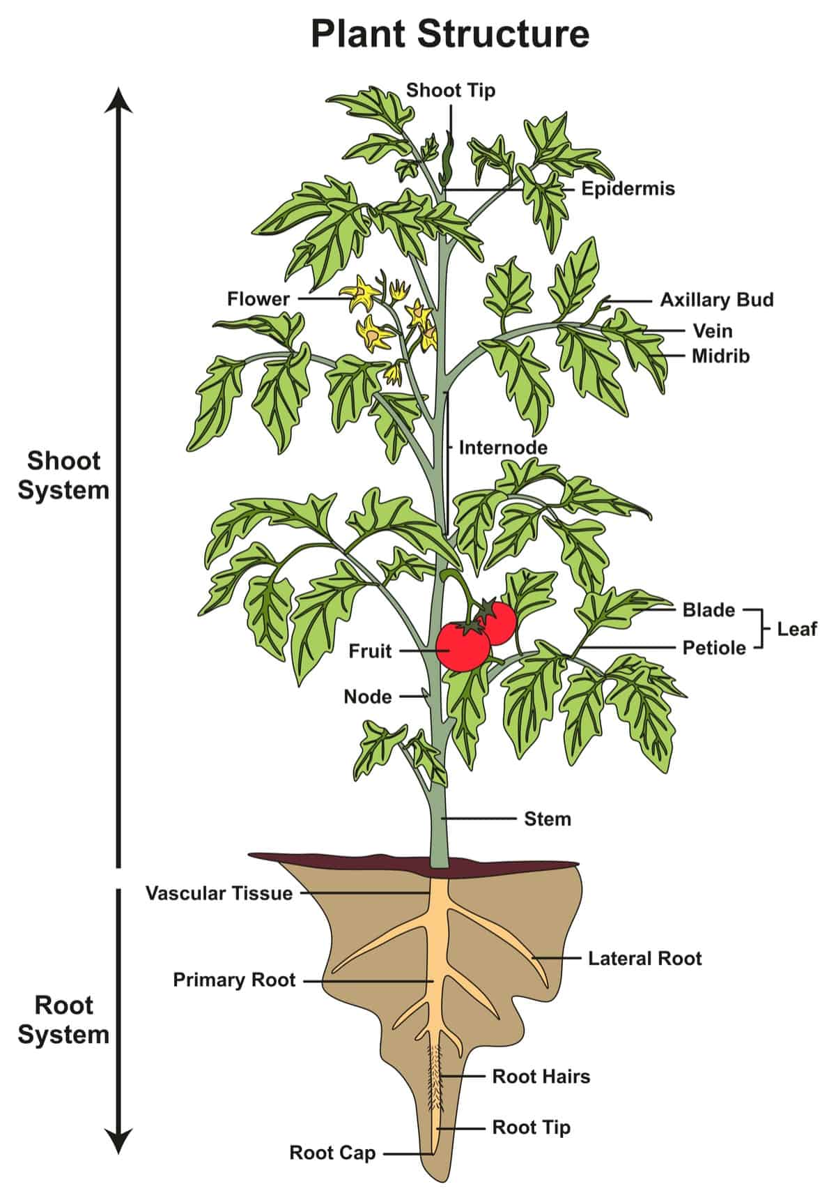
- The Three Basic Plant organs: Roots, Stems, and Leaves
Root system

Shoot system

- Roots
- Function

- Tap roots

- Lateral roots

- Advantages of a taproot

- Advantages of a fibrous system

- Root hairs

- Mycorrhizal associations

- Evolutionary adaptations of roots

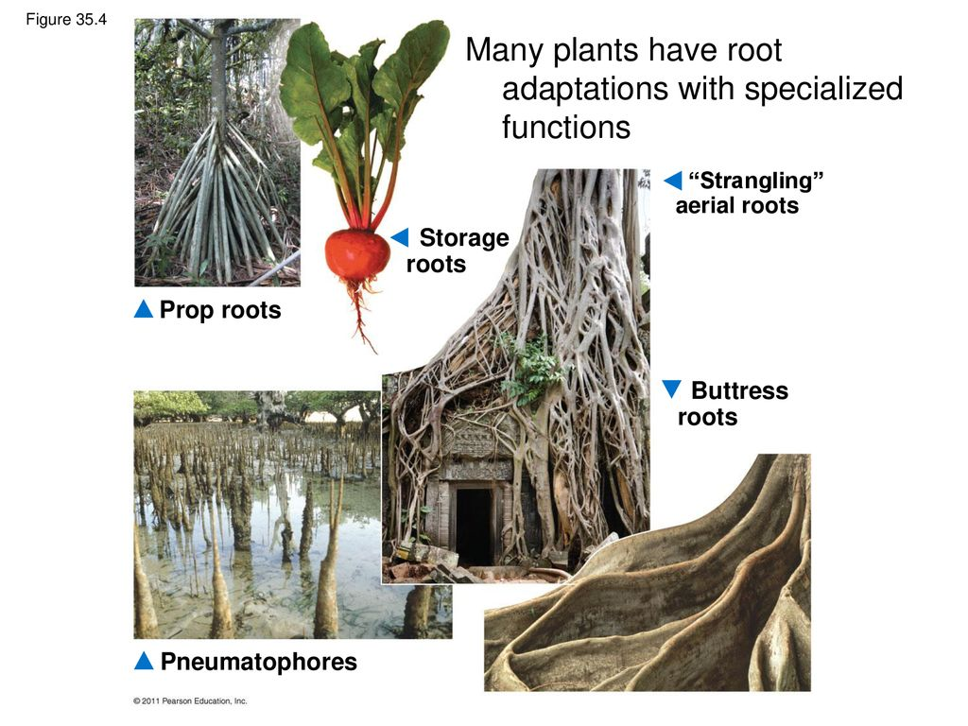
- Stems
- Stem

- Node

- Internode

- Apical bud

- Axillary bud

- Evolutionary adaptations of stems

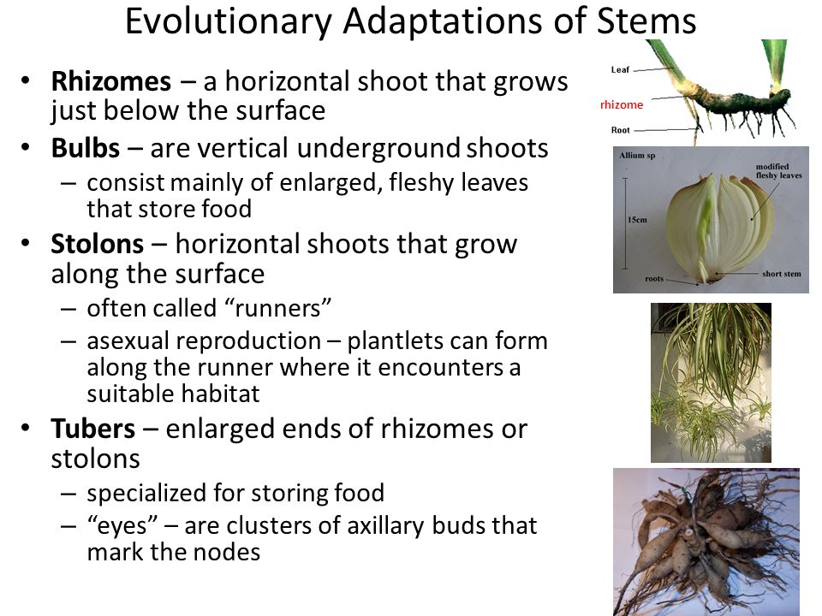
- Leaves
- Leaf

- Blade

- Petiole

- Veins

- Evolutionary Adaptations of Leaves
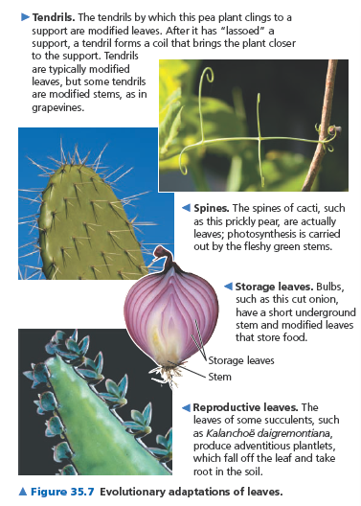
- Dermal, Vascular, and Ground Tissue Systems
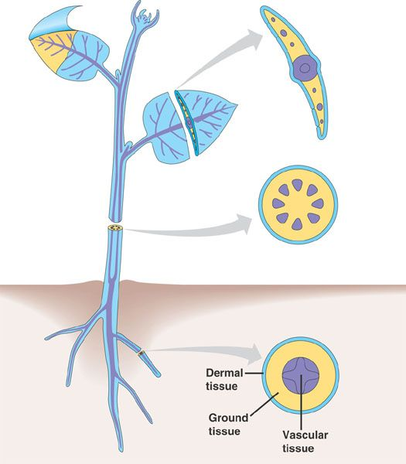
- Dermal Tissue System

- Epidermis

- Cuticle

- Periderm

- Trichomes

- Vascular Tissue System

- Xylem

- Phloem

- Stele

- Ground Tissue System

- Pith

- Cortex

- Functions

- Common Types of Plant Cells

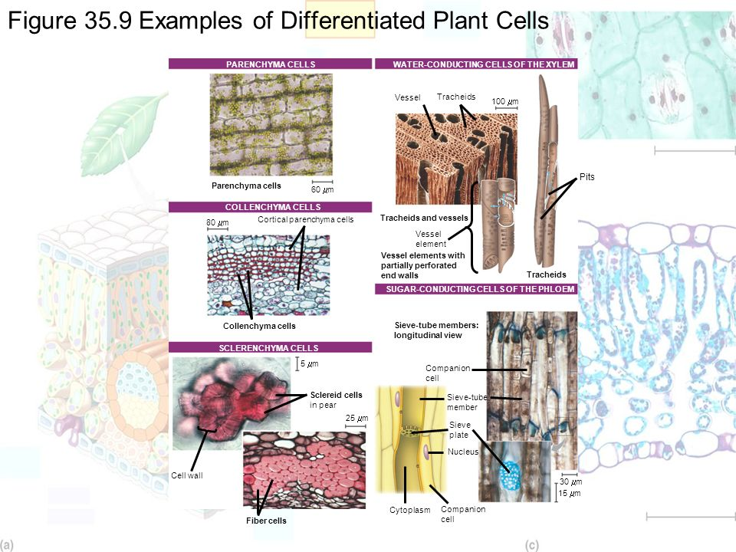

Use text to take notes on these different types of cells

MERISTEMS GENERATE NEW CELLS FOR GROWTH AND CONTROL THE DEVELOPMENTAL PHASES AND LIFE SPANS OF PLANTS

Indeterminate growth

Meristems

Determinate growth

- Different Meristems Produce Primary and Secondary Growth
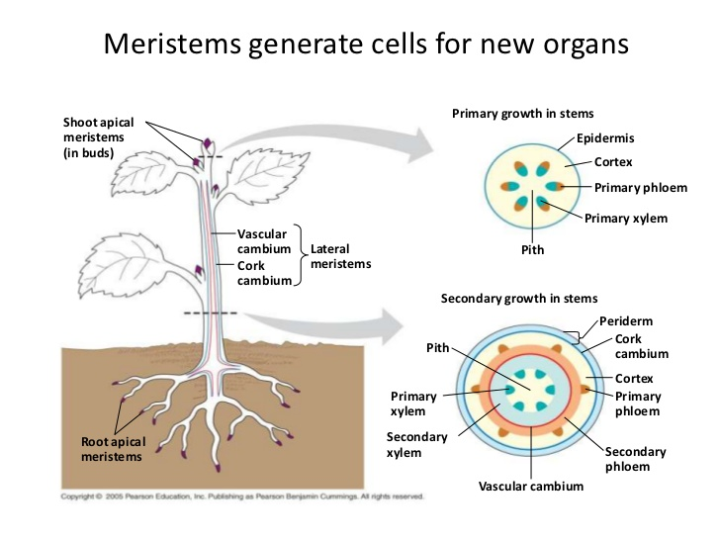
- Apical Meristems (Primary Growth)

- Lateral Meristems (Secondary Growth)
- Vascular cambium

- Cork cambium

PRIMARY GROWTH LENGTHENS ROOTS AND SHOOTS

- Primary Growth of Roots
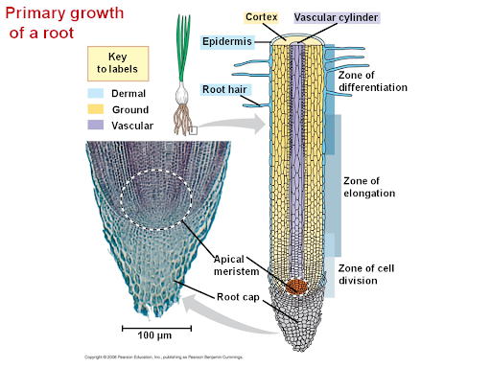
- Root Cap

- Zone of cell division

- Zone of elongation

- Zone of differentiation

- Tissues involved in primary growth

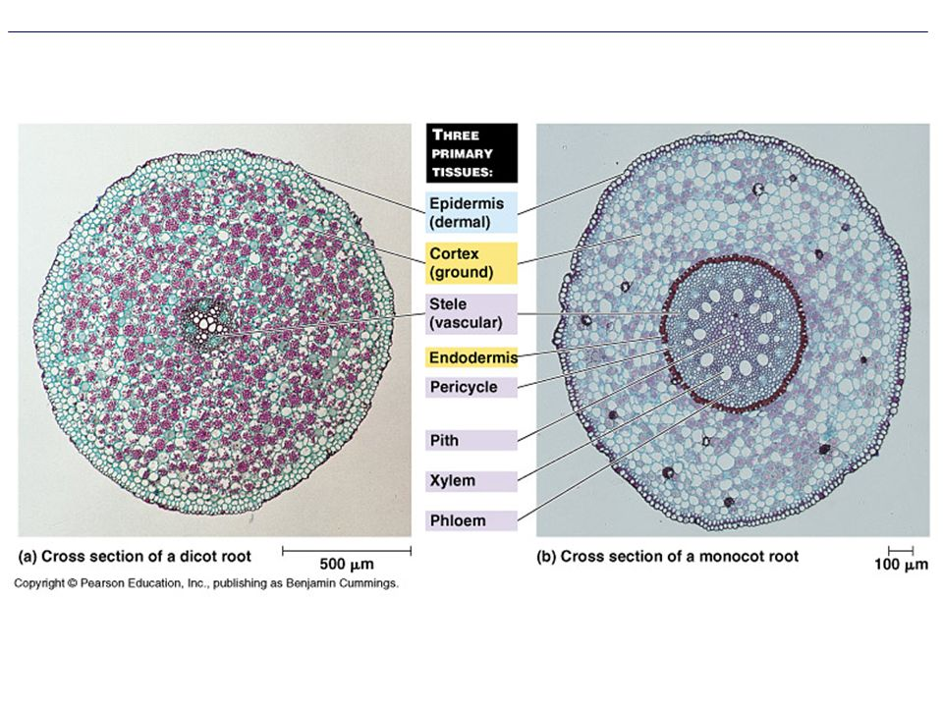
- Function of the endodermis

- Function of the pericycle

- Primary Growth of Shoots

Leaf primordia

Apical dominance

- Tissue organization of leaves
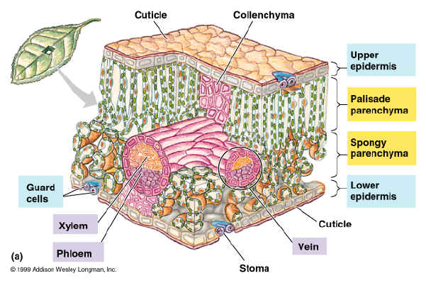

- Stomata

- Guard cells

- Mesophyll

- Spongy mesophyll

- Palisade mesophyll

- Vascular tissue

- Tissue Organization of Stems
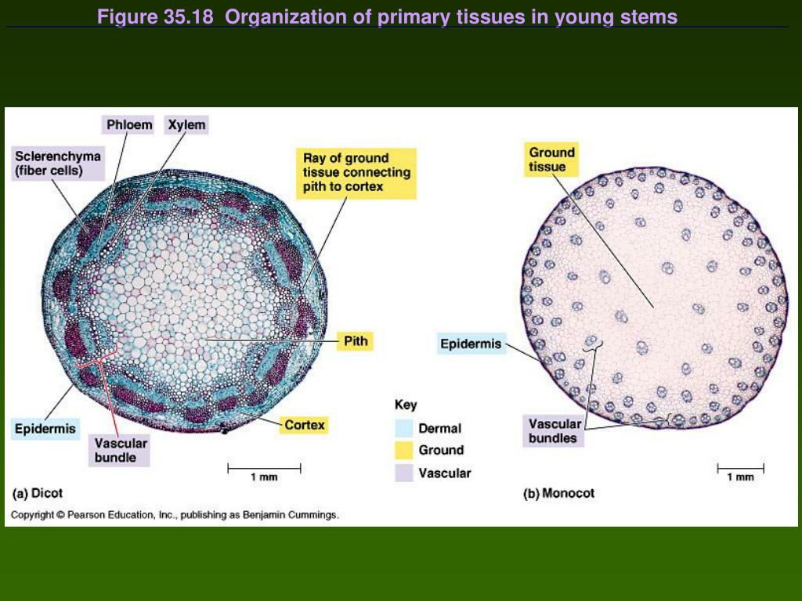

From previous material, you should know the functions of these cells.

SECONDARY GROWTH INCREASES THE DIAMETER OF STEMS AND ROOTS IN WOODY PLANTS
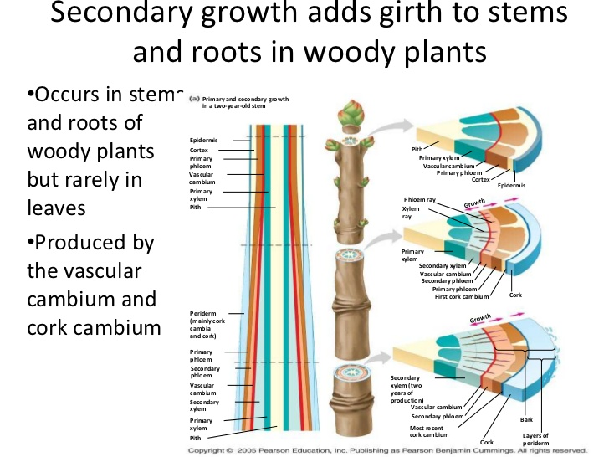

- The Vascular Cambium and Secondary Vascular Tissue

- Secondary xylem

- Spring Wood vs Summer Wood

- Heartwood

- Sapwood

- Secondary Phloem

- The Cork Cambium and the Production of Periderm

- Cork Cells

- Function of Cork

- Difference between “Bark” and “Cork”

- Lenticels

