ADVANCED BIOLOGY: CARBON AND THE MOLECULAR DIVERSITY OF LIFE
(USE CHAPTER 4 AND 5 AS A RESOURCE)

Organic Compounds

Macromolecules

IMPORTANT FUNCTIONAL GROUPS IN CARBON COMPOUNDS
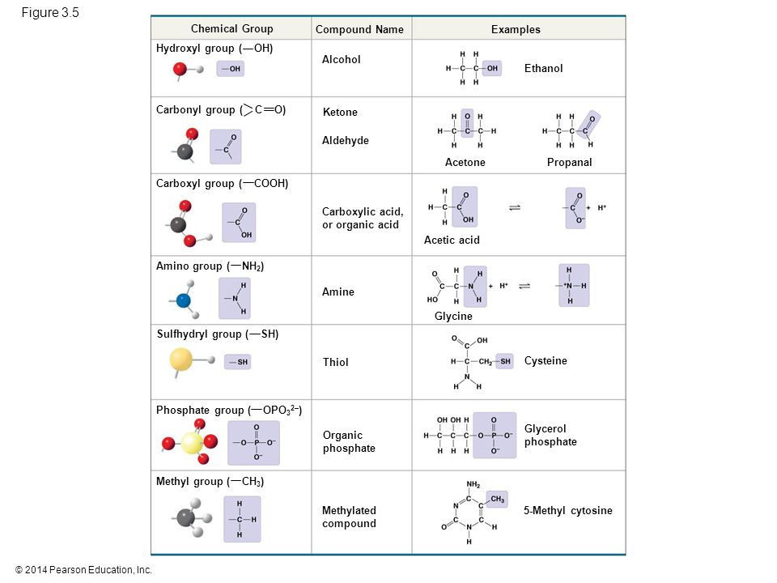

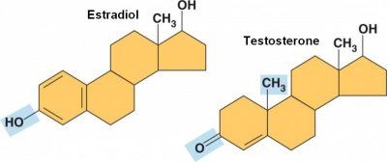

ATP: An Important Source of Energy for Cellular Processes
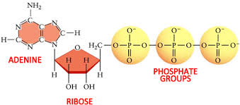

MACROMOLECULES ARE POLYMERS, BUILT FROM MONOMERS
Polymer

Monomer

- The Synthesis and Breakdown of Polymers

- Enzymes

- Dehydration reaction (synthesis)

- Hydrolysis (breakdown)

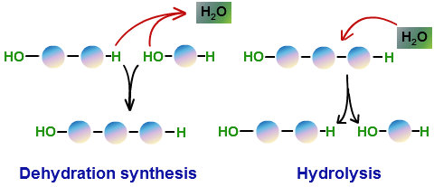

- The Diversity of Polymers

CARBOHYDRATES SERVE AS FUEL AND BUILDING MATERIAL
Carbohydrates

- Sugars

- Monosaccharides

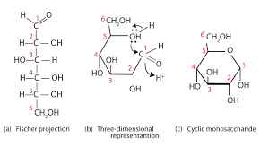

- Disaccharides

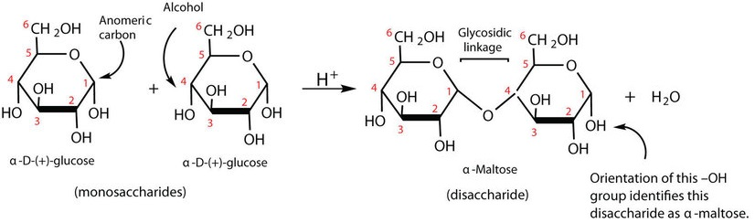
- Polysaccharides

- Storage polysaccharides
- Starch

- Glycogen

- Structural polysaccharides
- Cellulose

- Chitin

LIPIDS ARE A DIVERSE GROUP OF HYDROPHOBIC MOLECULES
Lipids

- Fats

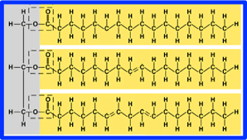

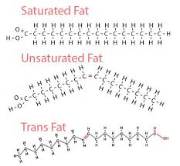
- Phospholipids
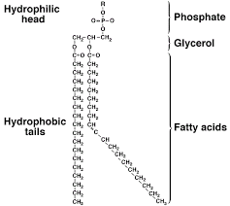

- Steroids
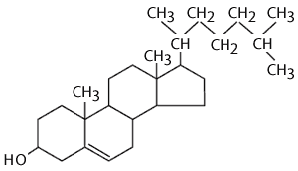

PROTEINS INCLUDE A DIVERSITY OF STRUCTURES, RESULTING IN A WIDE RANGE OF FUNCTIONS

Catalysts

Polypeptides

Protein

- Amino Acids
- Basic structure of amino acids

- R group determines identity of amino acid (See figure 5.17)

- Nonpolar
- Polar
- Electrically charged

- Polypeptides
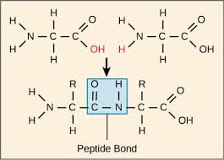

- Protein Structure and Function

- Primary Structure

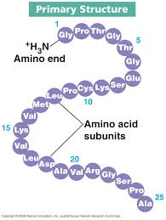

- Secondary Structure
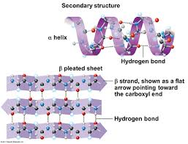

- Tertiary Structure
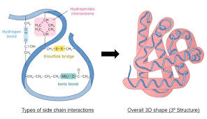

- Quaternary Structure
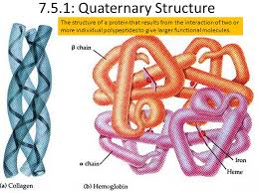

- Sickle Cell Disease: A change in Primary Structure
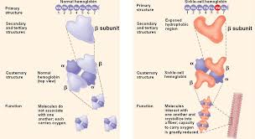

- What determine Protein Structure

- Protein Folding in the Cell

NUCLEIC ACIDS STORE, TRANSMIT, AND HELP EXPRESS HEREDITARY INFORMATION

Nucleic Acids

The Roles of Nucleic Acids
- Deoxyribonucleic Acid

- Ribonucleic Acid

The Components of Nucleic Acids
- Polynucleotides and nucleotides
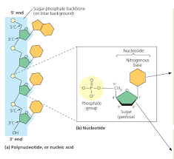

- Nitrogenous bases
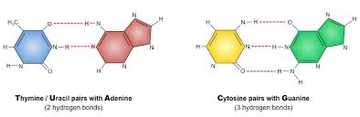

- Sugars
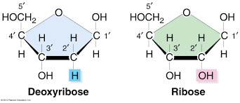

Nucleotide Polymers

