ADVANCED BIOLOGY: MEMBRANE TRANSPORT AND CELL SIGNALING
(USE CHAPTER 7AND 11 AS A RESOURCE)
Selective Permeability

CELLULAR MEMBRANES ARE FLUID MOSAICS OF LIPIDS AND PROTEINS
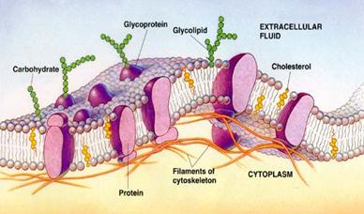
Amphipathic

Fluid Mosaic Model

- The Fluidity of Membranes
- Phospholipids

- Proteins

- Cholesterol

- Evolution of Differences in Membrane Lipid Composition
- Extreme cold

- Extreme heat

- Varied Temperatures

- Membrane Proteins and Their Functions

- Integral Proteins

- Peripheral Proteins

- Functions

(1)

(2)

(3)

(4)

(5)

(6)
4. The Role of Membrane Carbohydrates in Cell-Dell Recognition
a. Cell to Cell Recognition

b. Types

5.Synthesis and Sidedness of Membranes

MEMBRANE STRUCTURE RESULTS IN SELECTIVE PERMEABILITY

Substances that move it and out

- The Permeability of the Lipid Bilayer
- What can pass through?

- What can’t pass through?

- Transport Proteins

- Channel proteins

- Aquaporins

- Carrier proteins

- Specificity

PASSIVE TRANSPORT IS DIFFUSION OF A SUBSTANCE ACROSS A MEMBRANE WITH NO ENERGY INVESTMENT
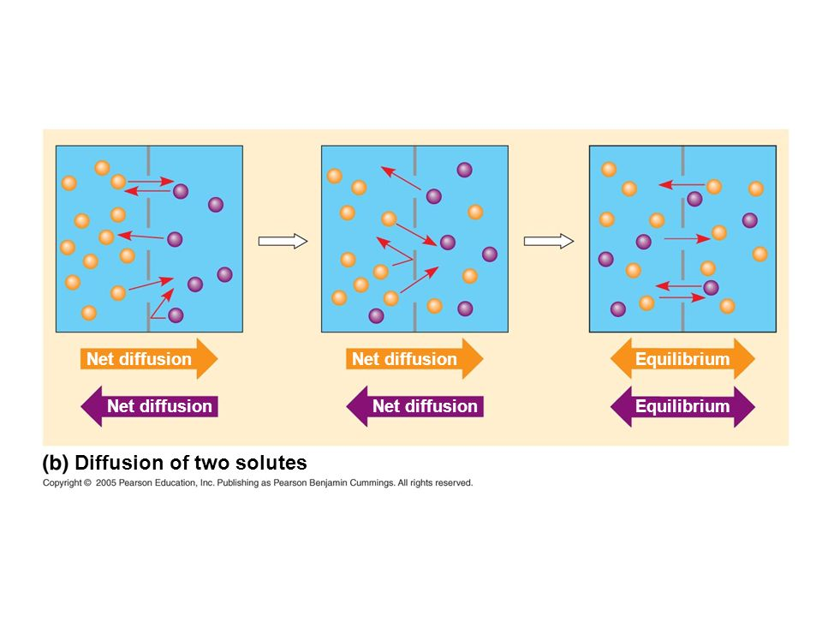
Diffusion

Concentration gradient

Passive transport
- Effects of Osmosis on Water Balance
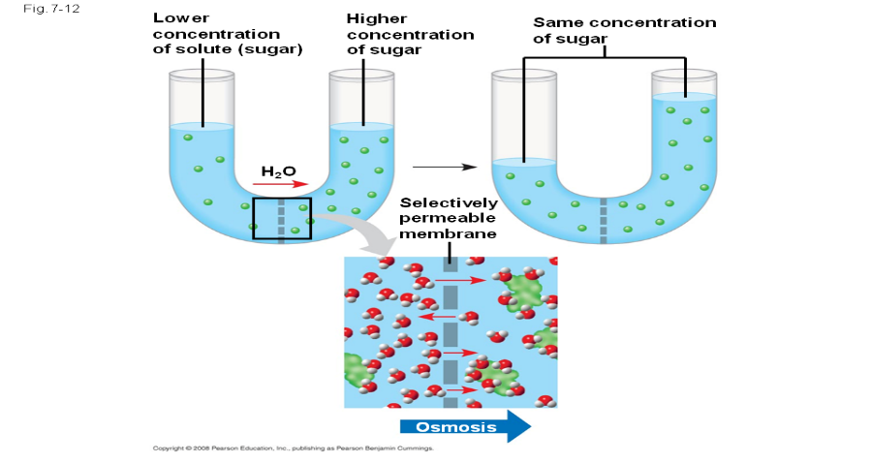

- Water Balance of Cells Without Walls
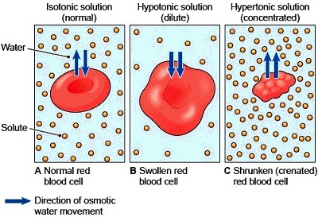

- Isotonic

- Hypotonic

- Hypertonic

- Osmoregulation

- Water Balance of Cells with Walls

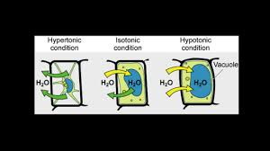
- Hypotonic (turgid)

- Isotonic (flaccid)

- Hypertonic (plasmolysis)

- Facilitated Diffusion: Passive Transport Aided by Proteins
- Facilitated diffusion

- Ion channels

ACTIVE TRANSPORT USES ENERGY TO MOVE SOLUTES AGAINST THEIR GRADIENTS

- The Need for energy in Active Transport
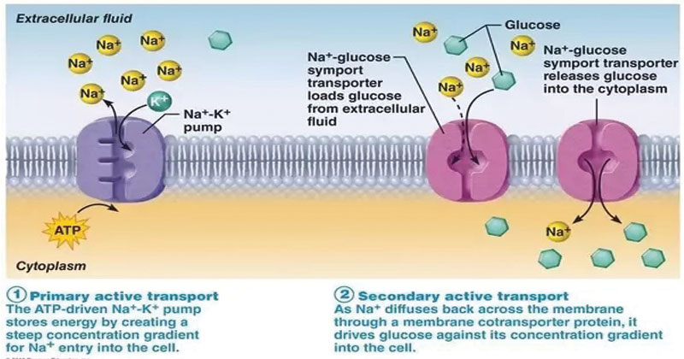

- How Ion Pumps Maintain Membrane Potential
- Membrane Potential

- Electrochemical gradient

- Electrogenic pump

- Cotransport: Coupled Transport by a Membrane Protein

BULK TRANSPORT ACROSS THE PLASMA MEMBRANE OCCURS BY EXOCYTOSIS AND ENDOCYTOSIS
- Exocytosis

- Endocytosis
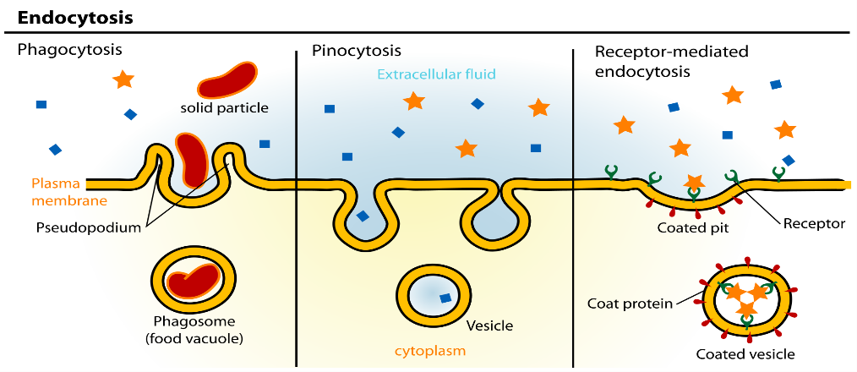

- Phagocytosis

- Pinocytosis

- Receptor Mediated

THE PLASMA MEMBRANE PLAYS A KEY ROLE IN MOST CELL SIGNALING

- Local and Long Distance Signaling

- Local

- Long Distance

- The Three Stages of Cell Signaling: A Preview

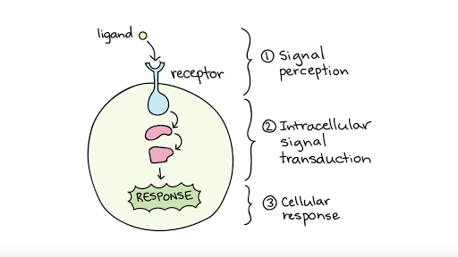

- Reception, the Binding of a Signaling Molecule to a Receptor Protein

Ligand

- Receptors in the Plasma Membrane
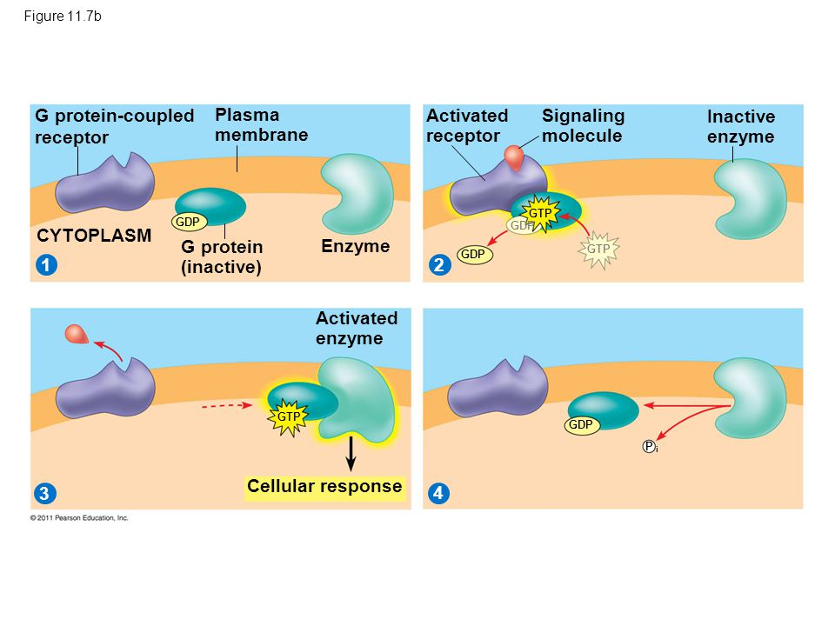

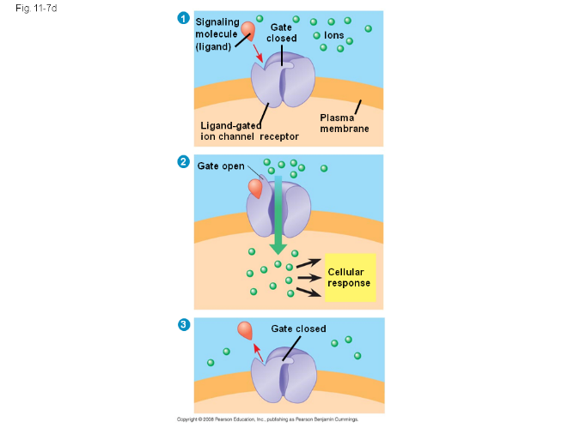

- Intracellular receptors
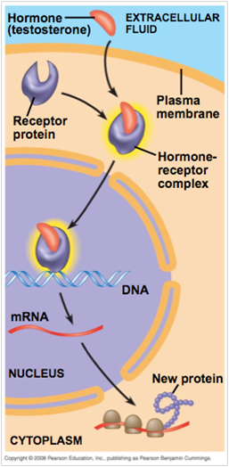

- Transduction by Cascades of Molecular Interactions

- Protein Phosphorylation and Dephosphorylation
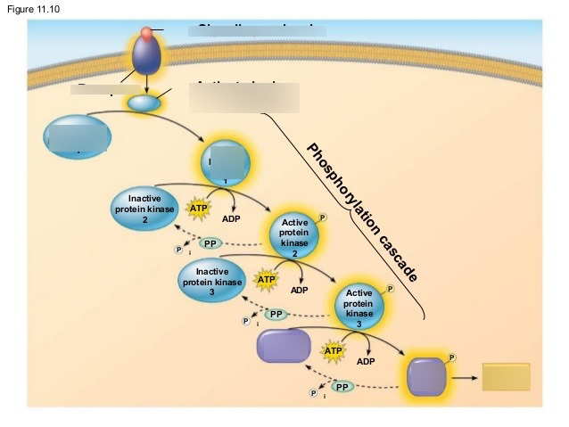
- Small Molecules and Ions as Second Messengers
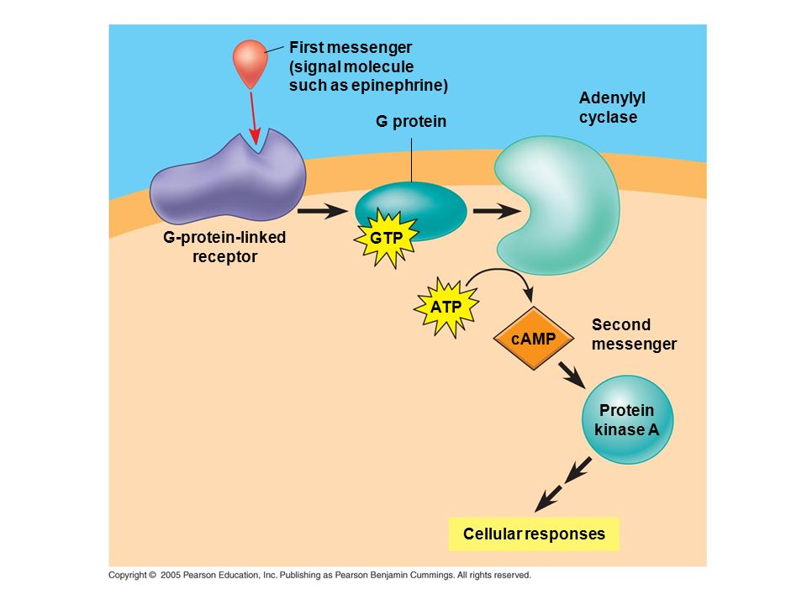

- Response: Regulation of Transcription or Cytoplasmic Activities

