ADVANCED BIOLOGY: MEIOSIS AND SEXUAL LIFE CYCLES
(USE CHAPTER 13 AS A RESOURCE)
Heredity

Variation

Genetics

OFFSPRING ACQUIRE GENES FROM PARENTS BY INHERITING CHROMOSOMES
- Inheritance of Genes
- Genes

- The Language of DNA

- Gametes

- Somatic Cells

- Locus

- Comparison of Asexual and Sexual Reproduction
- Asexual Reproduction

- Clone

- Sexual Reproduction

FERTILIZATION AND MEIOSIS ALTERNATE IN SEXUAL LIFE CYCLES
Life cycle

- Sets of Chromosomes in Human Cells
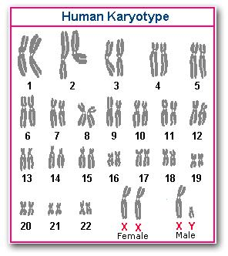
- Homologous chromosomes

- Sex Chromosomes

- Autosomes

- Diploid Cell

- Haploid Cell

- Behavior of Chromosome Sets in the Human Life Cycle
- Fertilization

- Zygote

- Germ Cells

- Meiosis

- The Variety of Sexual Life Cycles
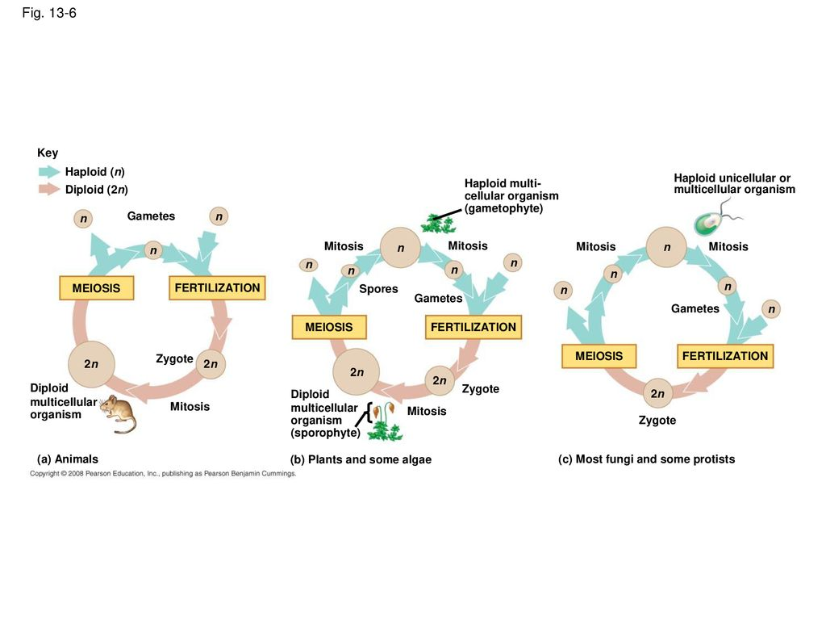

MEIOSIS REDUCES THE NUMBER OF CHROMOSOME SETS FROM DIPLOID TO HAPLOID

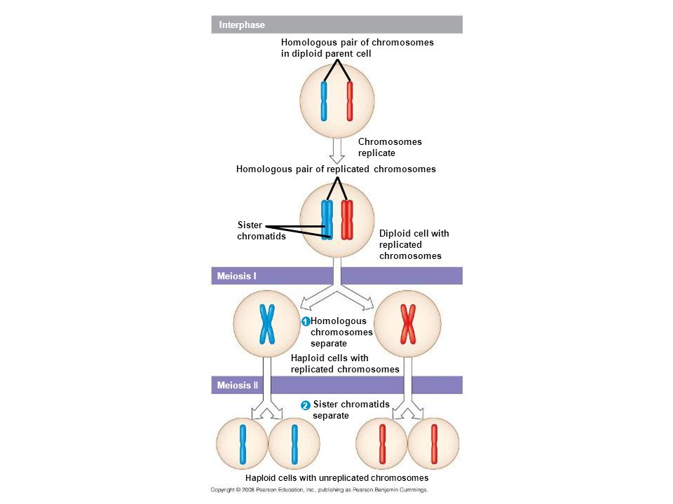

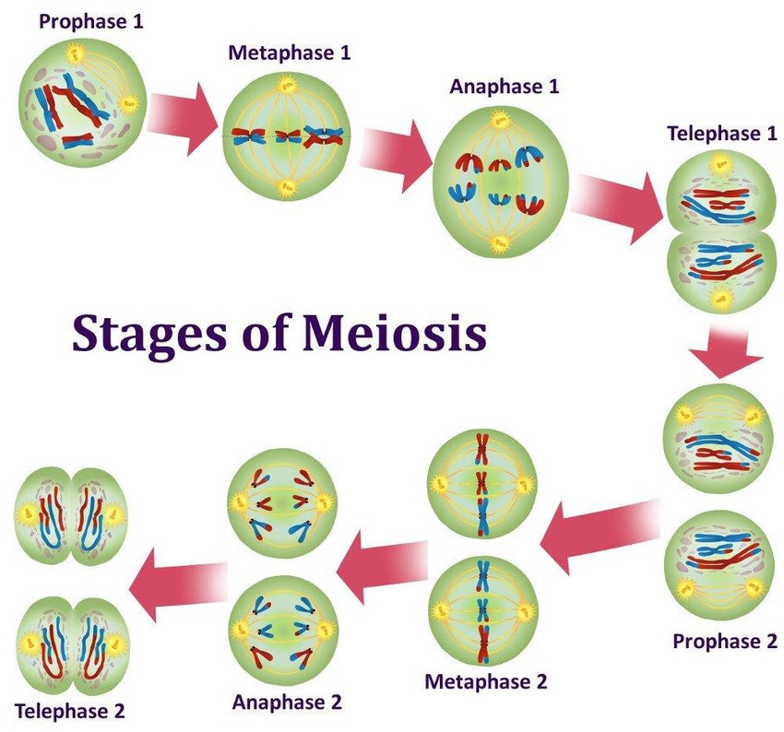

A Comparison of Mitosis and Meiosis
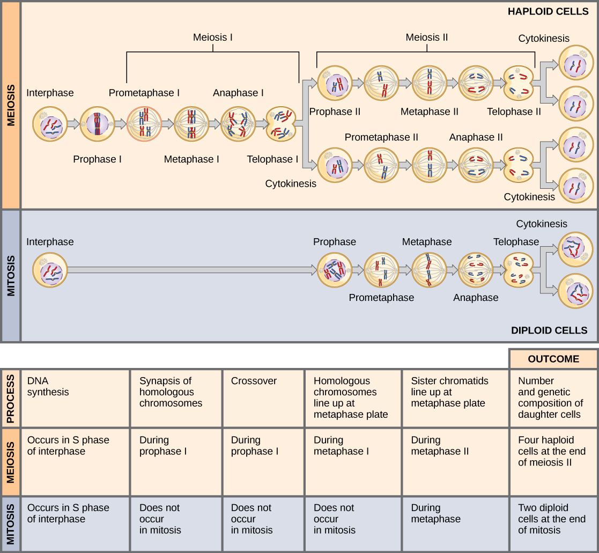

- Synapsis and crossing over

- Homologous pairs at the metaphase plate

- Separation of Homologs
GENETIC VARIATION PRODUCED IN SEXUAL LIFE CYCLES CONTRIBUTES TO EVOLUTION
- Origins of Genetic Variation Among Offspring

- Independent Assortment of Chromosomes 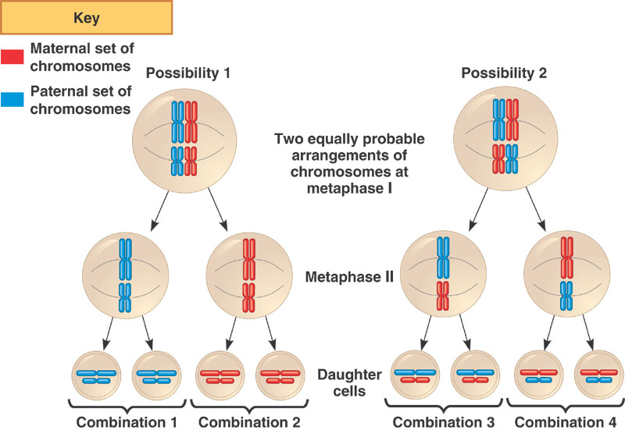

- Crossing Over
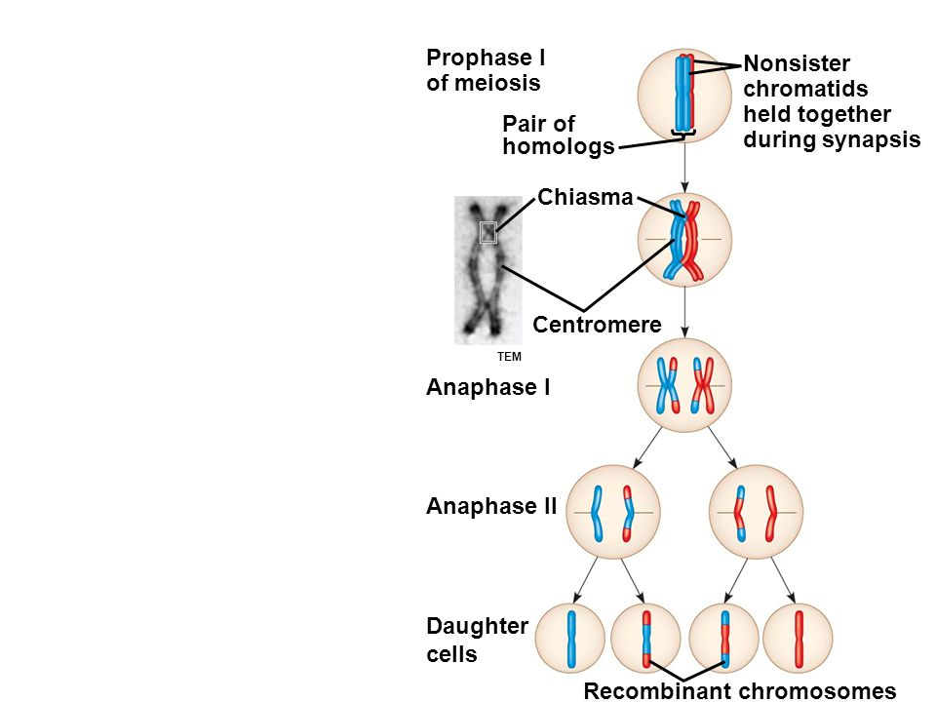

- Random Fertilization

- The Evolutionary Significance of Genetic Variation Within Populations

