INTRODUCTION TO ANATOMY AND PHYSIOLOGY NOTES
Anatomy

Physiology

Homeostasis

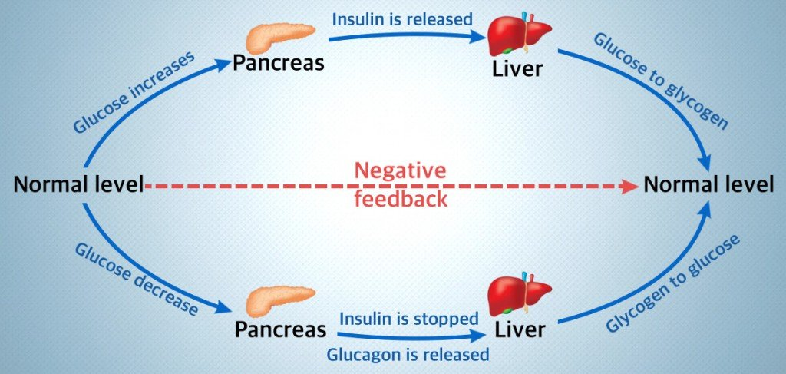

Set Point

Effectors

ANATOMICAL TERMINOLOGY

- Relative Positions
- Superior

- Inferior

- Anterior

- Posterior

- Medial

- Lateral

- Proximal

- Distal

- Superficial

- Deep

- Body Sections
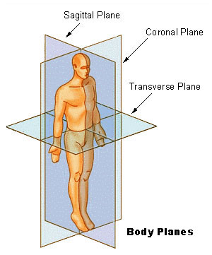

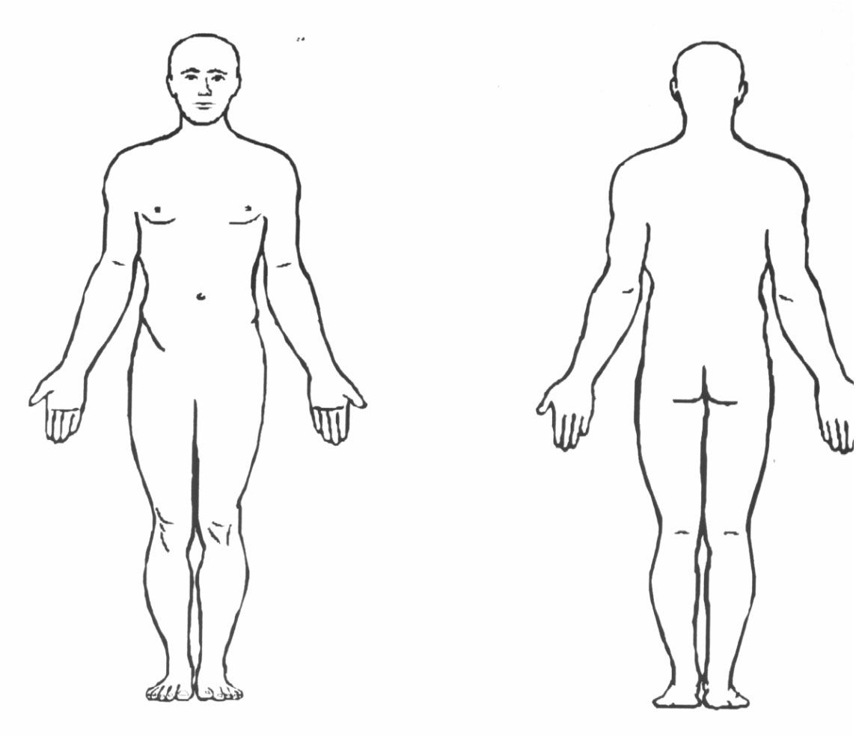
Cephalic | Sternal | Antebrachial | Lumbar
Nasal | Pectoral | Patellar | Gluteal
Orbital | Brachial | Coxal | Femoral
Oral | Umbilical | Vertebral | Inguinal
Cervical | Abdominal | Axillary | Pedal

