HONORS CHEMISTRY UNIT 5 NOTES (NUCLEAR CHEMISTRY)

RADIOACTIVE DECAY

Radioactive

Becquerel and the Curies

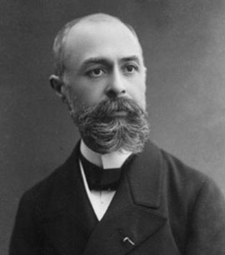

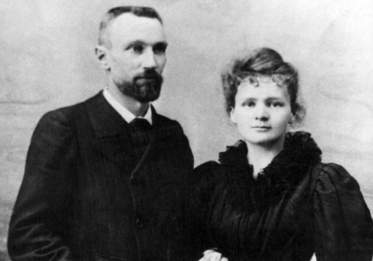

Nucleons

Nuclide

Reminder: Mass number and Atomic Number

Types of Radioactive Decay

PARTICLE/RAY | SYMBOL(S) | PENETRATING POWER
Alpha Particle

Beta Particle

Gamma Ray

Positron

Neutron

Proton

Terminology used with the above particles

- Emission(emitted)

- Production

- Capture

- Release

- Absorbed

The purpose of radioactive decay

Decay series

Balancing nuclear reactions

Reactant mass numbers and atomic numbers must equal product mass numbers and atomic numbers.

Examples

²³⁵₉₂U → ⁴₂He + _______

Carbon-11 produces a positron

²³⁵₉₂U + ⁰₋₁e → _______

²²⁶₈₈Ra decays by alpha emission

CHECK POINT:

Bismuth-241 produces a beta particle

¹⁹⁵₇₉Au + ______ → ¹⁹⁵₇₈Pt

³⁸₁₉K → ³⁸₁₈Ar + ______

Thorium-232 decays by proton capture

NUCLEAR TRANSFORMATIONS

History

How is it done?

DETECTION OF RADIOACTIVITY AND THE CONCEPT OF HALF-LIFE

Geiger Counter
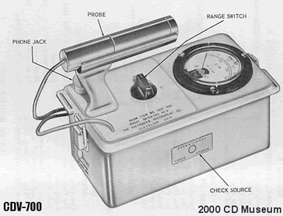

Half-life

Variables in solving half-life problems

m_{o}

m_{t}

t

t_{1/2}

EXAMPLES

- m_{o}= 100 g, m_{t} = 25 g, t_{1/2} = 5 minutes, t =

2. m_{o} = 200 g, m_{t} = , t_{1/2} = 15 years, t = 60 years

3. m_{o}= , m_{t} = 90 g, t_{1/2} = 1.2 x 10⁴ years, t = 6.0 x 10⁴ years

4. m_{o} = 50 g, m_{t} = 6.25 g, t_{1/2} = t = 12 seconds

DATING BY RADIOACTIVITY

MEDICAL APPLICATIONS OF RADIOACTIVITY

NUCLEAR ENERGY

Fission

Fusion

NUCLEAR FISSION

Chain reaction
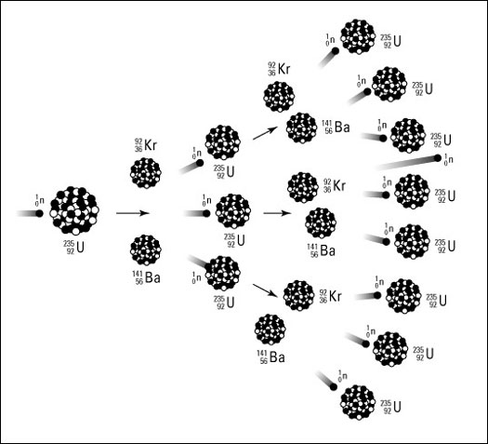

Critical mass

NUCLEAR REACTORS

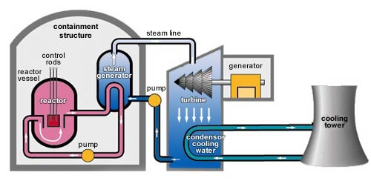

NUCLEAR FUSION

EFFECTS OF RADIATION

