HONORS CHEMISTRY UNIT 16 NOTES (ENERGY)

THE NATURE OF ENERGY

Energy

Potential Energy

Kinetic Energy

Law of conservation of Energy

TEMPERATURE AND HEAT

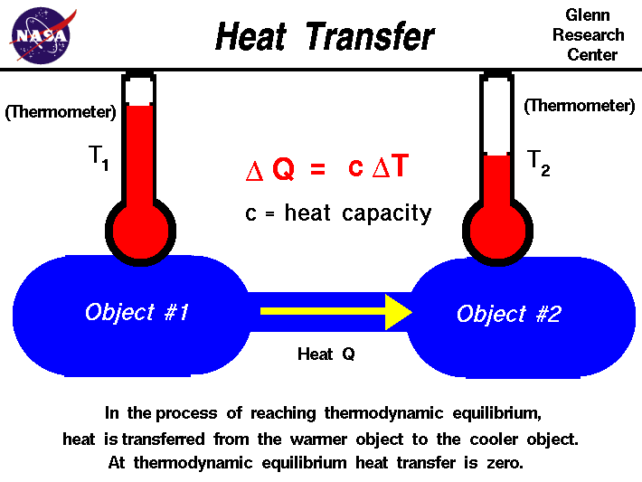

Temperature

Heat

EXOTHERMIC AND ENDOTHERMIC PROCESSES

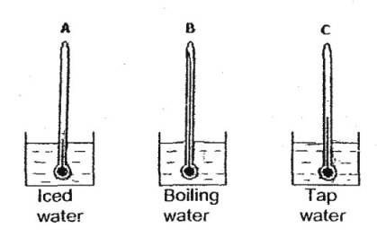

System

Surroundings

Graphical representation of an Endothermic Reaction

Graphical representation of an Exothermic Reaction

MEASURING ENERGY CHANGES

The calorie and the joule

The formula and what it means

Specific heat (capacity)

Sample problem 1: Determine the amount of energy (heat) in joules required to raise the temperature of 7.40 g of water from 29.0oC to 46.0oC.

Sample problem 2: What quantity of energy (in joules) is required to heat a piece of iron weighing 1.3 g from 25oC to 46oC? Specific heat of iron is 0.45 J/g. oC

ENTHALPY

Calorimetry

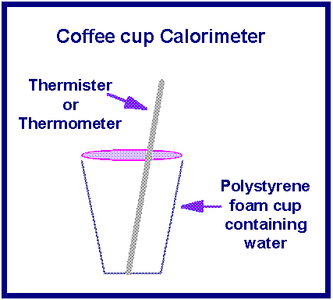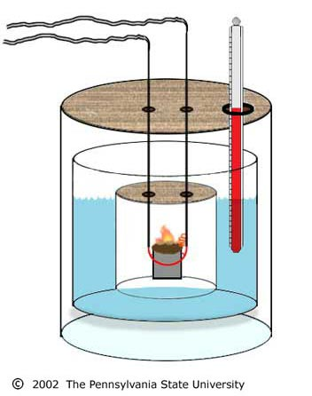

How is it used?

ENTHALPY AND STOICHIOMETRY

Sample problem 3:

CH4 + 2O2 → CO2 +2 H2O ΔH = -890 kJ

How many kJ of energy are released when a 5.8 g sample of methane is burned at constant pressure?

Sample problem 4: The Reaction that occurs in heat packs used to treat sports injuries is

4Fe + 3O2 → 2Fe2O3  ΔH = -1652 kJ

How much heat is released when 1.00 g of Fe is reacted with excess oxygen?

HESS’S LAW

Characteristics of Enthalpy Changes

1.

2.

Xe(g) + 2F2(g) → XeF4(s) ∆H = -251 kJ

Then……

XeF4(s) → Xe(g) + 2F2(g)  ∆H =

2Xe(g) + 4F2(g) → 2XeF4(s) ∆H =

Sample problem 5:

What is the energy change for the reaction N2(g) + 2O2(g) → 2NO2(g) if it occurs by the following reactions?

N2(g) + O2(g) →2NO(g) ∆H = 180 kJ

2NO(g) + O2(g) → 2NO2(g) ∆H = -112 kJ

Sample problem 6:

Two forms of carbon are graphite, the soft, black, slippery material used in “lead” pencils and as a lubricant for locks, and diamond, the brilliant, hard gemstone. Using the enthalpies of combustion for graphite and diamond, calculate the change in enthalpy (∆H) for the conversion of graphite to diamond.

Cgraphite →Cdiamond

Cgraphite  + O2(g) → CO2(g)  ∆H = -394 kJ

Cdiamond + O2(g) → CO2(g) ∆H = -396 kJ

Sample problem 7: Given the following data:

S(s) + 3/2O2(g) → SO3(g)  ∆H = -395.2 kJ

2SO2(g) + O2(g) → 2SO3(g) ∆H = -198.2 kJ

Calculate ∆H for the reaction S(s) + O2(g) → SO2(g)

ENERGY AS A DRIVING FORCE

Energy spread

Quality vs Quantity

“Heat Death” of the Universe

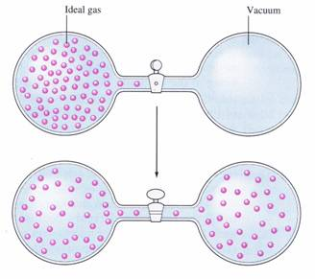

Matter Spread

[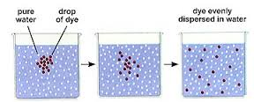](http://www.google.com/url?sa=i&rct=j&q=&esrc=s&source=images&cd=&cad=rja&uact=8&docid=1COXGLzkynU0qM&tbnid=nQu0A6uk1HFX3M:&ved=0CAUQjRw&url=http://www.biologyjunction.com/homeostasis_notes_bi.htm&ei=GcZCU8LCB8nayAHrj4DwCQ&psig=AFQjCNHxuTZuxTxjzgtqAklGOTGzhQqijQ&ust=1396971328417230)

Entropy

First Law of Thermodynamics

Second Law of Thermodynamics