HONORS CHEMISTRY UNIT 14: GASES

Review: Properties of gases

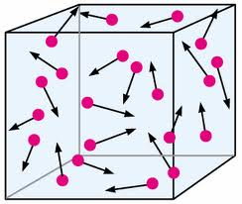

PRESSURE

Barometer
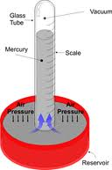

Pressure Units

TEMPERATURE

STP

VOLUME

MOLES

BOYLE’S LAW

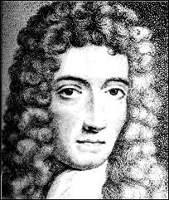

Sample problem 1: The volume of a gas is 17.4 L measured at standard pressure. Calculate the pressure in torr if the volume is changed to 20.4 L and the temperature remains constant.

Sample problem 2: A sample of gas occupies a volume of 73.5 mL at a pressure of 710. torr and a temperature of 30ºC. What will the volume be in mL at 650. torr and 30ºC?

CHARLES’ LAW

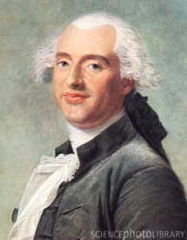

Sample problem 3: A gas occupies a volume of 4.50 L at 27ºC. At what temperature in ºC would the volume be 6.00 L if the pressure remains constant.

Sample problem 4: A sample of gas occupies a volume of 150. mL at 1.00 atm and 27ºC. Calculate its volume at 0ºC and 1.00 atm.

GAY-LUSSAC’S LAW
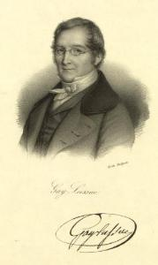

Sample problem 5: The temperature of 1.00 L of gas originally at STP is changed to 220.ºC at constant volume. Calculate the final pressure of the gas in torr.

Sample problem 6: A sample of gas occupies a volume of 3.50 L at 25ºC under a pressure of 1.25 atm. What is the temperature of the gas if the pressure is decreased to 0.750 atm with the volume remaining constant?

THE COMBINED GAS LAW (COMBINING BOYLE’S AND CHARLES’)

Sample problem 7: A certain gas occupies 500. mL at STP. What volume in milliliters will it occupy at 10.0 atm and 100.ºC?

Sample problem 8: A certain gas occupied 20.0 L at 50.ºC and 780. torr. Under what pressure in torr would the gas occupy 75.0 L at 0ºC?

DALTON’S LAW OF PARTIAL PRESSURE

Sample problem 9: A 1.00 L flask at 27ºC contains a mixture of three gases, A, B, and C at partial pressures of 300. torr, 250. torr and 425 torr respectively.

- Calculate the total pressure in torr of the mixture of gases

- Calculate the volume in liters at STP occupied by the gases remaining if gas A is selectively removed.

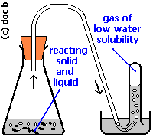

Sample problem 10: The volume of a certain gas collected over water is 150. mL at 30ºC and 720.0 torr. Calculate the volume in mL of the DRY gas at STP. The vapor pressure of water at 30ºC is 31.8 torr. HINT: First find the pressure under the original conditions without water vapor.

THE IDEAL GAS LAW

Sample problem 11: Calculate the volume in liters of 2.15 mol of oxygen gas at 27ºC and 1.25 atm.

Sample problem 12: Calculate the pressure in torr of 0.652 mol of oxygen gas occupying 10.0 L at 30.ºC.

Sample problem 13: Calculate the number of grams of oxygen gas in a 5.25 L cylinder at 27ºC and 1.30 atm.

MOLECULAR (MOLAR) MASS PROBLEMS

Sample problem 14: Calculate the molecular mass of ethane gas if 600. mL of the gas measured at 30.ºC and 630. torr has a mass of 0.600 g

Sample problem 15: Calculate the molecular mass of a certain gas if 450. mL of the gas collected over water and measured at 30.ºC and 720.0 torr has a mass of 0.515 g. the vapor pressure of water at 30.ºC is 31.8 torr.

DENSITY OF GASES

Sample problem 16: Calculate the density of sulfur dioxide in grams per liter at 640. torr and 30.ºC

Sample problem 17: Calculate the density of oxygen gas at STP

GAS LAWS AND STOICHIOMETRY

Sample problem 18: Calculate the volume of oxygen in liters measured at 35ºC and 630. torr that could be obtained by heating 10.0 g of potassium chlorate
2KClO_{3(s)} → 2KCl_{(s)} + 3O_{2(g)}

Sample problem 19: Calculate the number of grams of potassium chloride that can be obtained along with 2.50 L of oxygen gas at 18ºC and 1.45 atm. Use equation from sample problem 18.

Sample problem 20: How many L of oxygen gas at STP can be produced from 15.0 g of potassium chlorate? Use the equation from 18

THE KINETIC MOLECULAR THEORY OF GASES

1.

2.

3.

4.

5.

Relating KMT to our laws

