HONORS CHEMISTRY UNIT 1

THE IMPORTANCE OF STUDYING CHEMISTRY

WHAT IS CHEMISTRY?
Chemistry

Macroscopic Observations Microscopic Observations
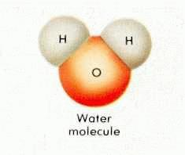

Qualitative Observations vs Quantitative Observations

SOLVING PROBLEMS USING A SCIENTIFIC APPROACH
How do you know what really caused the problem? An investigation

USING SCIENTIFIC THINKING TO SOLVE A PROBLEM: THE SCIENTIFIC METHOD
1.

2.

3.

Theory

Law

Observation

Hypothesis

Experiment
Law
Theory
Prediction
Experiment
Theory
Modified
As needed
Experiment

Your responsibility in chemistry

Design an experiment to answer the following research question: Does boiling raw spaghetti noodles increase the length of the noodles?
Hypothesis:

Experimental Set-up:

How are you organizing/reporting data?

Write a new research question that you could explore involving spaghetti noodles.

SIGNIFICANT DIGITS IN SCIENCE

MEASUREMENT AND CALCULATIONS
UNCERTAINTY IN MEASUREMENT

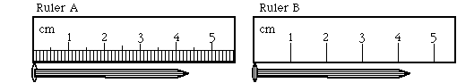

SIGNIFICANT FIGURES (DIGITS)

RULES FOR COUNTING SIGNIFICANT FIGURES
- Nonzero integers

- Zeros
- Leading zeros

- Captive zeros

- Trailing zeros

- Exact numbers

Examples

- 0.0108 g

- 0.0050060 g

- 5.030 x 10³ ft

- 110 riders started, but only 60 finished

CHECK POINT

- 0.000304 g

- 1.270 x 10² m

- 0.9020 L

- 480 cars were in the parade

Determining Significant Figures (Digits) in Calculations

- Multiplication and Division

EXAMPLES
- 12.6 x 0.53

- 8.315 ÷ 298

- 5.44 x 0.235

- Addition and Subtraction

EXAMPLES
- 12.11 + 18.0

- 0.6875 – 0.1

- 32,575 + 985.663

What if you have to do both?

EXAMPLES

a. (12.6 x 0.53) – 4.59

b. (25.36 – 4.15) ÷ 2.317

SCIENTIFIC NOTATION

What is it used for?

Turning numbers greater than one into scientific notation

Turning numbers less than one into scientific notation

CHECK POINT
  - 12,500

  - 247

  - 0.0024

  - 0.0000072

  - 350,000,000

