ADVANCED BIOLOGY: GENE EXPRESSION: FROM GENE TO PROTEIN
(USE CHAPTER 17 AS A RESOURCE)
THE FLOW OF GENETIC INFORMATION

GENES SPECIFY PROTEINS VIA TRANSCRIPTION AND TRANSLATION

- Evidence from the Study of Metabolic Defects
- Garrod’s observations of alkaptonuria

- Nutritional Mutants in Neurospora: Scientific Inquiry

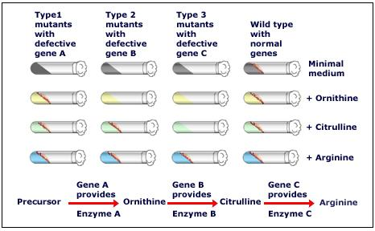

- The Products of Gene Expression: A Developing Story

- Basic Principles of Transcription and Translation

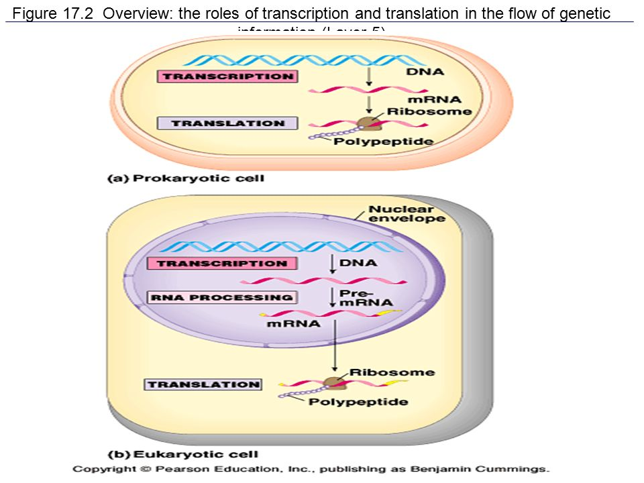

- The Genetic Code

- Codons: Triplets of Nucleotides
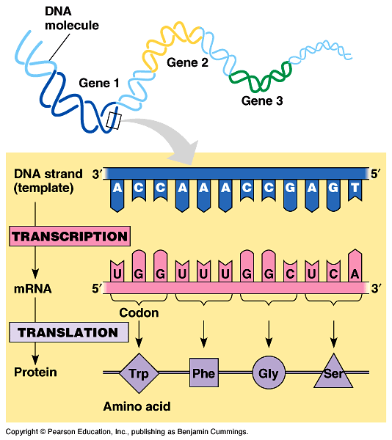

- Cracking the Code
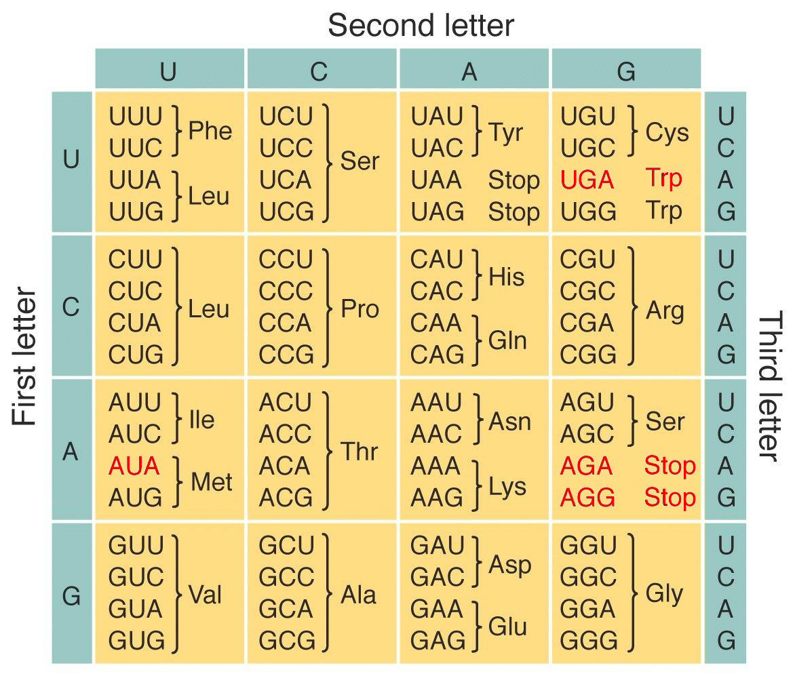
- Evolution of the Genetic Code

TRANSCRIPTION IS THE DNA-DIRECTED SYNTHESIS OF RNA: A CLOSER LOOK

- Molecular Components of Transcription
- RNA Polymerase

- Promoter

- Transcription Unit

- Synthesis of a RNA Transcript

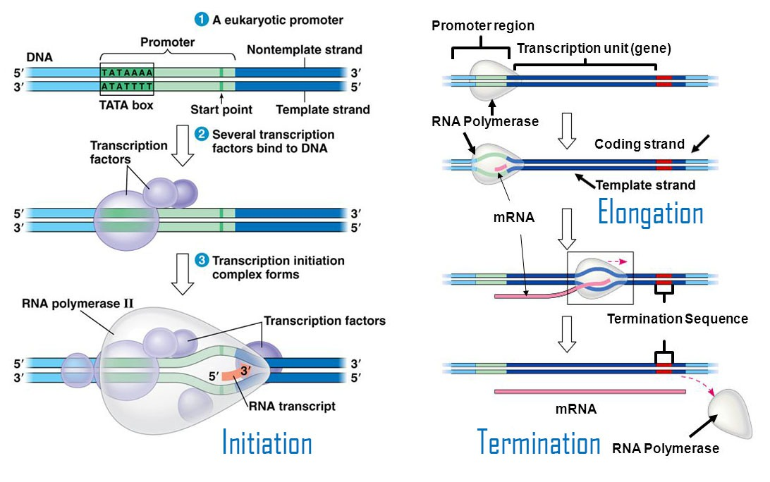
- RNA Polymerase Binding and Initiation of Transcription
- Promoter

- Transcription factors

- Transcription Initiation Complex

- TATA box

- Elongation of the RNA Strand

- Termination of Transcription

EUKARYOTIC CELLS MODIFY RNA AFTER TRANSCRIPTION
RNA Processing
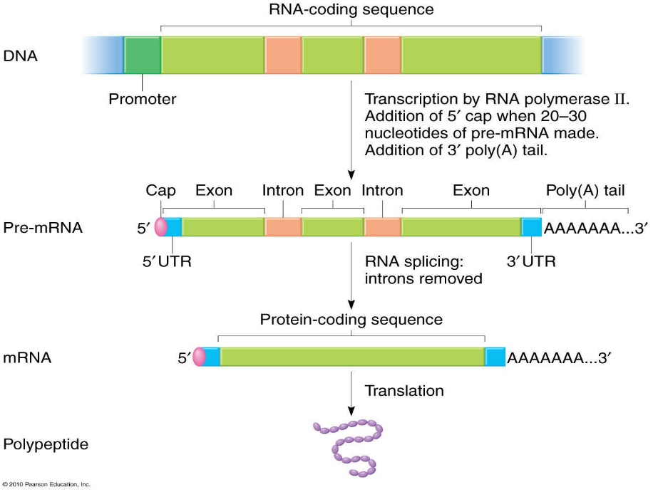

- Alteration of mRNA Ends

- Gene Splicing

- Alternative RNA Splicing

- Ribozymes

TRANSLATION IS THE RNA-DIRECTED SYNTHESIS OF A POLYPEPTIDE: A CLOSER LOOK

- Molecular Components of Translation

- The Structure and Function of Transfer RNA

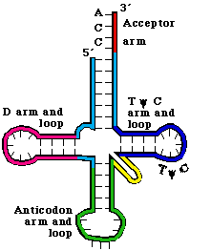

- Anticodon

- Where made

- Aminoacyl-tRNA synthetases

- Wobble

- Ribosomes
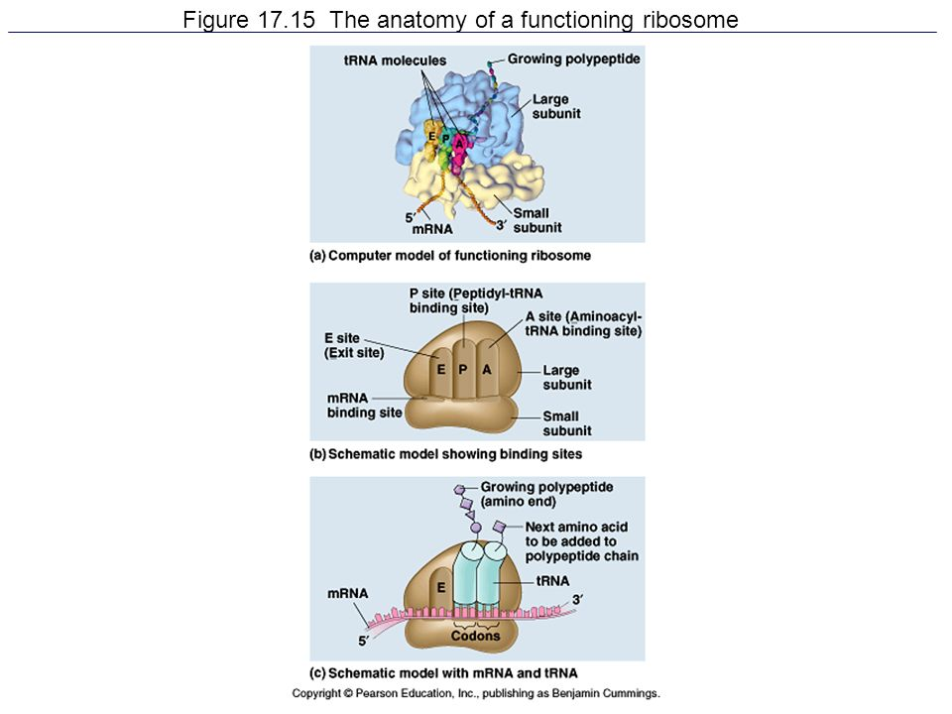

- Building a Polypeptide
- Ribosome Association and Initiation of Translation

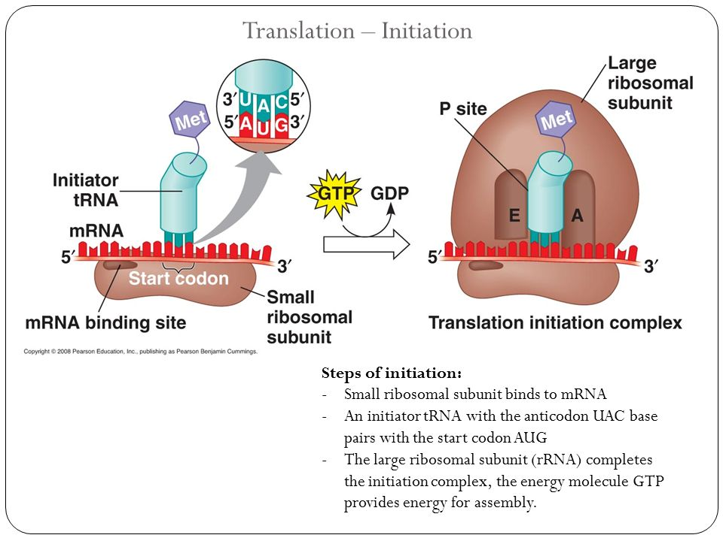

- Elongation of the Polypeptide Chain
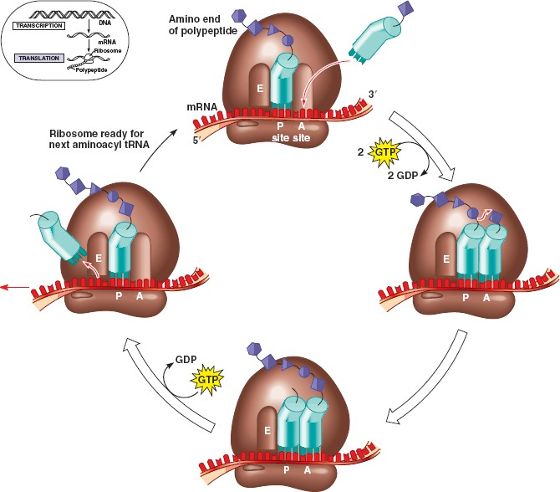

- Termination of Translation
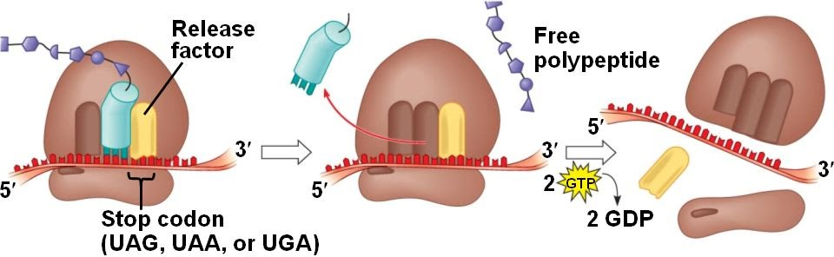

- Completing and Targeting the Functional Protein
- Protein Folding and Post-Translational Modifications

- Targeting Polypeptides to Specific Locations
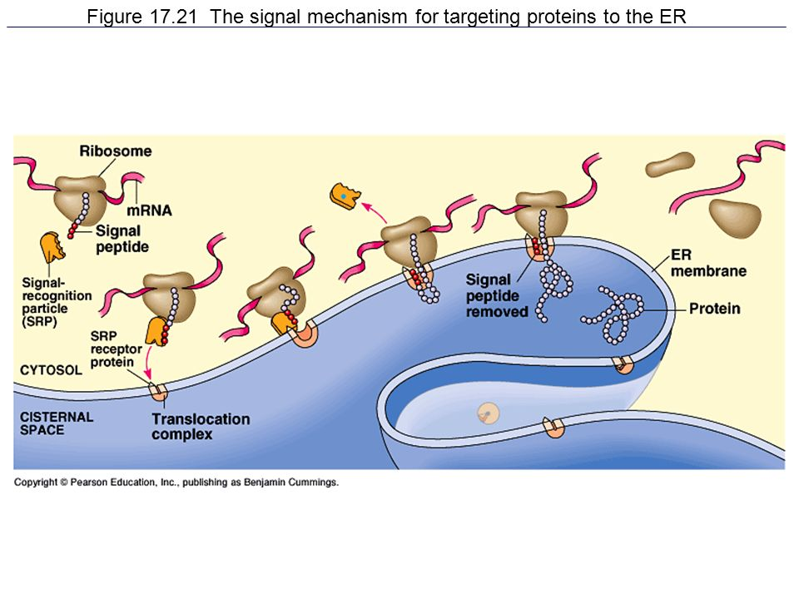

- Signal peptide

- Signal-Recognition Particle (SRP)
- Making Multiple Polypeptides in Bacteria and Eukaryotes
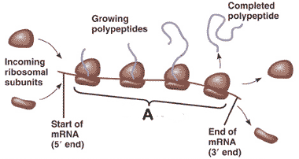

MUTATIONS OF ONE OR A FEW NUCLEOTIDES CAN AFFECT PROTEIN STRUCTURE AND FUNCTION

Mutations

Point Mutations

- Types of Small-Scale Mutations
- Substitutions

- Insertions and Deletions

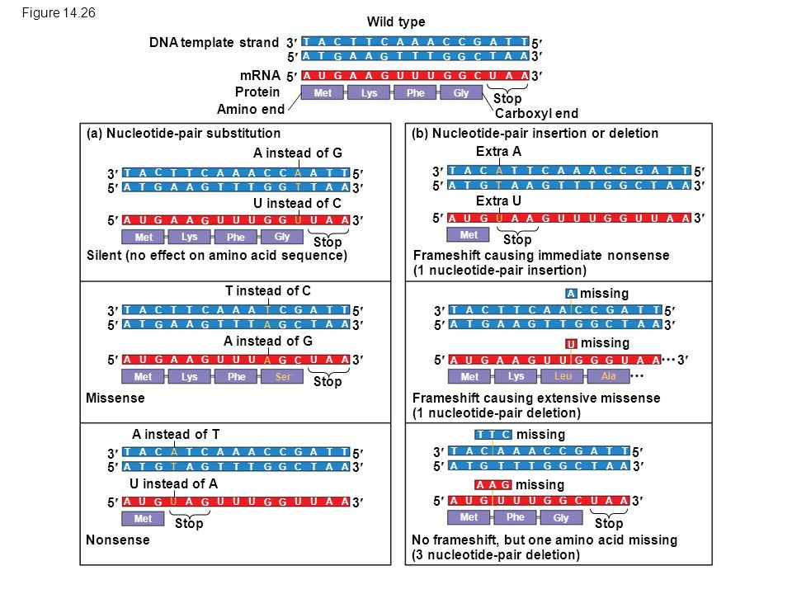

- Mutagens

- What is a Gene? Revisiting the Question

