ADVANCED BIOLOGY: DESCENT WITH MODIFICATION
(USE CHAPTER 22 AS A RESOURCE)

THE DARWINIAN REVOLUTIONO CHALLENGED TRADITIONAL VIEW OF A YOUNG EARTH INHABITED BY UNCHANGING SPECIES

- Scala Naturae and Classification of Species

- Ideas About Change over Time

- Lamarck’s Hypothesis of Evolution

DESCENT WITH MODIFICATIONS BY NATURAL SELECTION EXPLAINS THE ADAPTATIONS OF ORGANISMS AND THE UNITY AND DIVERSITY OF LIFE

- Darwin’s Research

- The Voyage of the Beagle

- Darwin’s Focus on Adaptation

- Ideas from the Origin of Species
- Descent with Modification
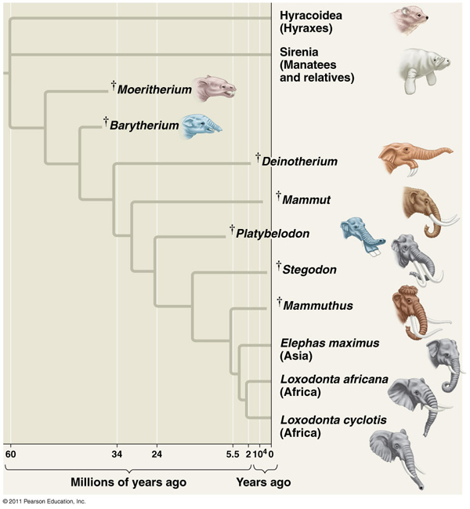

- Artificial Selection, Natural Selection, and Adaptation

- Artificial Selection

- Darwin’s Observations and Inferences

- Natural Selection: A Summary

EVOLUTION IS SUPPORTED BY AN OVERWHELMING AMOUNT OF SCIENTIFIC EVIDENCE

- Direct Observations of Evolutionary Change
- Natural Selection in Response to Introduced Plant Species

- The Evolution of Drug-Resistance Bacteria

- Homology

- Anatomical and Molecular Homologies
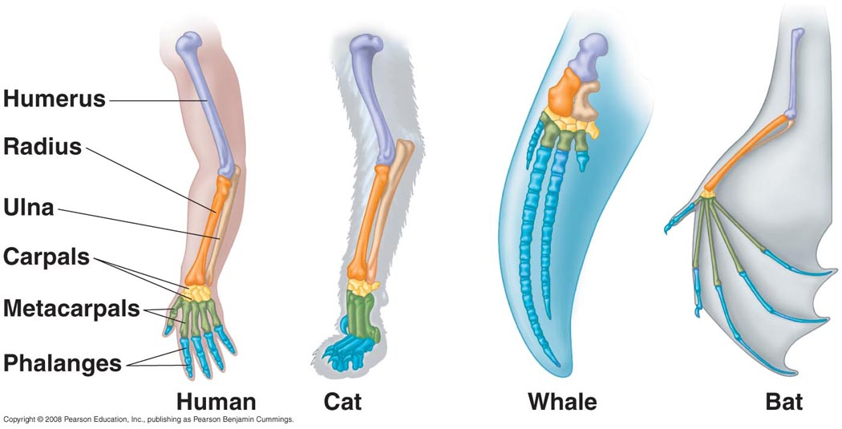

Homologous Structures

Vestigial Structures

Molecular Homologies

- A Different Cause Of Resemblance: Convergent Evolution
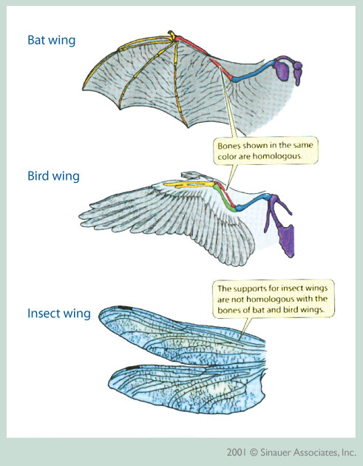
- Convergent Evolution

- Analogous

- The Fossil Record

- Biogeography

- What is Theoretical About Darwin’s View of Life?

