CHEMISTRY CHAPTER 4 (ATOMIC STRUCTURE) NOTEPACKET

4.1 STUDYING ATOMS
Ancient Greek Models of Atoms
- Democritus

- Aristotle

Dalton’s Atomic Theory
- Evidence for Atoms

- Dalton’s Theory

Thomson’s Model of the Atom
- Thomson’s Experiments
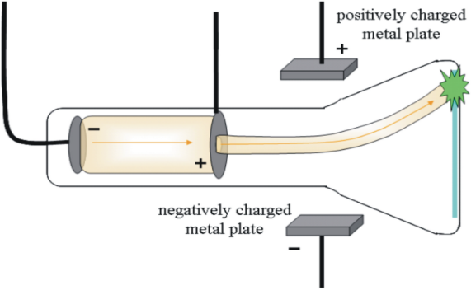
- Evidence for Subatomic Particles

- Thomson’s Model
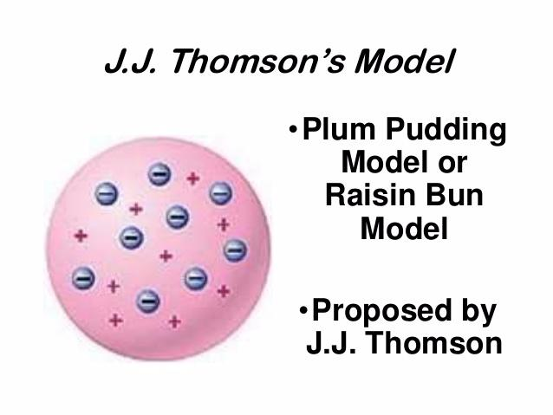
Rutherford’s Atomic Theory
- Rutherford’s Hypothesis

- The Gold Foil Experiment
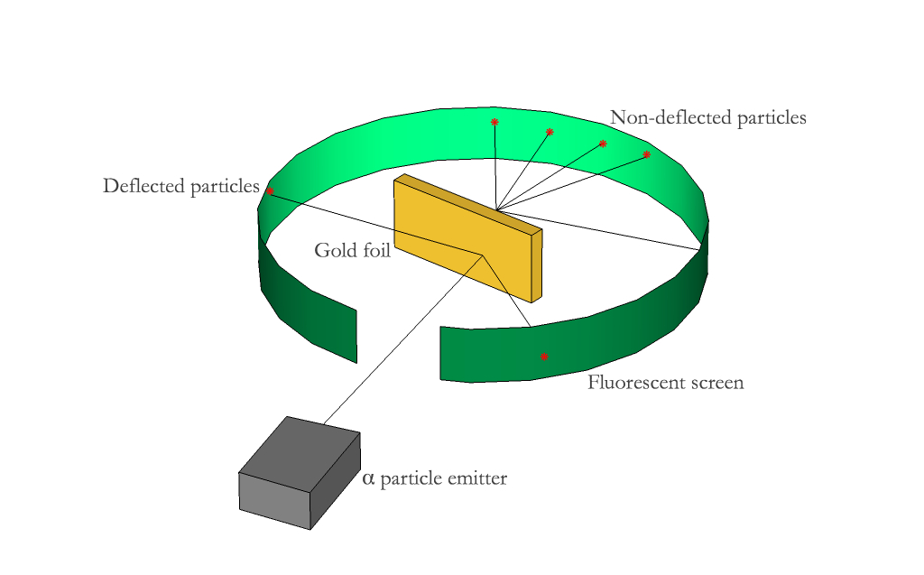

- Discovery of the Nucleus

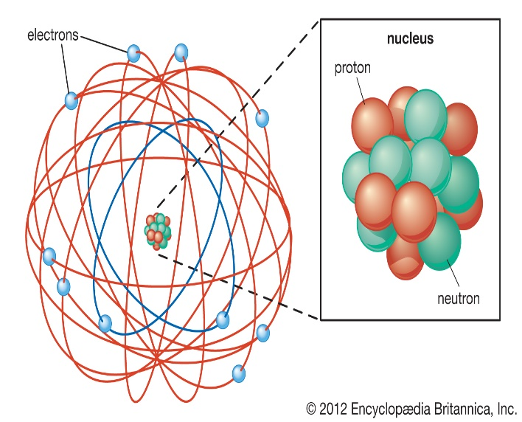

4.2 THE STRUCTURE OF THE ATOM
Properties of Subatomic Particles

- Protons

- Electrons

- Neutrons

Comparing Subatomic Particles
Particle | Symbol | Charge | Mass

Atomic Number and Mass Number
- Atomic Number

- Mass Number

- Isotopes

Symbols used to represent isotopes of atoms

^{A}_{Z}X

A=
Z=
X=

Determining the number and type of subatomic particles found in an atom

¹²C

Fluorine-19

Ag-108

Self Check: Give the number of protons, electrons, and neutrons for
- Bromine-79

- Calcium-40

- ⁶⁴Cu

4.3 MODERN ATOMIC THEORY
Bohr’s Model of the Atom
- Energy Levels

- Evidence for Energy Levels

Electron Cloud Model

Atomic Orbitals

Electron Configurations
- Principle Energy Levels

- Sublevels

- Writing Electron Configurations and their Importance

- Ground State and the Excited State

