ADVANCED BIOLOGY: THE CHEMICAL CONTEXT OF LIFE
(USE CHAPTER 2 AND 3 AS A FURTHER RESOURCE)
MATTER CONSISTS OF CHEMICAL ELEMENTS IN PURE FORM AND IN COMBINATION CALLED COMPOUNDS
- Elements and Compounds

- The Elements of Life

- Evolution of Tolerance to Toxic Elements

CHEMICAL BONDS
- Covalent bonds

- Ionic Bonds

- Intermolecular attractions

- Molecular Shape and Function

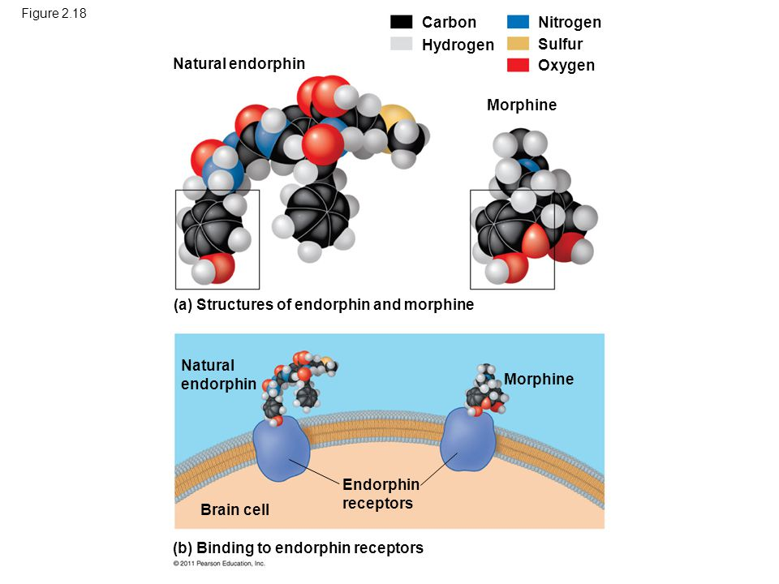

CHEMICAL REACTIONS MAKE AND BREAK CHEMICAL BONDS
- Reactants

- Products

- Chemical Equilibrium

HYDROGEN BONDING GIVES WATER PROPERTIES THAT HELP MAKE LIFE POSSIBLE ON EARTH
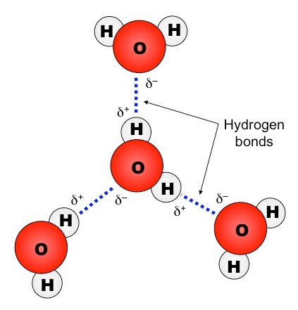
- Cohesion of Water Molecules

- Moderation of Temperature by Water

- Temperature and Heat

- Water’s High Specific Heat

- Evaporative Cooling

- Floating of Ice on Liquid Water

- Water: The Solvent of Life

- Hydrophilic and Hydrophobic Substances

- Solute Concentration

- Acids and Base

- The pH Scale

- Buffers

