ADVANCED BIOLOGY: INTRODUCTION-EVOLUTION AND THE FOUNDATIONS OF BIOLOGY
(USE CHAPTER 1 AS A FURTHER RESOURCE)
Read the overview

COMMON THEMES OF BIOLOGY
Theme: New Properties emerge at each level in biological hierarchy

- Emergent properties

- Structure and Function

- The Cell: An Organism’s Basic Unit of Structure and Function

- Eukaryotic Cell

- Prokaryotic Cell

Theme: Life’s Processes Involve the Expression and transmission of Genetic Information
- DNA Structure and Function

- Genes

- Structure

- Function

- Gene Expression

- Genomics: Large Scale Analysis of DNA sequences

- Genome

- Genomics

- Bioinformatics

Theme: Life Requires the Transfer and Transformation of Energy and Matter
- Energy Flow

- Chemical Cycling

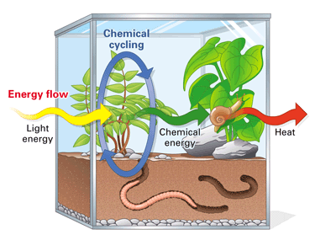
Theme: Organisms Interact with Other Organisms and the Physical Environment
See Figure 1.4

THE CORE THEME: EVOLUTION ACCOUNTS FOR THE UNIT AND DIVERSITY OF LIFE
Classifying the Diversity of Life: The Three Domains of Life
- Bacteria

- Archaea

- Eukarya

- Unity in the Diversity of Life

Charles Darwin and the Theory of Natural Selection
1.

2.

3.

4. Natural Selection

The Tree of Life
- Example: Mammalian forelimb

- Descent with modification: Darwin’s finches (See figure 1.22)

BIOLOGICAL INQUIRY ENTAILS FORMING AND TESTING HYPOTHESES BASED ON OBSERVATIONS OF NATURE
Science and Inquiry

Making Observations
- Data

- Inductive Reasoning

Forming and Testing Hypotheses

- Deductive Reasoning

- Example: Dead flashlight

- Experimental Controls

Theories in Science
1.

2.

3.

