ADVANCED BIOLOGY: CELLULAR RESPIRATION AND FERMENTATION
(USE CHAPTER 9 AS A RESOURCE)

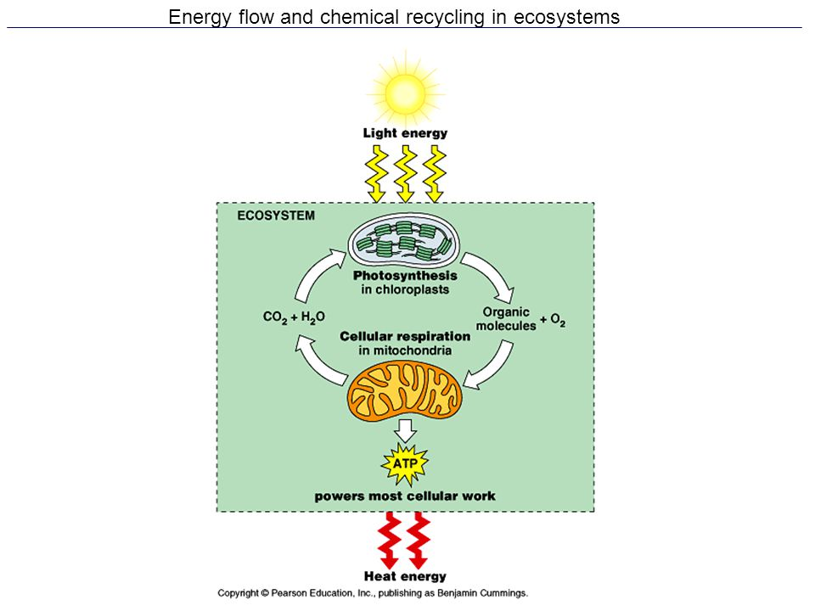

CATABOLIC PATHWAYS YIELD ENERGY BY OXIDIZING ORGANIZ FUELS
- Catabolic Pathways and Production of ATP

- Fermentation

- Aerobic respiration

- Anaerobic respiration

- Overall Respiration Reaction

- Redox Reactions: Oxidation and Reduction

- The Principle of Redox

- Oxidation

- Reduction

- Oxidation of Organic Fuel Molecules During Cellular Respiration
C₆H₁₂O₆ + 6O₂ → 6H₂O + 6CO₂ + Energy

- Stepwise Energy Harvest via NAD⁺ and the Electron Transport Chain

- The Stages of Cellular Respiration: A Preview
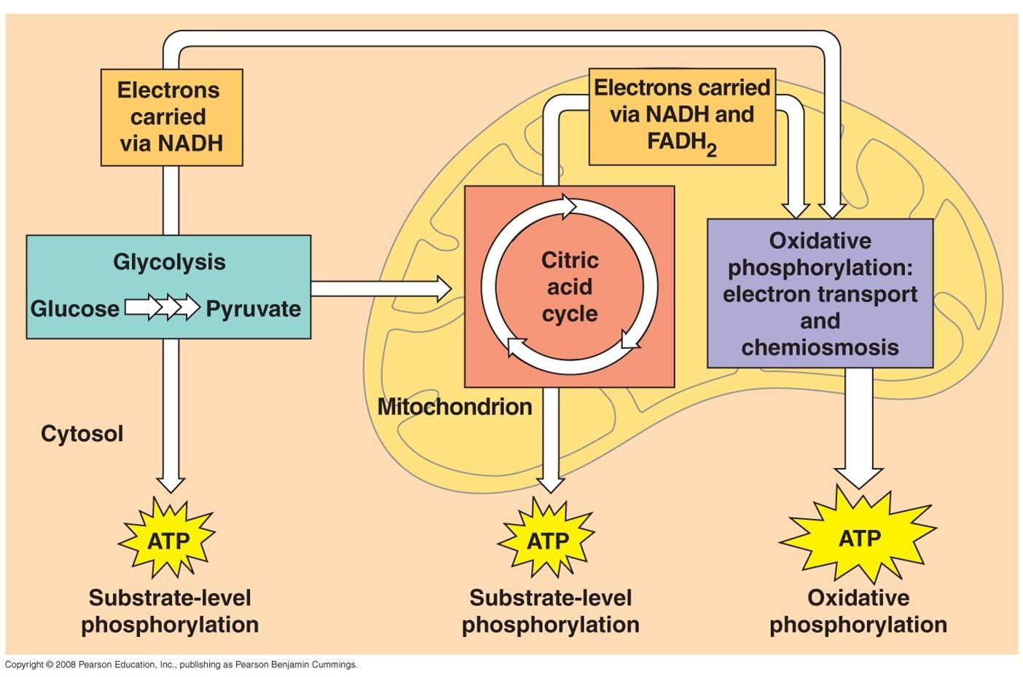

- Glycolysis

- Citric Acid Cycle (Kreb’s Cycle)

- Oxidative Phosphorylation

GLYCOLYSIS HARVESTS CHEMICAL ENERGY BY OXIDIZING GLUCOSE TO PYRUVATE
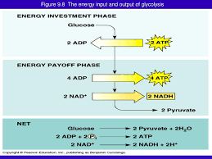

AFTER PYRUVATE IS OXIDIZED, THE CITRIC ACID CYCLE COMPLETES THE ENERGY-YIELDING OXIDATION OF ORGANIC MOLECULES
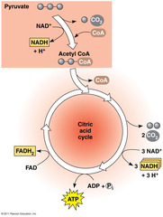

DURING OXIDATIVE PHOSPHORYLATION, CHEMIOSMOSIS COUPLES ELECTRON TRANSPORT TO ATP SYNTHESIS
- The Pathway of Electron Transport

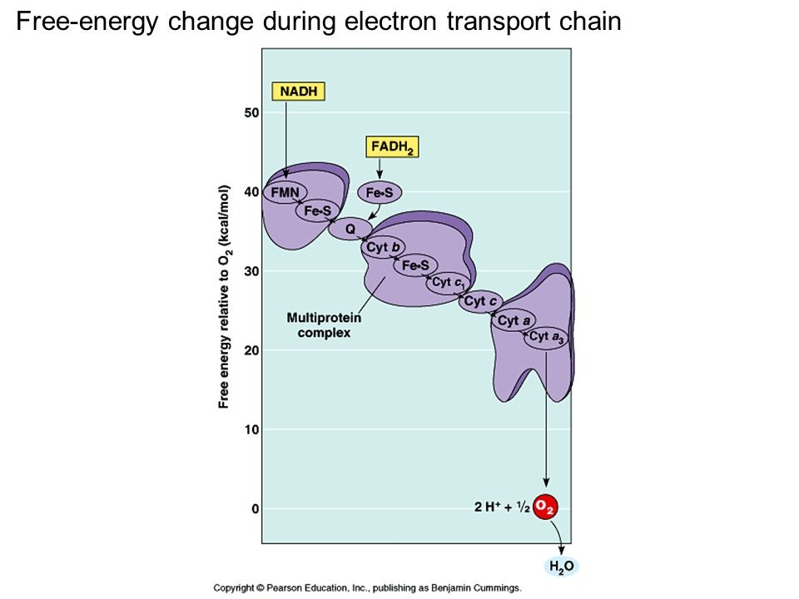

- Chemiosmosis: The Energy-Coupling Mechanism

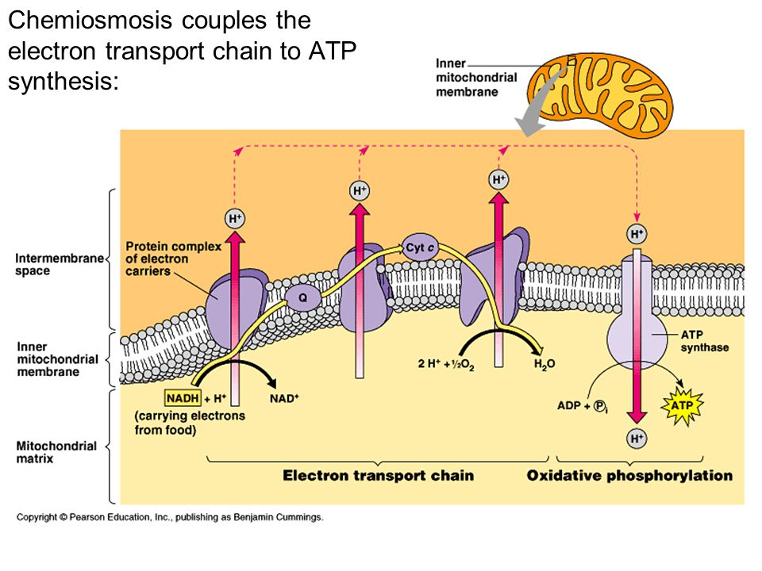
ATP Synthase

Chemiosmosis

Proton-motive force

- An Accounting of ATP Production by Cellular Respiration

FERMENTATION AND ANAEROBIC RESPIRATION ENABLE CELLS TO PRODUCE ATP WITHOUT THE USE OF OXYGEN

Anaerobic respiration

Fermentation

- Types of Fermentation
- Alcohol Fermentation
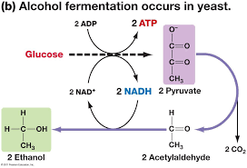

- Lactic Acid Fermentation
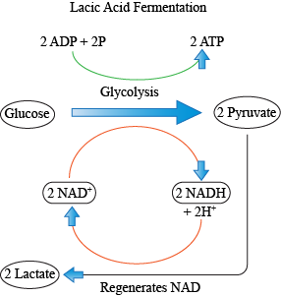

- Comparing Fermentation with Anaerobic and Aerobic Respiration
 | Fermentation | Aerobic Respiration | Anaerobic Respiration
Begins With
Electron Carrier
ATP Production
Final Electron Acceptor
Electron Transport Chain
Location

- Obligate Anaerobes

- Facultative Anaerobes

- The Evolutionary Significance of Glycolysis

GLYCOLYSIS AND THE CITRIC ACID CYCLE CONNECT TO MANY OTHER METABOLIC PATHWAYS
- The Versatility of Catabolism
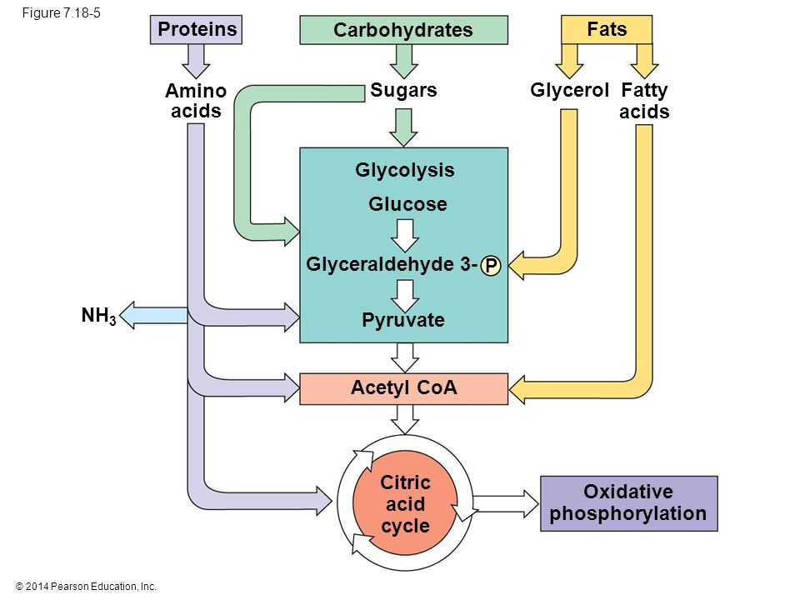

- Biosynthesis (anabolic pathways)

