AP CHEMISTRY CHAPTER 13 OUTLINE
CHEMICAL EQUILIBRIUM

13.1: THE EQUILIBRIUM CONDITION

H₂O_{(g)} + CO_{(g)} ↔ H_{2(g)} + CO_{2(g)}

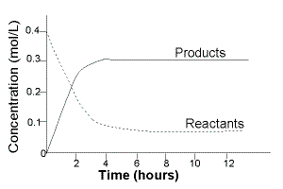

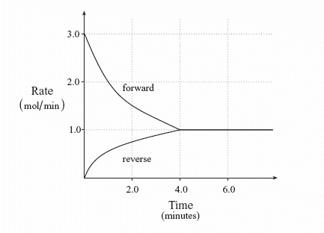

The Characteristics of Chemical Equilibrium
N_{2(g)} + 3H_{2(g)} ↔ 2NH_{3(g)}

13.2: THE EQUILIBRIUM CONSTANT

The law of mass action

The equilibrium expression

Manipulating the K for a reaction
jA + kB ↔ lC + mD

forward

reverse

original multiplied by some factor n

Summary of equilibrium expressions
1.

2.

3.

Equilibrium position

13.3: EQUILIBRIUM EXPRESSIONS INVOLVING PRESSURES

How are K and K_{p} related

Converting K_{p} to K

13.4: HETEROGENEOUS EQUILIBRIUM

13.5: APPLICATIONS OF THE EQUILIBRIUM CONSTANT

K Predicts
1.

2.

3.

Extent of a reaction

Reaction Quotient (Q)

Comparing K and Q

- Q = K

- Q > K

- Q < K

Calculating Equilibrium Pressures and Concentrations

13.6: SOLVING EQUILIBRIUM PROBLEMS

1.

2.

3.

4.

5.

6.

7.

Treating systems that have small equilibrium constants

13.7: LE CHATELIER’S PRINCIPLE

Effect of change in concentration

The Effect of a Change in Pressure
1.

2.

3.

The Effect of a Change in Temperature

