ADVANCED BIOLOGY: AN INTRODUCTION TO METABOLISM
( USE CHAPTER 8 AS A RESOURCE)
AN ORGANISM’S METABOLISM TRANSFORMS MATTER AND ENERGY
Metabolism

- Metabolic pathways

- Catabolic pathways

- Anabolic pathways

- Bioenergetics

- Forms of energy
- Chemical Energy

- Thermal Energy

- Free Energy and Metabolism
- Exergonic Reaction

- Endergonic Reaction

ATP POWERS CELLULAR WORK BY COUPLING EXERGONIC REACTION TO ENDERGONIC REACTIONS
Chemical Work

Transport Work

Mechanical Work

Energy coupling

- The Structure and Hydrolysis of ATP
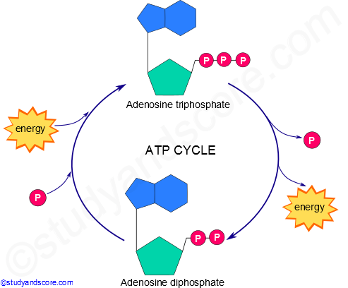

- How the Hydrolysis of ATP Performs Work
- Chemical Work

- Transport Work

- Mechanical Work

ENZYMES SPEED UP METABOLIC REACTION BY LOWERING ENERGY BARRIERS
Enzyme

Catalyst

- The Activation Energy Barrier
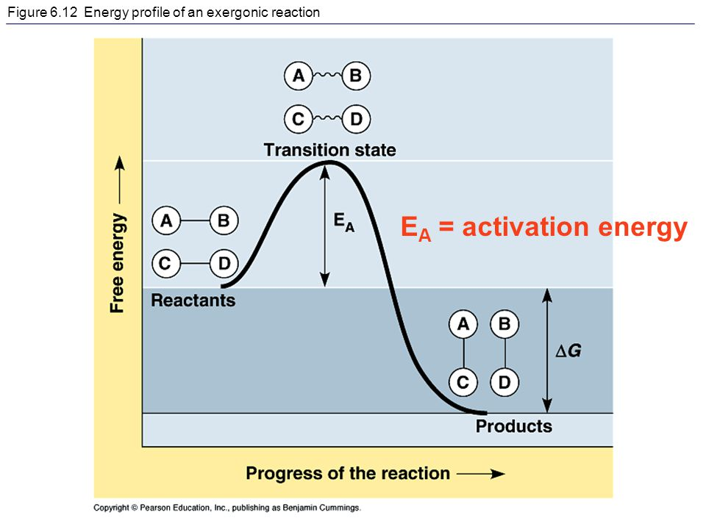

- How Enzymes Speed Up Reactions
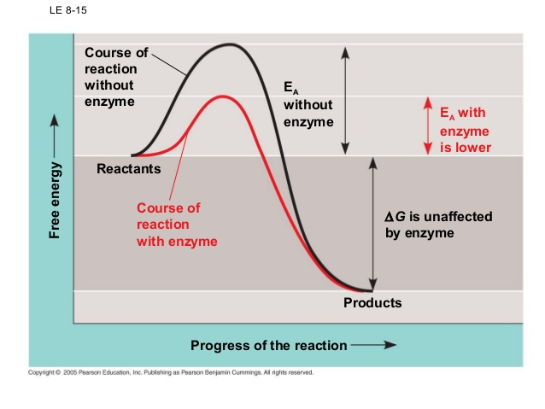

- Substrate Specificity of Enzymes
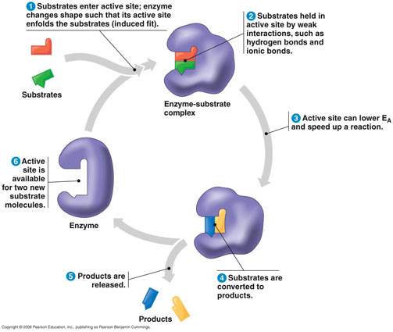
- Substrate

- Enzyme-Substrate Complex

- Active Site

- Induced Fit

- Catalysis in the Enzyme’s Active Site

a.

b.

c.

d.

- Rate of reaction

- Effects of Local Conditions on Enzyme Activity
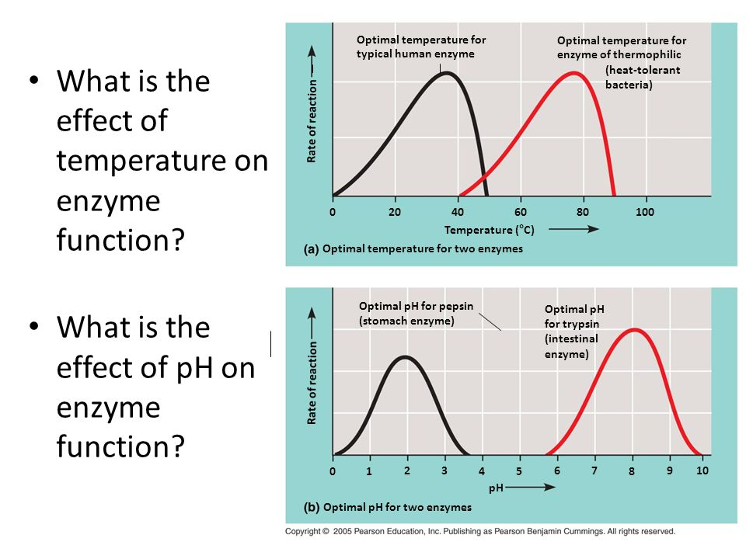
- Effects of Temperature and pH

- Cofactors

- Cofactors

- Coenzyme

- Enzyme Inhibitors
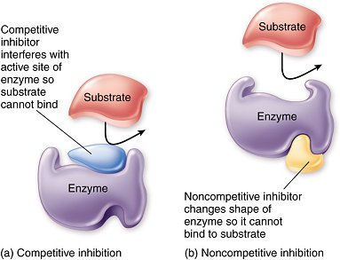

- Competitive Inhibitors

- Noncompetitive Inhibitors

- The Evolution of Enzymes

REGULATION OF ENZYME ACTIVITY HELPS CONTROL METABOLISM

- Allosteric Regulation of Enzymes

- Allosteric Activation and Inhibition
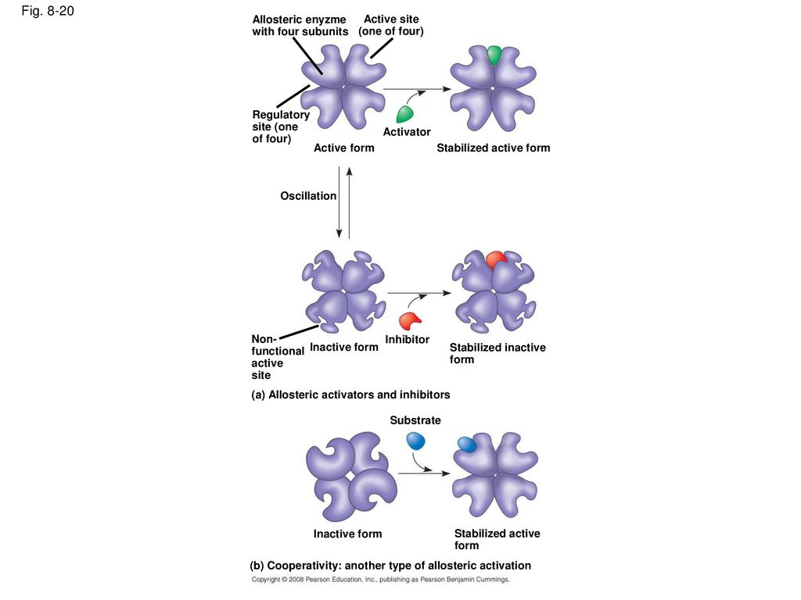

(1) Activator

(2) Inhibitor

- Cooperativity

- Feedback Inhibition
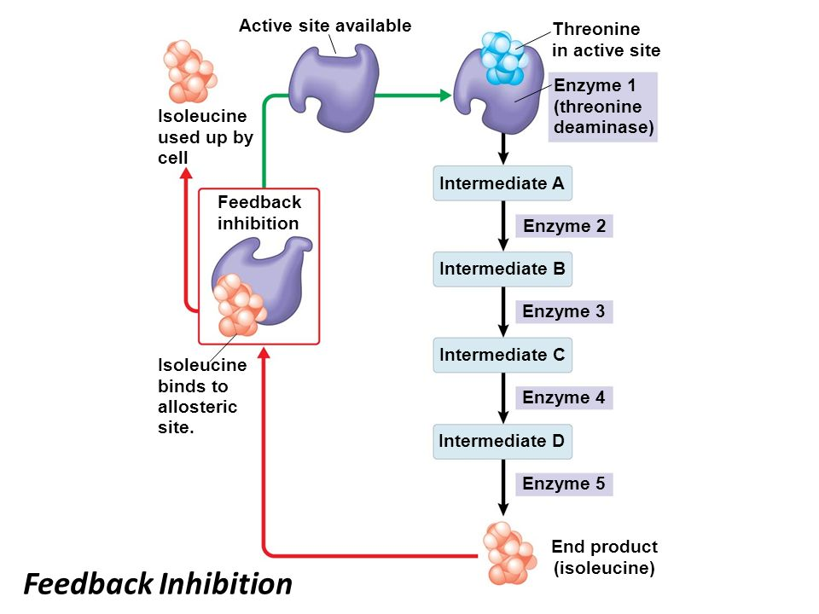

- Specific Localization of Enzymes Within the Cell

