SIGNIFICANT DIGITS IN SCIENCE

MEASUREMENT AND CALCULATIONS

UNCERTAINTY IN MEASUREMENT

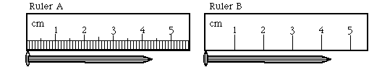

SIGNIFICANT FIGURES (DIGITS)

RULES FOR COUNTING SIGNIFICANT FIGURES

- Nonzero integers

- Zeros
- Leading zeros

- Captive zeros

- Trailing zeros

- Exact numbers

Examples

- 0.0108 g

- 0.0050060 g

- 5.030 x 10³ ft

- 110 riders started, but only 60 finished

CHECK POINT

- 0.000304 g

- 1.270 x 10² m

- 0.9020 L

- 480 cars were in the parade

Determining Significant Figures (Digits) in Calculations

- Multiplication and Division

EXAMPLES
- 12.6 x 0.53

- 8.315 ÷ 298

- 5.44 x 0.235

- Addition and Subtraction

EXAMPLES
- 12.11 + 18.0

- 0.6875 – 0.1

- 32,575 + 985.663

What if you have to do both?

EXAMPLES

a. (12.6 x 0.53) – 4.59

b. (25.36 – 4.15) ÷ 2.317

SCIENTIFIC NOTATION

What is it used for?

Turning numbers greater than one into scientific notation

Turning numbers less than one into scientific notation

CHECK POINT
  - 12,500

  - 247

  - 0.0024

  - 0.0000072

  - 350,000,000

