ADVANCED BIOLOGY: THE MOLECULAR BASIS OF INHERITANCE
(USE CHAPTER 16 and 20 AS A RESOURCE)

DNA IS THE GENETIC MATERIAL

- The Search for the Genetic Material: Scientific Inquiry
Protein or DNA

- Evidence that DNA can Transform Bacteria
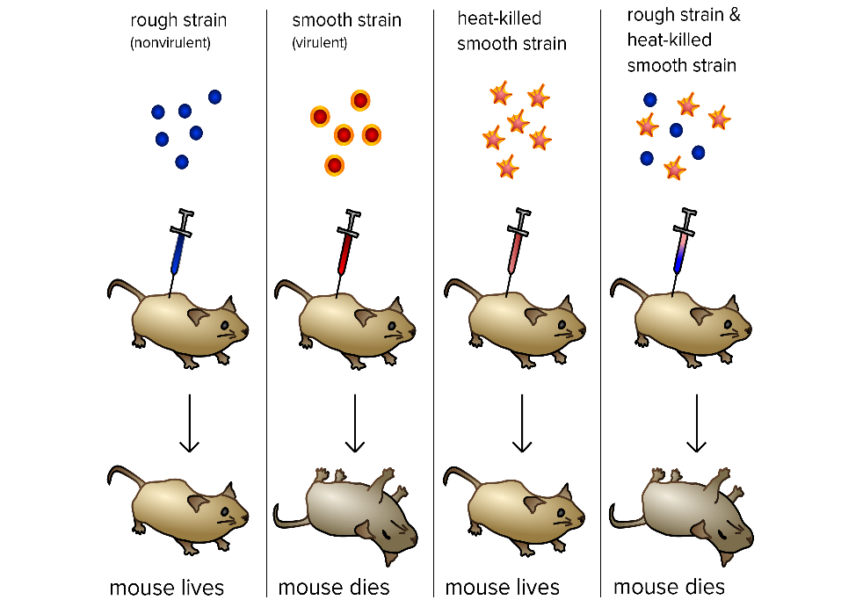

- Evidence That Viral DNA Can Program Cells

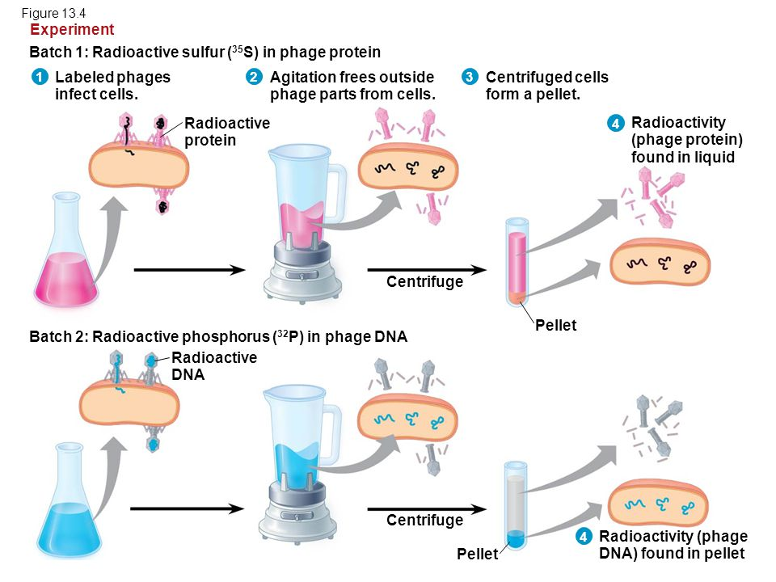

- Additional Evidence that DNA Is the Genetic Material

Chargaff’s Rules

- Building a Structural Model of DNA: Scientific Inquiry
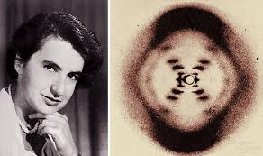

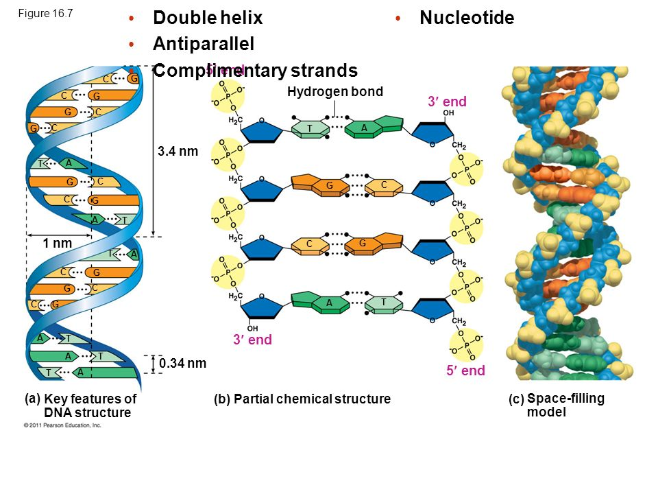

MANY PROTEINS WORK TOGETHER IN DNA REPLICATION AND REPAIR
- The Basic Principle: Base Pairing to a Template Strand
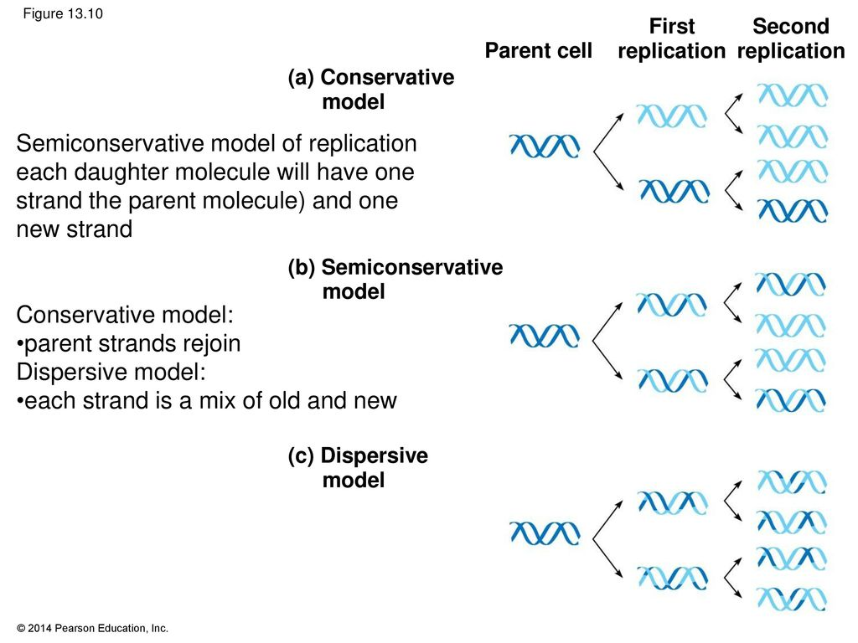

- DNA Replication: A Closer Look
- Size of the genome

- Getting Started
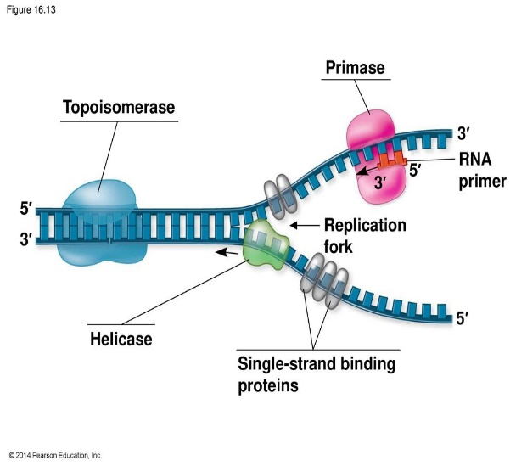

- Synthesizing a New DNA Strand
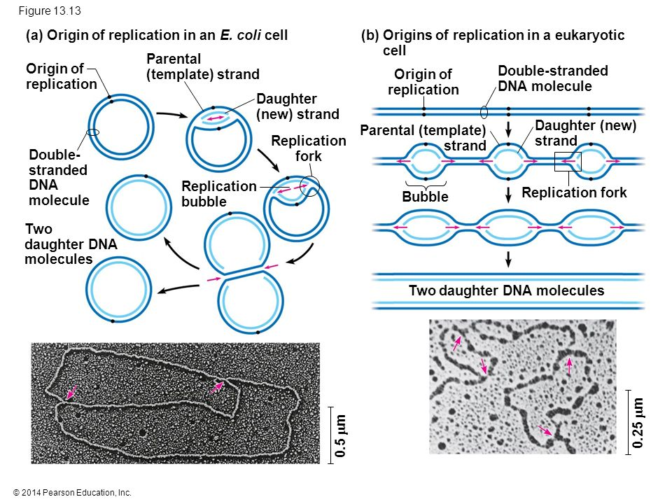

- Antiparallel Elongation

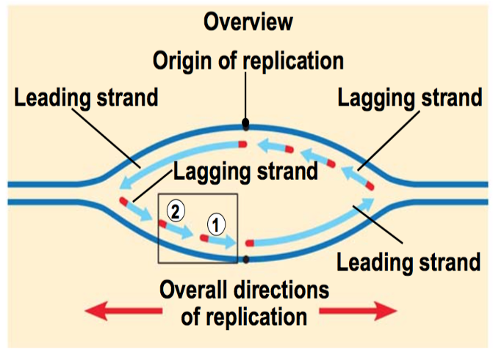
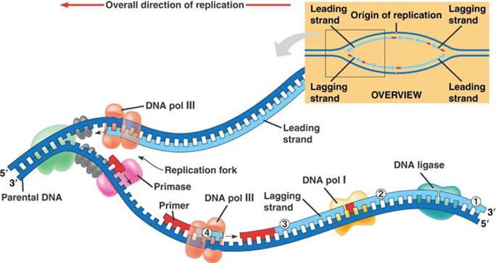

- The DNA Replication Complex

- Proofreading and Repairing DNA

- Mismatch repair

- Nuclease

- Nucleotide excision repair

- Evolutionary Significance of Altered DNA Nucleotides

- Replicating the Ends of DNA Molecules

A CHROMOSOME CONSISTS OF A DNA MOLECULE PACKED TOGETHER WITH PROTEINS
Size of the Bacterial chromosome

Nucleoid region

Size of the Eukaryotic Chromosomes

Chromatin

- Heterochromatin

- Euchromatin

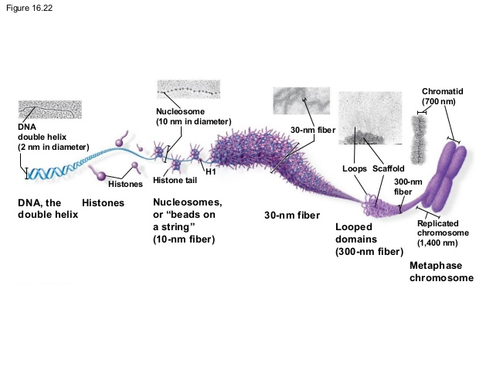

UNDERSTANDING DNA STRUCTURE AND REPLICATION MAKES GENETIC ENGINEERING POSSIBLE

Nucleic Acid Hybridization

Genetic Engineering

- DNA Cloning: Making Multiple Copies of a Gene or Other DNA Segment

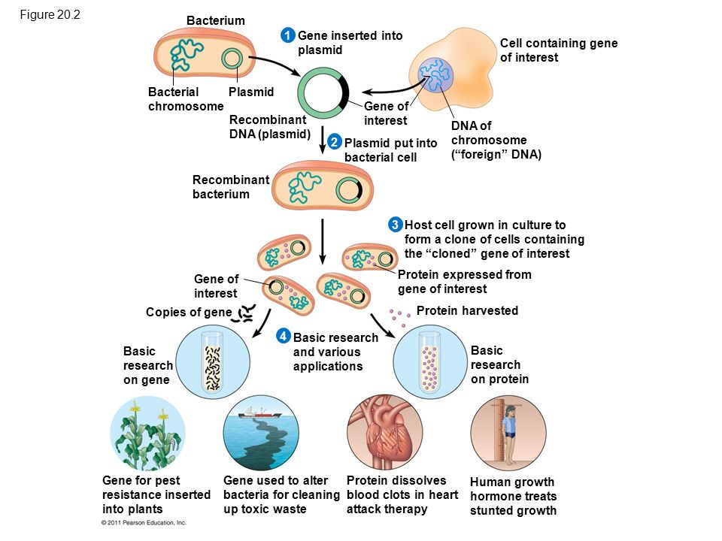
- Plasmids

- Recombinant DNA

- Gene Cloning

- Using Restriction Enzymes to Make Recombinant DNA
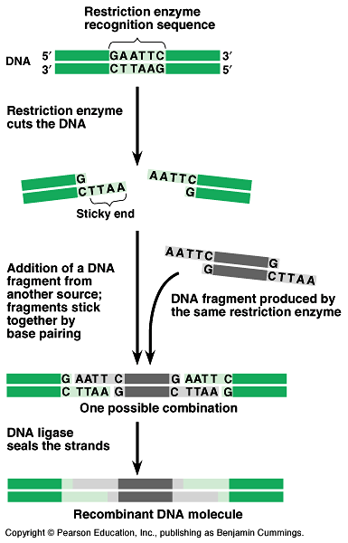

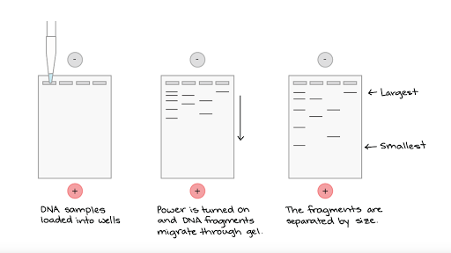
- Amplifying DNA in Vitro: PCR and its use in cloning

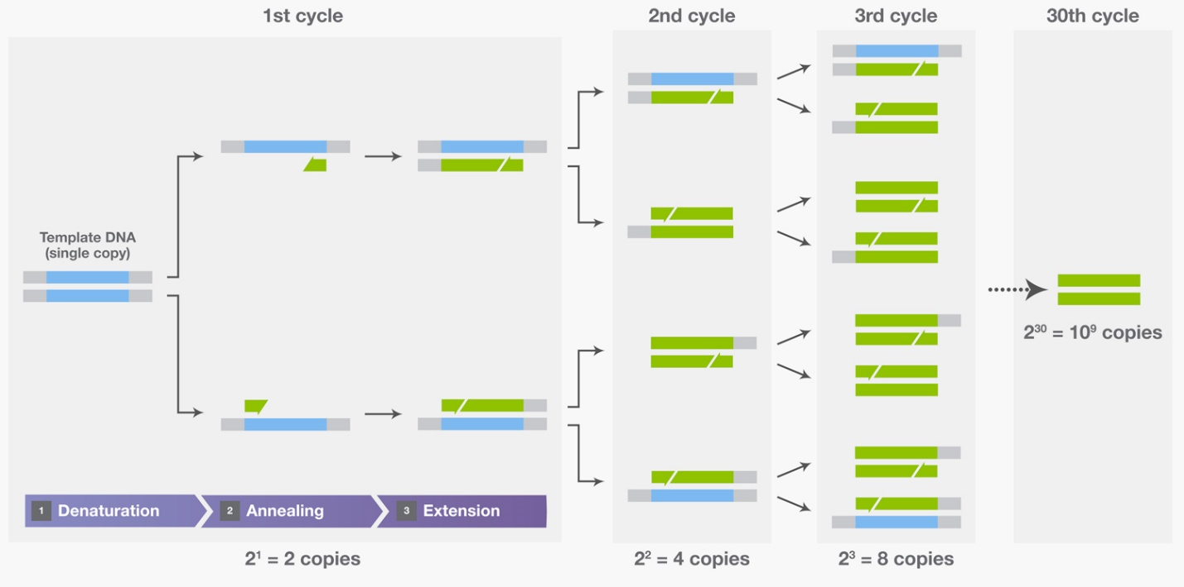

- DNA Sequencing

