ADVANCED BIOLOGY: THE CHROMOSOMAL BASIS OF INHERITANCE
(USE CHAPTER 15 AS A RESOURCE)

MENDELIAN INHERITANCE HAS ITS PHYSICAL BASIS IN THE BEHAVIOR OF CHROMOSOMES

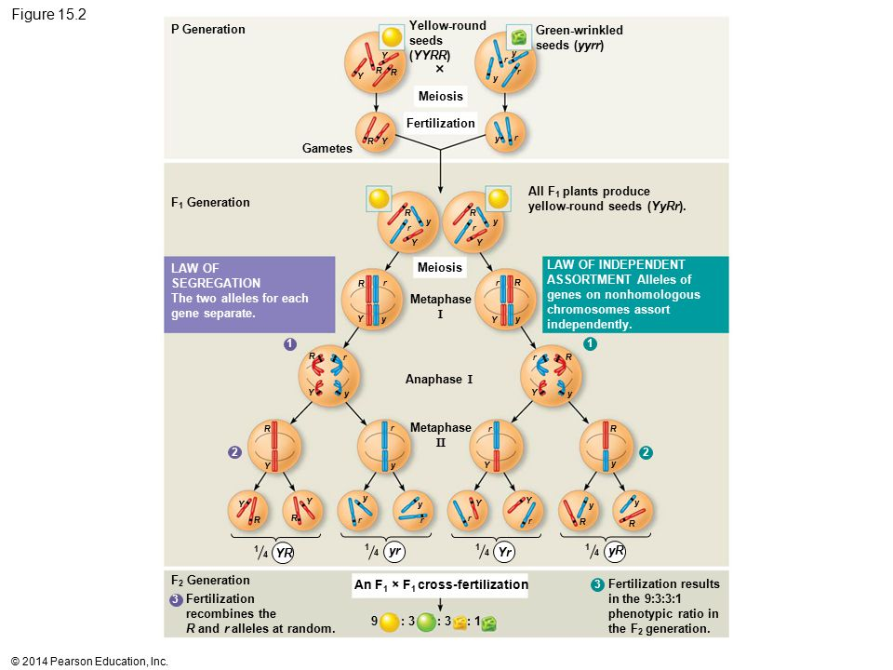

- Morgan’s Experimental Evidence: Scientific Inquiry
- Morgan’s Choice of Experimental Organism

- Prolific Breeding/Generation Time

- Chromosome Number

- Patience

- Symbol notation

- Correlating Behavior of a Gene’s Alleles with Behavior of a Chromosome Pair

SEX-LINKED GENES EXHIBIT UNITUE PATTERNS OF INHERITANCE

- The Chromosomal Basis of Sex

- Sex-Linked Gene

- X-Linked Gene

- Inheritance of X-Linked Genes

- Duchenne Muscular Dystrophy

- Hemophilia

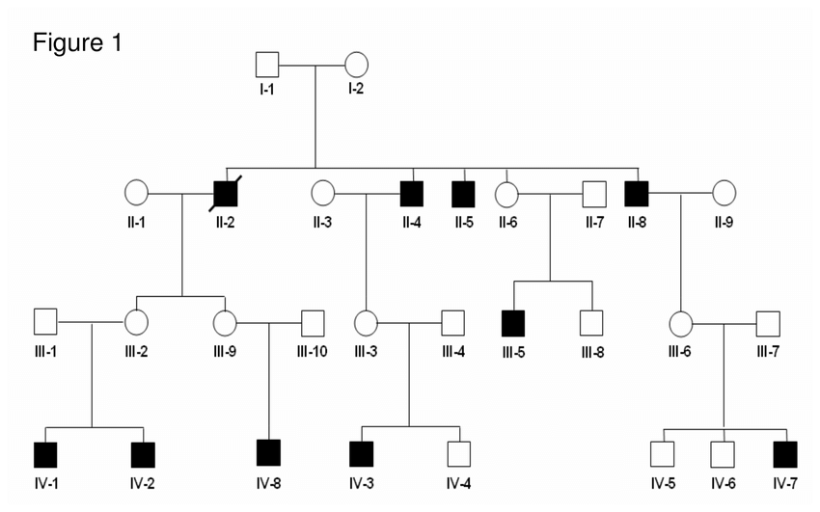

- X Inactivation in Female Mammals
- Barr Body

- Mosaic

- Methylation

- Calico Cats

LINKED GENES TEND TO BE INHERITED TOGETHER BECAUSE THEY ARE LOCATED NEAR EACH OTHER ON THE SAME CHROMOSOME

Linked Genes

- How Linkage Affects Inheritance
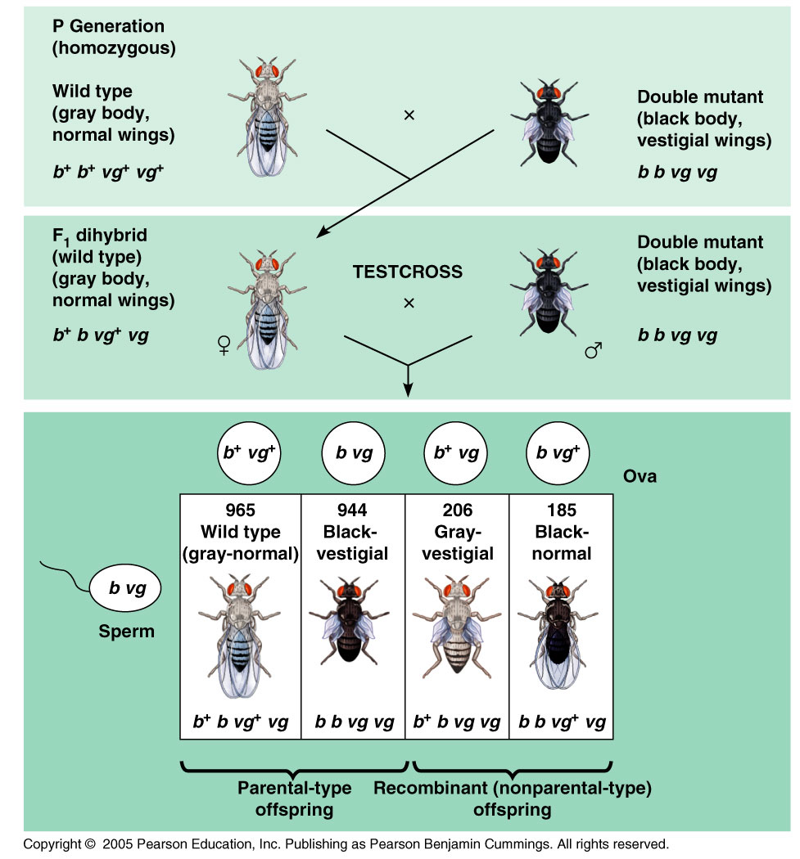

- If genes are on different chromosomes

- If genes are located on the same chromosome

- Genetic recombination

- Genetic Recombination and Linkage
- Recombination of Unlinked Genes: Independent Assortment of Chromosomes

- Parental Types

- Recombinant Types or Recombinants

- Recombination of Linked Genes: Crossing Over

- New Combinations of Alleles: Variation for Natural Selection

- Mapping the Distance Between Genes Using Recombination Data: Scientific Inquiry

- Genetic map

- Linkage Map

- Map Units

- Cytogenic Maps
ALTERATIONS OF CHROMOSOME NUMBER OR STRUCTURE CAUSE SOME GENETIC DISORDERS

- Abnormal Chromosome Number
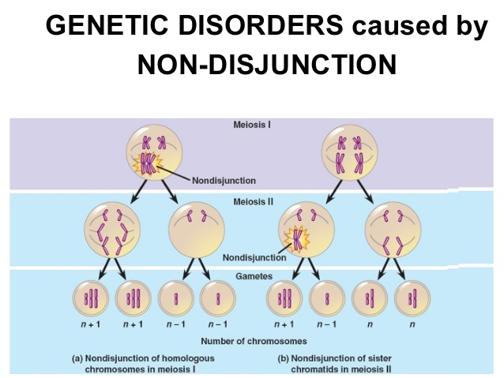
- Nondisjunction

- Aneuploidy

- Monosomic

- Trisomic

- Polyploidy

- Alterations of Chromosome Structure
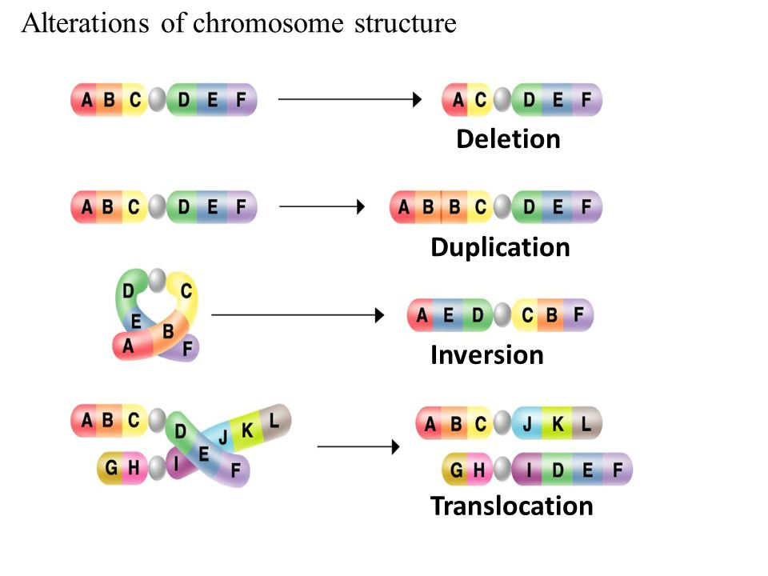

- Human Disorders Due to Chromosomal Alterations

- Down Syndrome
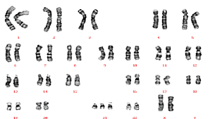

- Aneuploidy of Sex Chromosomes

- Disorders Caused by Structurally Altered Chromosomes

