ADVANCED BIOLOGY: THE CELL CYCLE
(USE CHAPTER 12 AS A RESOURCE)
Cell Division

Cell Cycle

MOST CELL DIVISION RESULTS IN GENETICALLY IDENTICAL DAUGHTER CELLS

- Cellular Organization of the Genetic Material
- Genome

- Chromosomes

- Chromatin

- Somatic Cells

- Gametes

- Distribution of Chromosomes During Eukaryotic Cell Division

- Sister chromatids

- Centromere

- Mitosis

- Cytokinesis

THE MITOTIC PHASE ALTERNATES WITH INTERPHASE IN THE CELL CYCLE
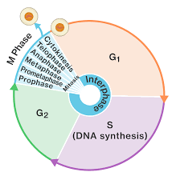
- Phases of the Cell Cycle
- M Phase
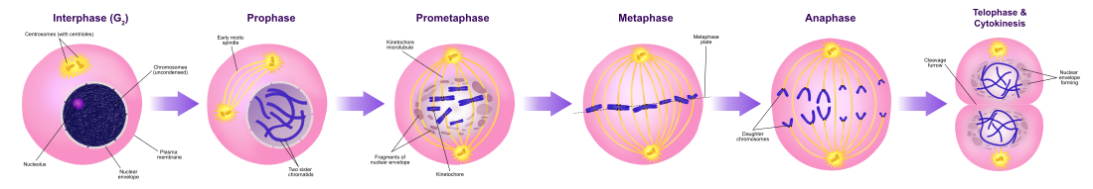

- Interphase
- G₁ Phase

- S Phase

- G₂ Phase

- The Mitotic Spindle: A Closer Look
- Mitotic Spindle

- Centrosome

- Aster

- Kinetochore

- Metaphase Plate

- Movement of chromosomes toward poles

- Nonkinetochore microtubules

- Cytokinesis: A Closer Look
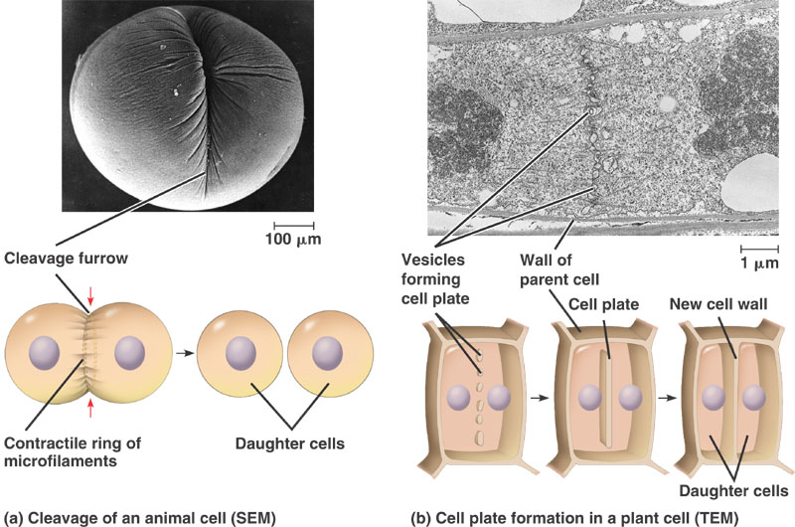
- Binary Fission in Bacteria:
- Binary Fission

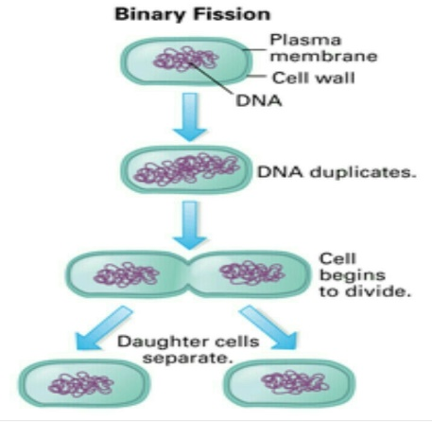

- Bacterial Chromosomes

- The Evolution of Mitosis

THE EUKARYOTIC CELL CYCLE IS REGULATED BY A MOLECULAR CONTROL SYSTEM

- Evidence for Cytoplasmic Signals

- Checkpoints for the Cell Cycle Control System
- Cell Cycle Control System

- Checkpoint

- G₀ Phase

- Growth factors

- Density Dependent Inhibition

- Anchorage Dependence

- Loss of Cell Cycle Controls in Cancer Cells

