ADVANCED BIOLOGY: RESOURCE ACQUISITION, NUTRITION, AND TRANSPORT IN VASCULAR PLANTS
(USE CHAPTER 36 and 37 AS A RESOURCE)
ADAPTATIONS FOR ACQUIRING RESOURCES WERE KEY STEPS IN THE EVOLUTIONO F VASCULAR PLANTS
Xylem

Phloem

- Shoot Architecture and Light Capture
- Advantages of Height and Branching Patterns

- Requirements for height

- Phyllotaxy

- Canopy

- Leaf Orientation

- Root Architecture and Acquisition of Water and Minerals
- Root growth directionality

- Mutualistic relationships

DIFFERENT MECHANISMS TRANSPORT SUBSTANCES OVER SHORT OR LONG DISTANCES
- The Apoplast and Symplast: Transport Continuums
- Apoplast
- Symplast

- Apoplastic route

- Symplastic route

- Transmembrane route

- Short-Distance Transport of Solutes Across Plasma Membranes
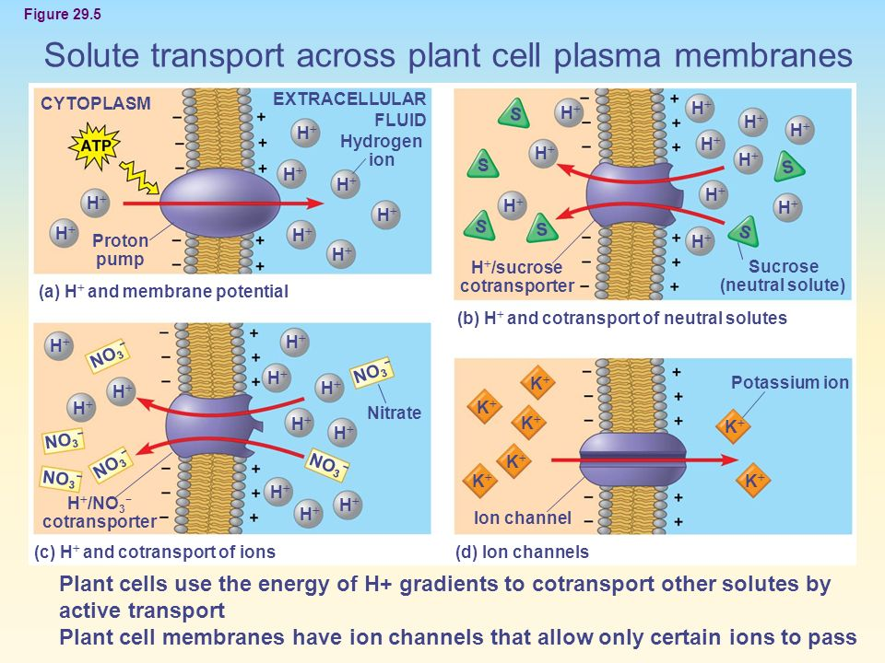

- Short-Distance Transport of Water Across Plasma Membranes
- Osmosis

- Water Potential

- How Solutes and Pressure Affect Water Potential

- Solute potential

- Pressure Potential

- Protoplast

- Turgor Pressure

- Water Movement Across Plant Cell Membranes

- Flaccid

- Plasmolysis

- Turgid

- Wilting

- Aquaporins: Facilitating Diffusion of water

- Long-Distance Transport: The Role of Bulk Flow

- Bulk Flow

- Where it occurs

PLANT ROOTS ABSORB ESSENTIAL ELEMENTS FROM THE SOIL

- Macronutrients and Micronutrients
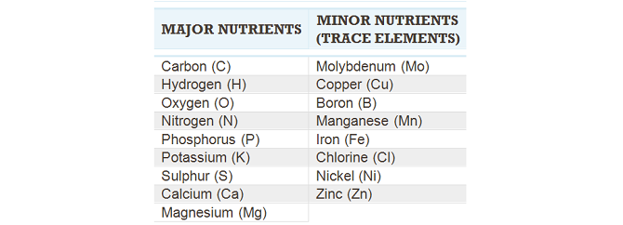

- Symptoms of Mineral Deficiency

- Soil Management

- Fertilization

- Adjusting soil pH

- The Living, Complex Ecosystem of Soil

- Soil Texture

- Topsoil Composition
- Inorganic Components

- Organic Components

- Living Components

PLANT NUTRITION OFTEN INVOLVES RELATIONSHIPS WITH OTHER ORGANISMS

- Soil Bacteria and Plant Nutrition

- Rhizobacteria

- Bacteria in the Nitrogen Cycle

- Ammonifying bacteria

- Nitrogen fixing bacteria

- Nitrification

- Nitrifying bacteria

- Nitrogen-Fixing Bacteria: A Closer Look

- Nitrogen fixation

- Nodules

- Bacteroids

- Fungi and Plant Nutrition

- The Two Main Types of Mycorrhizae
- Ectomycorrhizae

- Arbuscular mycorrhizae

- Agricultural and Ecological Importance of Mycorrhizae

- Epiphytes, Parisitic Plants, and Carnivorous Plants

TRANSPIRATION DRIVES THE TRANSPORT OF WATER AND MINERALS FROM ROOTS TO SHOOTS VIA XYLEM
- Absorption of Water and Minerals by Root Cells

- Transport of Water and Minerals into the Xylem
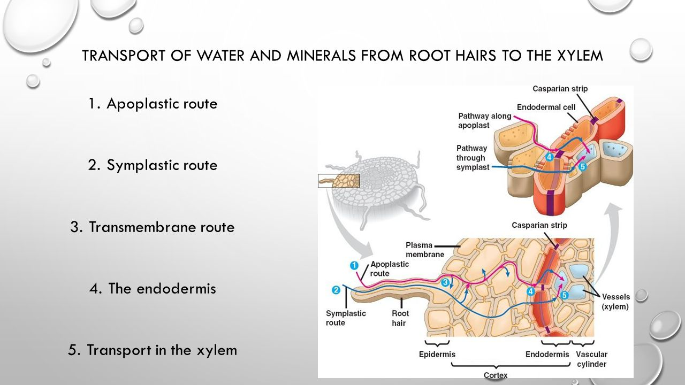

- Bulk Flow Transport via the Xylem
Xylem Sap

Transpiration

- Pulling Xylem Sap: The Cohesion-Tension Hypothesis

- Transpirational Pull

- Cohesion and Adhesion in the Ascent of Xylem
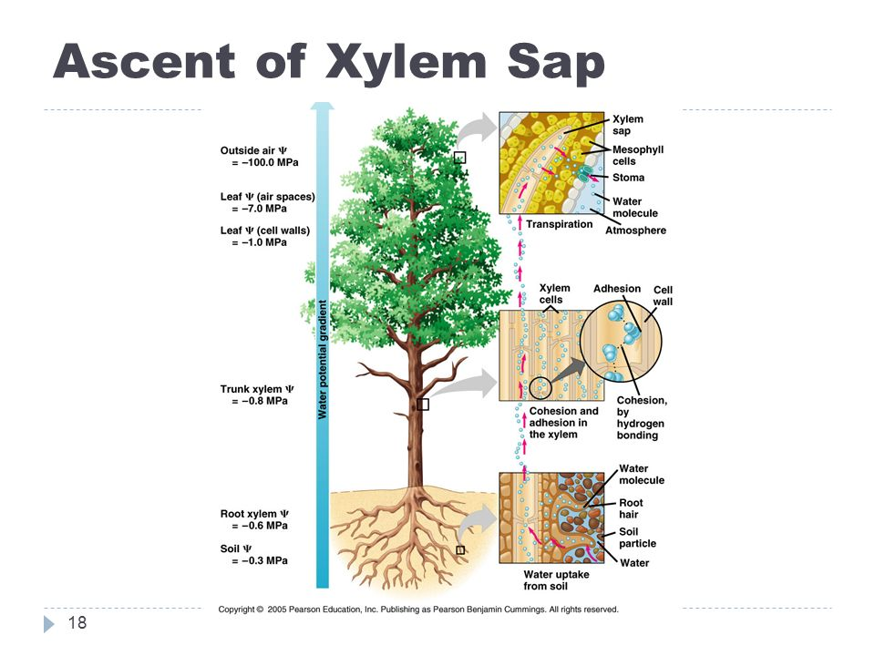

THE RATE OF TRANSPIRATION IS REGULATED BY STOMATA

- Stomata: Major Pathways for Water Loss

- Mechanisms or Stomatal Opening and Closing
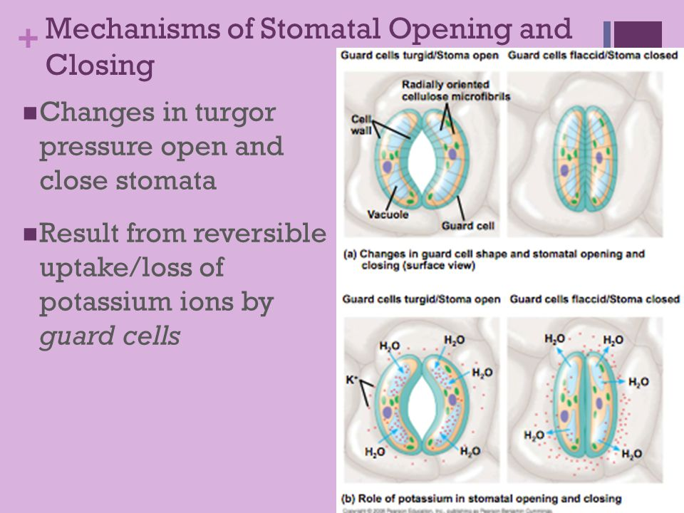

- Stimuli for Stomatal Opening and Closing

- Cue 1

- Cue 2

- Cue 3

- Effects of Transpiration on Wilting and Leaf Temperature

- Adaptations That Reduce Evaporative Water Loss

SUGARS ARE TRANSPORTED FROM SOURCES TO SINKS VIA THE PHLOEM

- Movement from Sugar Sources to Sugar Sinks

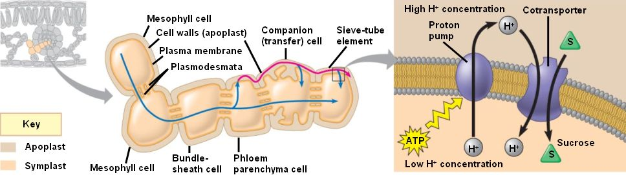

- Phloem Sap

- Sugar Source

- Sugar Sink

- Bulk Flow by Positive Pressure: The Mechanism of Translocation in Angiosperms
