ADVANCED BIOLOGY: REPRODUCTION AND DOMESTICATION OF FLOWERING PLANTS
(USE CHAPTER 38 AS A RESOURCE)
FLOWERS, DOUBLE FERTILIZATION, AND FRUITS ARE UNIQUE FEATURES OF THE ANGIOSPERM LIFE CYCLE
- Flower Structure and Function
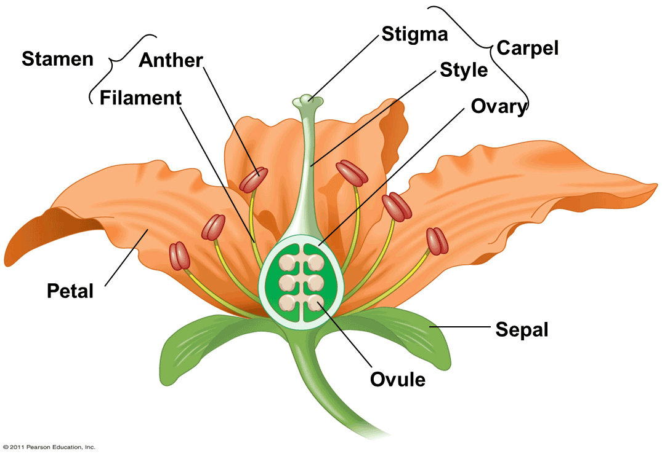

Complete flowers

Incomplete flowers

- Flower formation

- Development of Female Gametophytes

- Development of Male Gametophytes in Pollen Grains

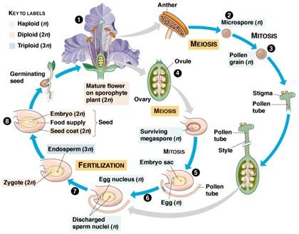

- Pollination

- Double Fertilization

- Seed Development, Form, and Function

- Endosperm Development
- Embryo Development

- Structure of the Mature Seed
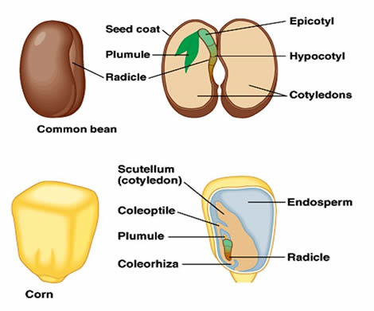

- Seed Dormancy: An Adaptation for Tough Times

- Seed Germination and Seedling Development

- Imbibition

- Dicots

- Monocots

- Fruit Form and Function

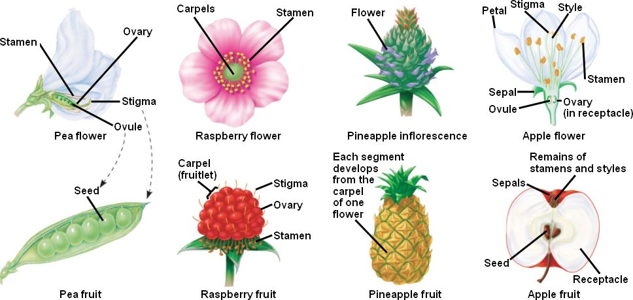

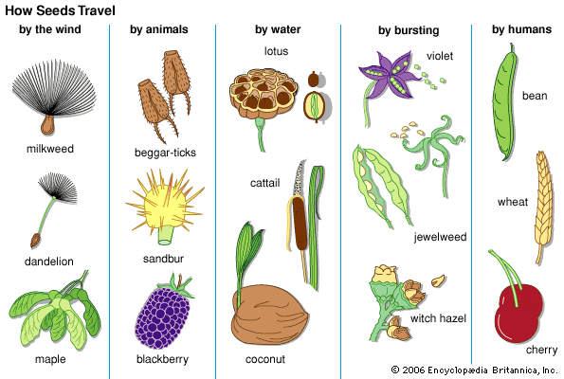

FLOWERING PLANTS REPRODUCE SEXUALLY, ASEXUALLY, OR BOTH

- Mechanisms of Asexual Reproduction

- Fragmentation

- Apomixis

- Advantages and Disadvantages of Asexual Versus Sexual Reproduction

- Mechanisms That Prevent Self-Fertilization

- Dioecious species

- Self-Incompatibility

- Totipotency, Vegetative Reproduction, and Tissue Culture

- Totipotent

- Vegetative Propagation and Grafting

- Test-Tube Cloning and Related Techniques

PEOPLE MODIFY CROPS THROUGH BREEDING AND GENETIC ENGINEERING

- Plant Breeding

- Plant Biotechnology and Genetic Engineering

- Reducing World Hunger and Malnutrition

- Reducing Fossil Fuel Dependency

- The Debate over Plant Biotechnology

- Issues of Human Health

- Possible Effects on Nontarget Organisms

- Addressing the Problem of Transgene Escape

