ADVANCED BIOLOGY: PHOTOSYNTHESIS
(USE CHAPTER 10 AS A RESOURCE)

Photosynthesis

Autotrophs

Heterotrophs

PHOTOSYNTHESIS CONVERTS LIGHT ENERGY TO THE CHEMICAL ENERGY OF FOOD

- Chloroplasts: The Sites of Photosynthesis in Plants
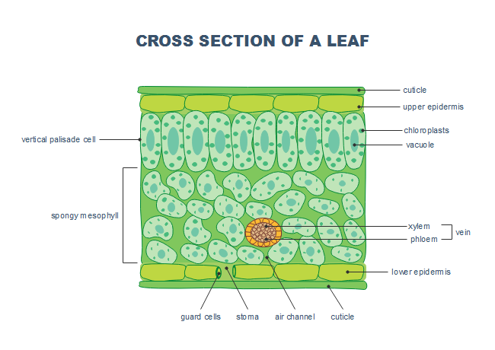

- Mesophyll

- Stomata

- Chloroplast

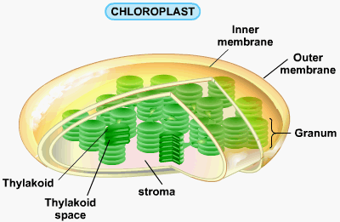

- Tracking Atoms Through Photosynthesis: Scientific Inquiry
- Reaction

- The Splitting of water

- Photosynthesis as a Redox Process

- The Two Stages of Photosynthesis: A Preview
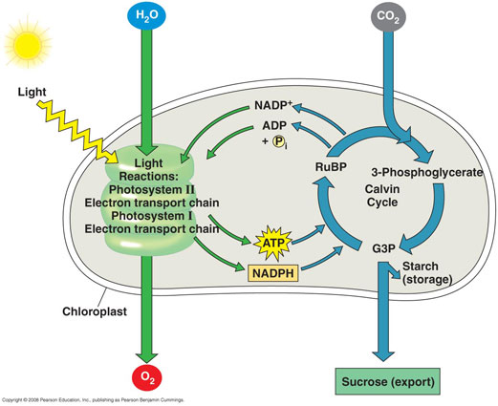

- Light Reactions

- Calvin Cycle

THE LIGHT REACTIONS CONVERT SOLAR ENERGY TO THE CHEMICAL ENERGY OF ATP AND NADPH
- The Nature of Sunlight (Read this information and take notes)

- Photosynthetic Pigments: The Light Receptors
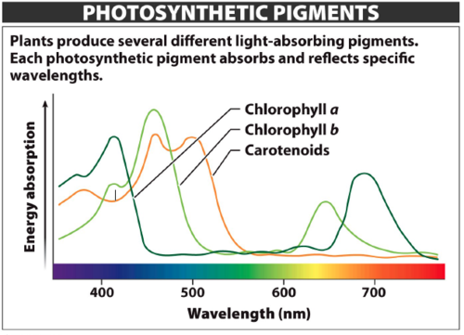

- Excitation of Chlorophyll by Light
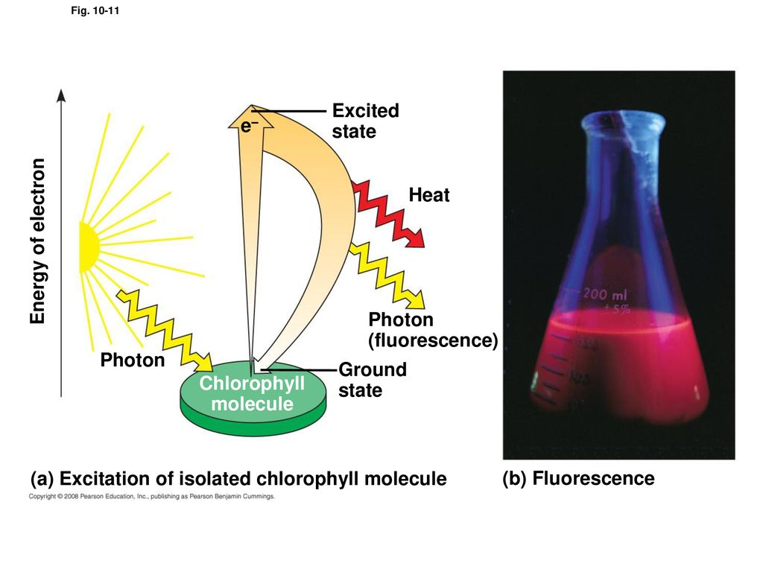
- A Photosystem: A Reactions-Center Complex Associated with Light-Harvesting Complexes
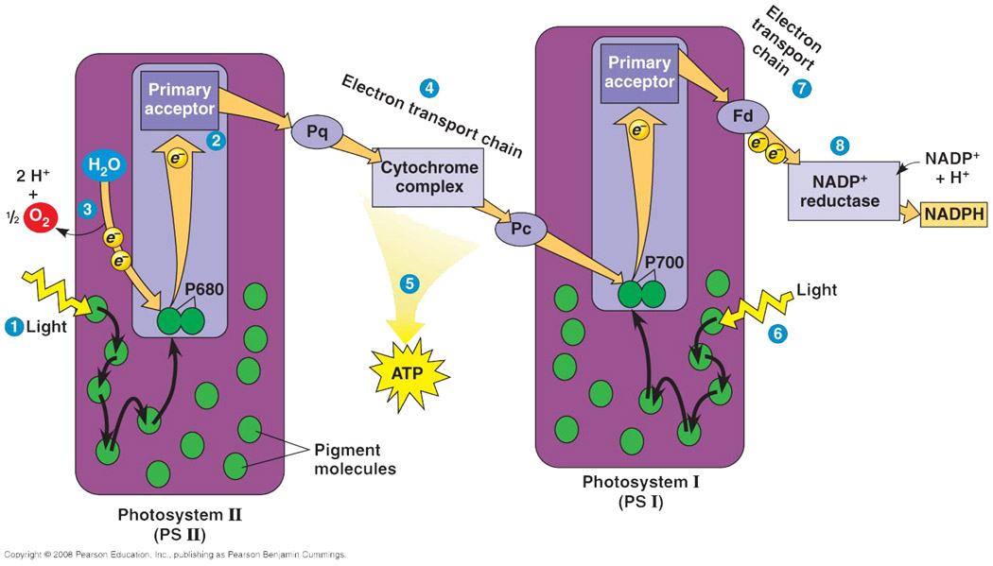

- A Comparison of Chemiosmosis in Chloroplasts and Mitochondria
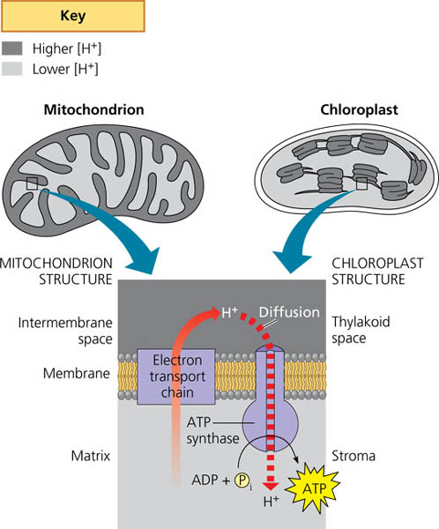
- Generation of ATP

- Electron Transport Chain

- ATP Synthase

- Source of electrons

- Proton gradient

THE CALVIN CYCLE USES THE CHEMICAL ENERGY OF ATP AND NADPH TO REDUCE CO₂ TO SUGAR
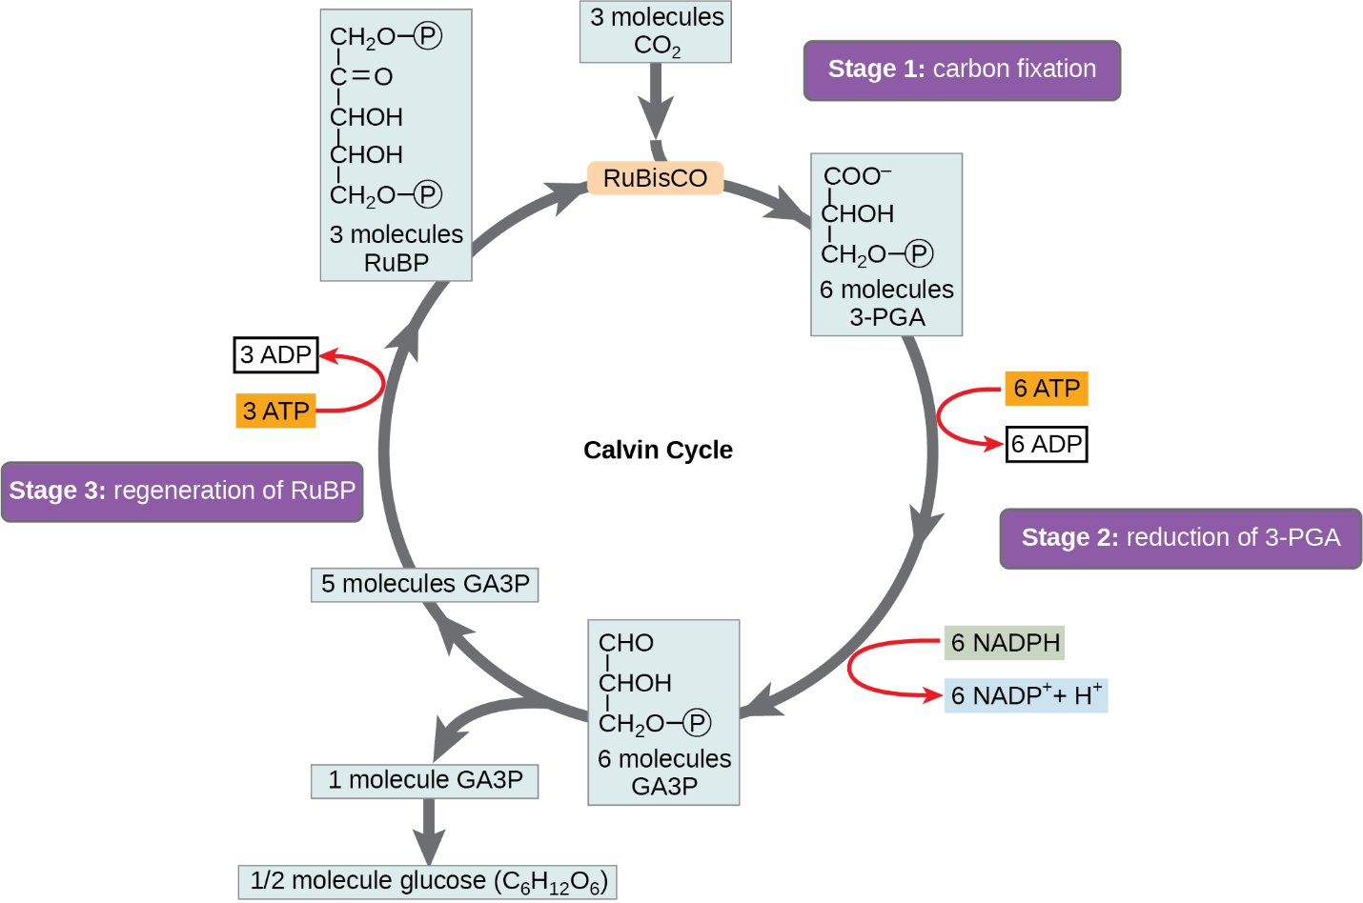

- Carbon fixation

- Reduction

- Regeneration of RuBP

- The Evolution of Alternative mechanisms of Carbon Fixation in Hot, Arid Climates

- Photorespiration

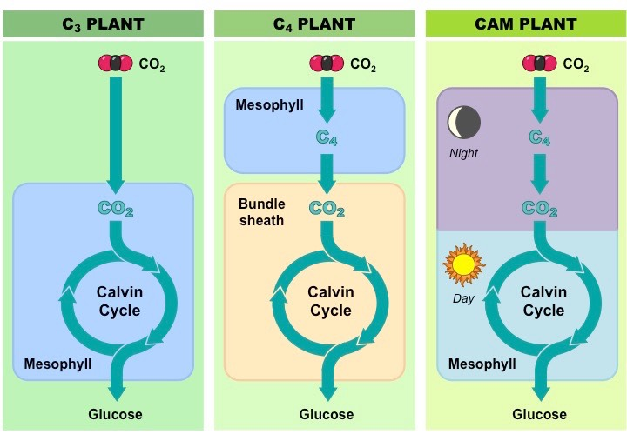
- C₃ Plants

- C₄ Plants

- CAM Plants

- The Importance of Photosynthesis: A Review

