ADVANCED BIOLOGY: MENDEL AND THE GENE IDEA
(USE CHAPTER 14 AS A RESOURCE)
MENDEL USED THE SCIENTIFIC APPORACH TO IDENTIFY TWO LAWS OF INHERITANCE
- Mendel’s Experimental, Quantitative Approach
- Character

- Trait

- Mendel’s controls

- True-breeding

- Hybridization

- P generation

- F₁ generation

- F₂ generation

- The Law of Segregation

Dominant trait

Recessive trait

- Mendel’s Model
(1)

(2)

(3)

(4)

- Useful Genetic Vocabulary
- Homozygous

- Heterozygous

- Phenotype

- Genotype

- The Test Cross

- The Law of Independent Assortment
- Monohybrids/monohybrid cross

- Dihybrids/dihybrid cross

- Law of Independent Assortment

THE LAWS OF PROBABILITY GOVERN MENDELIAN INHERITANCE

- The Multiplication and Addition Rules Applies to Monohybrid Crosses
- Multiplication Rule

- Addition Rule

- Solving Complex Genetics Problems with the Rules of Probability

INHERITANCE PATTERNS ARE OFTEN MORE COMPLEX THAN PREDICTED BY SIMPLE MENDELIAN GENETICS

- Extending Mendelian Genetics for a Single Gene
- Degrees of Dominance

- Complete dominance

- Incomplete dominance

- Codominance

- The Relationship between Dominance and Phenotype

- Frequency of Dominant Alleles

- Multiple Alleles

- Pleiotropy

- Extending Mendelian Genetics for Two or More Genes

- Epistasis

- Polygenic Inheritance

- Nature and Nurture: The Environmental Impact on Phenotype

- Integrating a Mendelian View of Heredity and Variation

MANY HUMAN TRAITS FOLLOW MENDELIAN PATTERNS OF INHERITANCE

- Pedigree Analysis

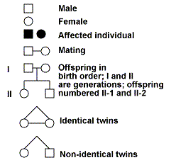
- Recessively Inherited Disorders
- Albinism

- Cystic Fibrosis

- Sickle-Cell Anemia

- Tay-Sach’s Disease

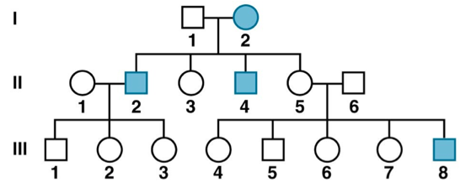
- Dominantly Inherited Disorders
- Achodroplasia

- Polydactyl

- Huntington’s Disease

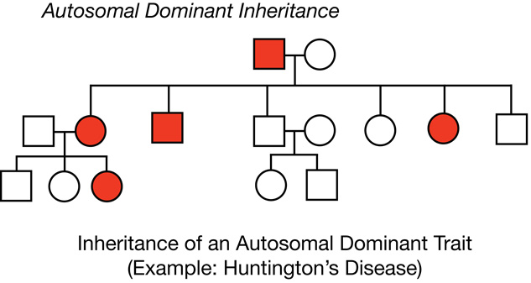

- Multifactorial Disorders

- Genetic Counseling Based On Mendelian Genetics

