HONORS CHEMISTRY UNIT 2: MATTER

THE PARTICULATE NATURE OF MATTER

Matter

The atomic nature of matter
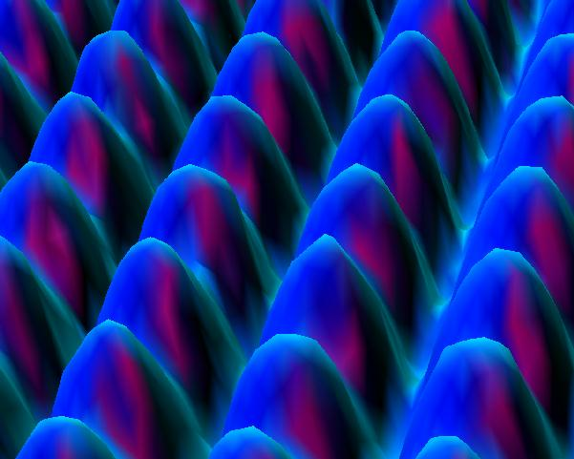

ELEMENTS AND COMPOUNDS

Elements – The letters of chemistry

Compounds- The Words of Chemistry

Molecules

Allotropes

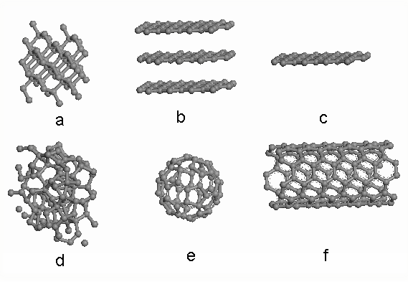

THE STATES OF MATTER

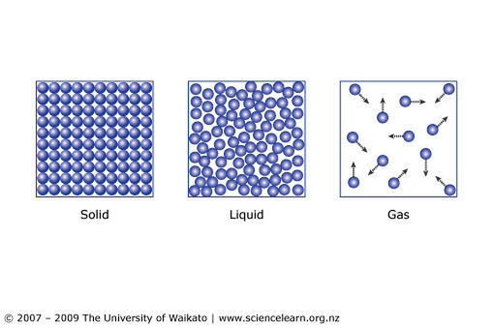

Solid

Liquid

Gas

PHYSICAL AND CHEMICAL PROPERTIES AND CHANGES

Physical properties

Chemical properties
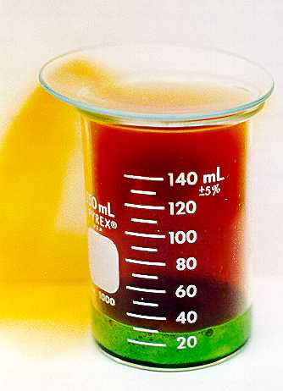

CHECK POINT: Identify the following as chemical or physical properties
a. The boiling point of a certain alcohol is 78ºC
b. Diamond is very hard
c. Sugar ferments to form alcohol
d. a metal wire conducts and electric current

DENSITY

Density

EXAMPLES

- What is the density of a rock with a mass of 25.2 g and a volume of 6.25 cm³?

- Calculate the volume in mL occupied by a certain object having a density of 8.00 g/mL and a mass of 25.0 g.

- Calculate the mass in grams of benzene having a density of 0.880 g/mL and a volume of 125 mL.

- What is the density of an object with a mass of 15.6 g and a volume of 35.0 mL?

- The density of Aluminum is 2.70 g/cm³. What is the mass of a piece of aluminum that occupies a volume of 60.0 cm³?

- Calculate the volume in mL of 360. g of liquid whose density is 1.20 g/mL.

Physical changes

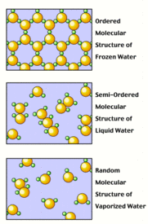

Chemical Changes

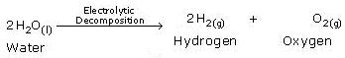

CHECK POINT: Identify the following as a physical or chemical change
a. Iron metal is melted
b. Iron combines with oxygen to form rust
c. Wood burns in air
d. A rock is broken into small pieces

MIXTURES AND PURE SUBSTANCES

Mixtures

Homogeneous

Heterogeneous

Pure Substances

CHECK POINT: Identify each of the following as a pure substance, a homogeneous mixture, or a heterogeneous mixture.
a. maple syrup
b. the oxygen and helium in a scuba tank
c. oil and vinegar salad dressing
d. common salt (sodium chloride)

SEPARATION OF MIXTURES

Distillation

Filtration

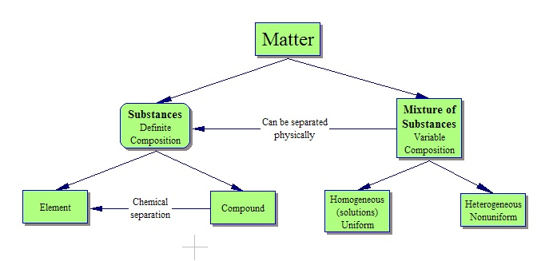

How would you separate a mixture of sand, salt and water?

