HONORS CHEMISTRY UNIT 7 NOTES

TYPES OF CHEMICAL BONDS

What is a chemical bond?

Bond energy

Bond length and bond strength

Types of chemical bonds

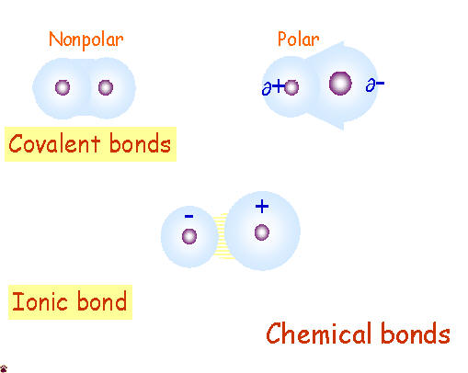

Ionic bonds

Covalent bonds
- (Nonpolar) covalent bonds

- Polar (covalent) bonds

Metallic

ELECTRONEGATIVITY

Using electronegativity to determine types of bonds

EXAMPLES
- HF

- H₂O

- NaF

- SiH₄

- Br₂

STABLE ELECTRON CONFIGURATIONS AND CHARGES ON IONS: A REVIEW

Electron configuration of ions

1.

2.

Electron configurations and Bonding

1.

2.

IONIC BONDING AND STRUCTURES OF IONIC COMPOUNDS

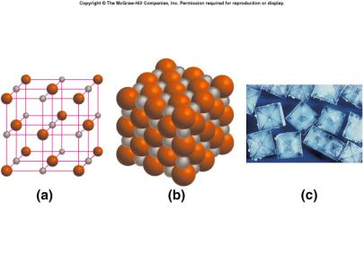

Sizes of ions

Polyatomic ions: Bonding

LEWIS STRUCTURES

Lewis Structure

Writing Lewis Structures for single atoms and ions

Predicting the number of bonds

Steps for Writing Lewis Structures of simple molecules
1.

2.

3.

EXAMPLES

H₂O

HCl

SiCl₄

LEWIS STRUCTURES OF MOLECULES WITH MULTIPLE BONDS

CO₂ an example

Single bond

Double bond

Triple Bond

Resonance

NO₂⁻ an example

How do you decide which one is the central atom?

EXAMPLES

HF

N₂

NH₃

CH₄

NO⁺

NO₃⁻

