HONORS CHEMISTRY UNIT 17 NOTEPACKET-SOLIDS AND LIQUIDS
INTERMOLECULAR FORCES

Intramolecular forces

Intermolecular forces

Types of intermolecular forces

- Dipole-dipole attraction

- Hydrogen bonding

- London Dispersion Forces

WATER AND ITS PHASE CHANGES

Drawing a heating curve for water.

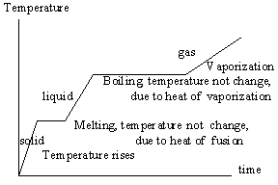
Normal Boiling Point

Normal Freezing Point

ENERGY REQUIREMENTS FOR THE CHANGES OF STATE

Molar heat of fusion

Molar heat of vaporization

Sample problem 1: Calculate the energy required to melt 8.5 grams of ice at 0ºC. The molar heat of fusion for ice is 6.02 kJ/mol.

Sample problem 2: Calculate the energy released when 15.5 g of water freezes at 0ºC. The molar heat of fusion for ice is 6.02 kJ/mol.

Putting together Specific Heat and Changes of State
Sample problem 3: Calculate the energy in kJ required to heat 25 g of liquid water from 25ºC to steam at 100ºC. The specific heat of water is 4.18 J/g . ºC and the molar heat of vaporization is 40.6 kJ/mol.

Sampler problem 4: Calculate the energy in kJ required to change 22.5 g of ice at 0ºC to steam at 100ºC. Use constants from previous problems.

Sample problem 5: How much energy in kJ is required to change 10.0 g of ice at -15.0⁰C to steam at 105.0ºC?
What other numbers will we need?

EVAPORATION AND VAPOR PRESSURE

Vaporization/Evaporation

Vapor Pressure

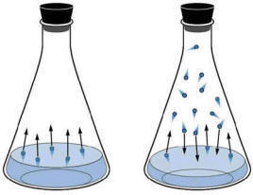

Volatile

Nonvolatile

Sample problem 6: Predict with substance in each of the following pairs will show the largest vapor pressure at a given temperature

- H₂O_{(l)} CH₃OH_{(l)}
- CH₃OH_{(l)}, CH₃CH₂CH₂CH₂OH_{(l)}

BOILING POINT AND VAPOR PRESSURE

THE SOLID STATE: TYPES OF SOLIDS

Crystalline solids

- Ionic solids
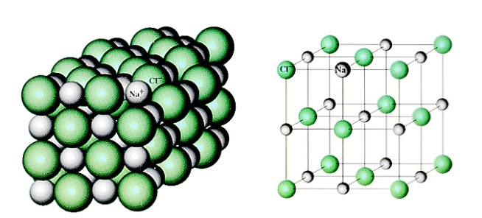

- Molecular solids
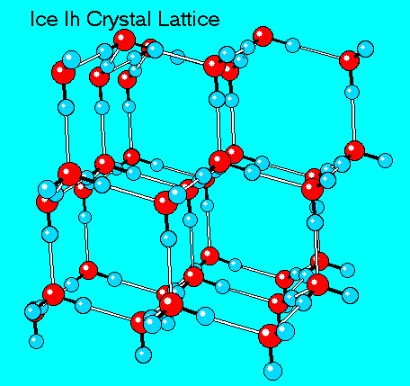

- Atomic solids

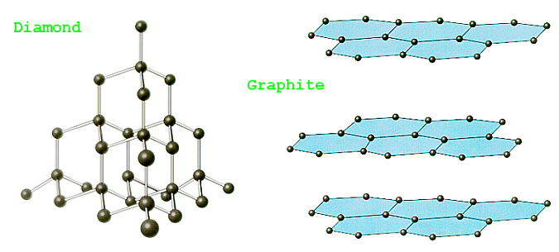

Bonding in Metals

Electron sea model

Alloys

- Substitutional Alloy

- Interstitial Alloy

Sample problem 7: Name the type of crystalline solid formed by each of the following substances
- Ammonia
- Iron
- Cesium fluoride
- Argon
- Sulfur (S₈)

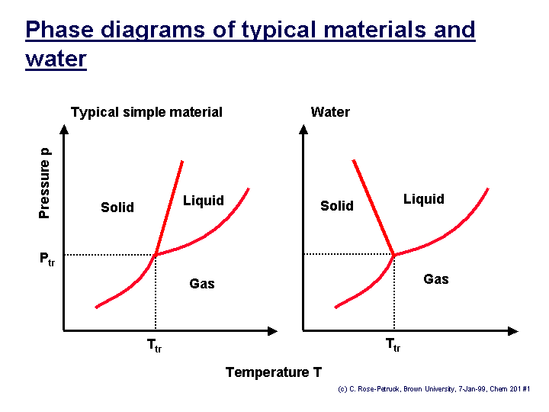

Interpreting phase diagrams

