HONORS CHEMISTRY UNIT 12 NOTES: SOLUTIONS

Solution

Solute

Solvent

Aqueous solutions

Types of solutions
Example | State of solution | Original state of solute | Original state of solvent
Air, natural gas
Antifreeze in water
Brass
Carbonated water
Seawater, sugar water

SOLUBILITY

Solubility of ionic substances:

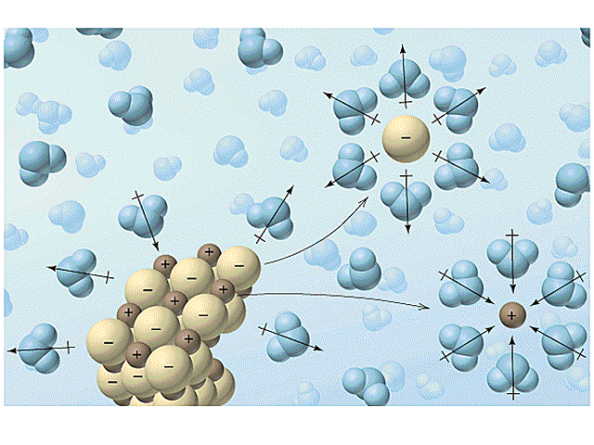
Properties of water and the properties of salt

SOLUBILITY RULES

Using the solubility rules to determine if the following are soluble in water

NaCl

CaCO₃

KNO₃

PbCl₂

MgO

NH₄Br

Sr(OH)₂

BaSO₄

Ni₂CrO₄

K₃PO₄

Solubility of Polar substances

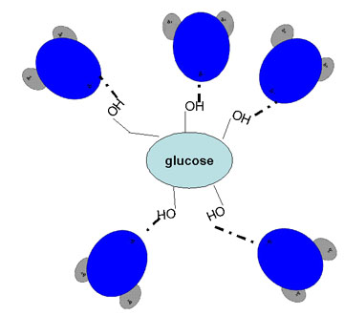

How do you tell what is polar?

Substances Insoluble in water

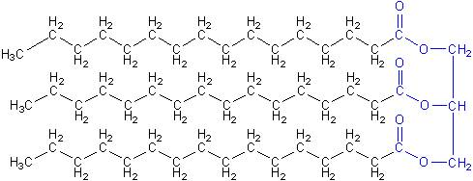

Why will they not dissolve?

SOLUTION COMPOSITION: AN INTRODUCTION

Saturated

Unsaturated

Supersaturated

A test of saturation….

FACTORS AFFECTING THE RATE OF DISSOLUTION

Surface area

Stirring

Temperature

SOLUTION COMPOSITION: MASS PERCENT

What is mass percent?

What are the components of a solution?: A quick review

Sample problem 1: Calculate the mass percent of sodium chloride if 19.0 g of sodium chloride is dissolved in enough water to make 175 g of solution.

Sample problem 2: Calculate the mass percent of sodium chloride if 19.0 g of sodium chloride is dissolved in 175 g of water.

Sample problem 3: Calculate the number of grams of sugar that must be dissolved in 825 g of solution in order to prepare a 20.0% by mass sugar solution

Sample problem 4: Calculate the number of grams of sugar that must be dissolved in 825 g of water in order to prepare a 20.0% by mass sugar solution

Sample problem 5: Calculate the number of grams of solution that is required to dissolve 10.0 g of phenol to prepare a 2.00% by mass phenol solution.

Sample problem 6: Calculate the number of grams of water that is required to dissolve 10.0 g of phenol to prepare a 2.00% by mass phenol solution.

SOLUTION COMPOSITION: MOLARITY

What is molarity?

Sample problem 7: Calculate the molarity of an aqueous sodium chloride solution containing 284 g of NaCl in 2.20 L of solution

Sample problem 8: Calculate the molarity of an aqueous sodium sulfate solution containing 35.0 g of sodium sulfate in 450. mL of solution.

Sample problem 9: Calculate the number of grams of sodium chloride necessary to prepare 230. mL of a 2.00 M NaCl solution. How would you prepare this solution?

Sample problem 10: Calculate the number of liters of a 6.00 M sodium hydroxide solution required to dissolve 410. g of sodium hydroxide

Molarity of ions:

Sample problem 10: What is the molarity of Na ions in a solution that is 2.50 M NaCl?

Sample problem 11: What is the molarity of Na ions in a solution that is 2.50 M Na₂SO₄?

Ionic solutions: What is really going on?

Diluting Solutions: What do you do?

Sample problem 12: What volume of 18 M sulfuric acid must be used to prepare 1.5 L of a 0.19 M sulfuric acid solution? How would you go about making this solution?

Sample problem 13: You only have 12 M HCl available. How would you make 1.50 L of a 2.0 M HCl solution?

STOICHIOMETRY OF SOLUTION REACTIONS

What do you need?

Sample problem 14: How many grams of silver chloride will precipitate out of solution when 35.5 mL of a 0.500 M AgNO₃ is combined with excess sodium chloride solution?

AgNO_{3(aq)} + NaCl_{(aq)} → AgCl_{(s)} + NaNO_{3(aq)}

Sample problem 15: How many mL of a 1.25 M Na₂SO₄ are required to produce 15.0 g of the precipitate BaSO₄?
Na₂SO_{4(aq)} + BaCl_{2(aq)} → BaSO_{4(s)} + 2NaCl_{(aq)}

Sample problem 16: When aqueous solutions of sodium sulfate and lead(II) nitrate are mixed, lead (II) sulfate precipitates. Calculate the mass of PbSO₄ formed when 1.25 L of 0.0500 M Pb(NO₃)₂ and 2.00 L of 0.0250 M Na₂SO₄ are mixed. Also, identify the limiting and excess reactant.

THE PROPERTIES OF SOLUTIONS: FREEZING POINT AND BOILING POINT

Colligative properties and the effects of freezing point and boiling point.

Electrolytic and Nonelectrolytic Solutions

