CHEMISTRY CHAPTER 3: STATES OF MATTER NOTEPACKET
3.1 SOLIDS, LIQUIDS AND GASES
Describing the States of Matter

- Solids

- Liquids

- Gases

- Other States of Matter

Kinetic Theory

Explaining the Behavior of Gases

- Motion in Gases

- Kinetic Theory of Gases
1.

2.

3.

4.

Explaining the Behavior of Liquids

Explaining the Behavior of Solids

3.2 THE GAS LAWS
Pressure
- Definition

- Units

Factors That Affect Gas Pressure

- Temperature
- Definition

- Temperature Conversions: An Approach To Problem Solving
- Fahrenheit

- Celsius

- Kelvin

- Converting from Kelvin to Celsius and vice versa

EXAMPLES

- 37.4ºC to K

- 298 K to ºC

- Converting from Celsius to Fahrenheit and vice versa
EXAMPLES

- 28.7ºC to ºF

- 101ºF to ºC

- Now Try

- 29.7 ºF to K

- 350. K to ºF

- Standard Temperature and Pressure

- Volume

- Number of Particles

Charles’s Law

Sample problem 1: A gas occupies a volume of 4.50 L at 27ºC. At what temperature in ºC would the volume be 6.00 L if the pressure remains constant.

Sample problem 2: A sample of gas occupies a volume of 150. mL at 1.00 atm and 27ºC. Calculate its volume at 0ºC and 1.00 atm.

Boyle’s Law

Sample problem 3: The volume of a gas is 17.4 L measured at standard pressure. Calculate the pressure in torr if the volume is changed to 20.4 L and the temperature remains constant.

Sample problem 4: A sample of gas occupies a volume of 73.5 mL at a pressure of 710. torr and a temperature of 30ºC. What will the volume be in mL at 650. torr and 30ºC?

Combined Gas Law

Sample problem 5: A certain gas occupies 500. mL at STP. What volume in milliliters will it occupy at 10.0 atm and 100.ºC?

Sample problem 6: A certain gas occupied 20.0 L at 50.ºC and 780. torr. Under what pressure in torr would the gas occupy 75.0 L at 0ºC?

3.3 PHASE CHANGES
Characteristics of Phase Changes

- Temperature and Phase Changes

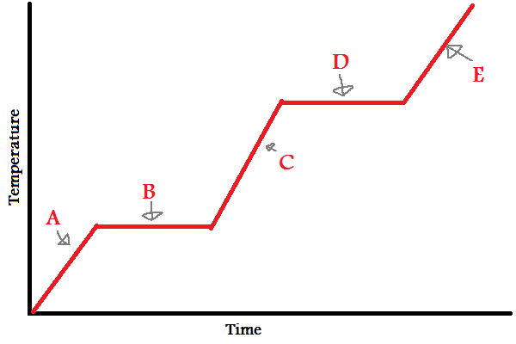

- Energy and Phase Changes

- Endothermic

- Exothermic

Melting and Freezing

- Melting

- Freezing

- Heat of fusion

Vaporization and Condensation

- Evaporation

- Boiling

- Heat of Vaporization

- Condensation

Sublimation and Deposition

