AP CHEMISTRY CHAPTER 4 OUTLINE
TYPES OF CHEMICAL REACTIONS AND SOLTUION STOICHIOMETRY

4.1-WATER, THE COMMON SOLVENT
Aqueous solutions

Polar molecules

Hydration

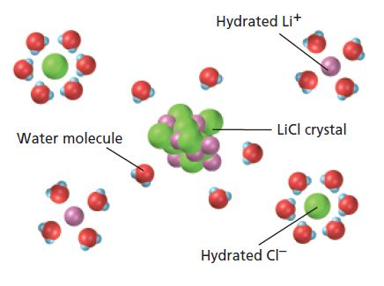

NH₄NO_{3(s)} →

Solubility

Hydrating nonionic substances

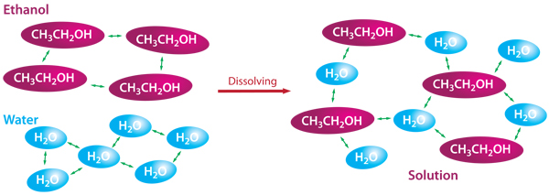

4.2-THE NATURE OF AQUEOUS SOLUTIONS: STRONG AND WEAK ELECTROLYTES

Solute/Solvent

Electrolytes
- Strong

- Weak

- Nonelectrolyte

4.3-THE COMPOSITION OF SOLUTIONS

Performing stoichiometric calculations with solutions

Molarity

IN CLASS CHECK: Formalin is an aqueous solution of formaldehyde (HCHO). At high concentrations it is used as a preservative for biologic specimens. How many grams of formaldehyde are contained in 2.5 L of 12.3 M formalin?

Standard solutions and their preparation

Stock solution

Dilution

4.4-TYPES OF CHEMICAL REACTIONS
- Precipitation reactions
- Acid-base reactions
- Oxidation-reduction reactions

4.5-PRECIPITATION REACTIONS

Precipitate

Determining the species present in solution in order to find the precipitate
K₂CrO_{4(aq)} + Ba(NO₃)_{2(aq)} →

Soluble and slightly soluble

4.6- DESCRIBING REACTIONS IN SOLUTION

Formula equation

Complete ionic equation

Spectator Ions

Net Ionic equations
4.7-STOICHIOMETRY OF PRECIPITATION REACTIONS

Problem Solving Strategy

4.8-ACID-BASE REACTION

Bronsted-Lowry
- Acid
- Base

Neutralization Reaction

Acid-Base titrations

Volumetric Analysis

Titration

Titrant

Equivalence Point/Stoichiometric Point

Endpoint

Requirements for a successful titration
- The exact reaction between the titrant and analyte must be known (and rapid)
- The stoichiometric (equivalence) point must be marked accurately
- The volume of titrant required to reach the stoichiometric point must be know accurately

Indicator
Standardizing the solution

4.9-OXIDATION-REDUCTION REACTIONS

Oxidation States (Numbers)

Where does the + go?

Rules for Assigning Oxidation States (See page 171)

The Characteristics of Oxidation-Reduction Reactions

2Na_{(s)} + Cl_{2(aq)} → 2NaCl_{(s)}

CH_{4(g)} + 2O_{2(g)} → CO_{2(g)} + 2H₂O_{(g)}

Oxidation

Reduction

Oxidizing Agent

Reducing Agent

IN CLASS CHECK: When powdered aluminum metal is mixed with pulverized iodine crystals and a drop of water is added to help the reaction get started, the resulting reaction produces a great deal of energy. The mixture bursts into flames, and a purple smoke of I₂ vapor is produced from the excess iodine. The equation for the reaction is
2Al_{(s)} + 3I_{2(s)} → 2AlI_{3(s)}
For this reaction, identify the atoms that are oxidized and reduced, and specify the oxidizing and reducing agents.

4.10-BALANCING OXIDATION-REDUCTION EQUATIONS

Oxidation States Method of Balancing Oxidation-Reduction Reactions

Cu_{(s)} + Ag⁺_{(aq)} → Ag_{(s)} + Cu²⁺_{(aq)}

H⁺_{(aq)} + Cl⁻_{(aq)} + Sn_{(s)} + NO₃⁻_{(aq)} → SnCl₆²⁻_{(aq)} + NO_{2(aq)} + H₂O_{(l)}

STEPS:
1.

2.

3.

4.

5.

6.

